**Table of Contents**

Introduction3

Skip Patterns5

Survey Introduction23

Demographics25

Family Structure27

Word Association29

Verb Generation30

Word Association (Image)33

Word Association (Slogan)38

Brand Recognition40

Tobacco Brand Recognition50

25% Update52

Single Target Implicit Association Task53

Flicker Paradigm (Image One)69

Disposable Income76

Store Visit Frequency80

Tobacco Initiation – Part 1203

Cigarette Use204

Tobacco Initiation – Part 2205

Tobacco Initiation – Part 3208

Recent Tobacco Use – Part 1210

Recent Tobacco Use – Part 2212

Tobacco Quantity – Part 1213

Modified Fagerstrom Tolerance Questionnaire (mFRQ) for Adolescents214

Tobacco Quantity – Part 2216

Access to Tobacco Products – Part 1217

Tobacco Cessation221

Tobacco Use Willingness222

Tobacco Initiation – Part 4223

Access to Tobacco Products – Part 2224

Perception of Peer Tobacco Use225

Tobacco Brand Preference227

Tobacco Brand Preference (Purchases) 229

Second-Hand Smoke Exposure231

Health Professional Warnings232

General Health Perceptions233

Flicker Paradigm (Image Two)234

Symmetry Span Task241

Go/No-Go Task251

65% Update254

Short Form Smoking Consequences Questionnaire (S-SCQ)255

Family and Peer Smoking259

Injunctive Norms262

Media Exposure264

Prevention Program Exposure269

75% Update271

Drug Use Frequency Scale272

Depression Anxiety Stress Scale (DASS-21)278

Head Injury282

Electronic Cigarette Commercials283

Point-of-Sale Sensitivity290

90% Update291

Perceived Stress PSS-10292

Price Consciousness294

Tobacco Shopper Type295

Enrollment In The Military297

Extracurricular Activities 298

Attrition300

Final Screen301

**Introduction**

All measures were administered to participants using a web-based survey programmed with Inquisit 4 Software. At the beginning of each survey, a whole number between 1 and 4 was assigned automatically in the field *Subject*. This number determined which version of the survey the participant received.

|  |  |  |
| --- | --- | --- |
| **Version** | **Initial Categories for Single Target Implicit Association Test** | **Initial Presentation of**  **Flicker Paradigm** |
| 1 | Unpleasant or Tobacco vs. Neutral | Flicker Paradigm (Image One) |
| 2 | Pleasant vs. Neutral or Tobacco | Flicker Paradigm (Image Two) |
| 3 | Pleasant or Tobacco vs. Neutral | Flicker Paradigm (Image One) |
| 4 | Unpleasant vs. Neutral or Tobacco | Flicker Paradigm (Image Two) |

The data from the survey was divided by Inquisit into 12 groups. A separate dataset was generated from each group. Four fields within each dataset permitted participant responses to be linked across groups.

The first field, *ID_Wave*, indicated which of three waves the participant completed.

The second field, *ID_School,* indicated which of 37 school locations the participant was from. This number was also used to trigger school-specific items, such as the stores near each school displayed in the Store Visit Frequency measure.

The third field, *ID_Participant*, was a unique value assigned to each student from a school that expressed interest in the study. Not all students that initially expressed interest completed the online survey.

The fourth field, *ID_Condition*, indicated which condition the student was randomly assigned to during the first wave of the study. A ‘9’ indicated that the participant was assigned to the first condition and completed the Symmetry Span Task in each of wave of the study. A ‘1’ indicated that the participant was assigned to the second condition and completed the Go/No-Go Task in each of wave of the study.

Collectively, these four fields were merged to create a *Survey ID* code that was unique for each survey completed by each participant. *ID_School* and *ID_Participant* remained constant for each individual participant across all three waves of the study.

*Variable Names*

All variables were labeled with a five-character prefix.

The first two characters denoted the wave. For example, *W1* indicated that the variable was from the first wave.

The next two characters denoted the measure the item was associated with. In the first wave these variables were labeled in sequence, i.e. the first measure was labeled *AA*, the second measure was labeled *AB*, and the final measure was labeled *BY*. These variable names were then retained in all waves regardless of their placement within the survey. Measures added to the second wave were assigned the character *C*, e.g. *CA*, *CB*, etc. Measures added to the third wave were assigned the character *D*, e.g. *DA*, *DB*, etc.

The last character in the five-character prefix was *Q*. It was followed by the question number. This number was sequential in the first wave and then remained constant in all subsequent waves. Thus, the variable *W1AAQ15* in the first wave was labeled *W2AAQ15* in the second wave even though it was the fifteenth question presented in the first wave and the third question presented in the second wave.

*Negative Values*

In the data generated from the online survey, negative values denote unique forms of data. The definition of each value is provided below:

* (Blank) = Participant chose not to answer the question or selected a response in a prior question that caused the question to be skipped.
* -7 = Participant selected ‘Don’t Know’, ‘Not Sure’, etc.
* -5 = Participant selected a fictional product brand or program.

***Skip Patterns***

During the survey, certain measures contained skip patterns. **Questions and responses that triggered a skip pattern in the survey are depicted below in red.** Questions that could be skipped as a result of a skip pattern are depicted below in blue.

***Store Visit Frequency***

[*Skip Pattern Question*]

**Are you currently a student at [Name of School Based on Entered ID]?**

Yes

**No**

[*Introduction*]

On the next screens, you will see pictures of stores near your school. For each picture, please indicate how often you visit the specific store at the address listed.

[*Repeated Screen*]

(picture)

(store name) at (address).

How often do you go to the store at THIS ADDRESS?

Never

Once a month

2-3 times a month

Once a week

2-3 times a week

Almost every day

***Tobacco Use***

**How old were you when you first tried…**

|  |  |  |  |  |  |  |  |  |  |  |  |  |  |
| --- | --- | --- | --- | --- | --- | --- | --- | --- | --- | --- | --- | --- | --- |
|  | **Never**  **tried** | Younger than 8 years old | 9 | 10 | 11 | 12 | 13 | 14 | 15 | 16 | 17 | 18 | 19 |
| ***Cigarettes***  ***(Marlboro, Camel, Newport, American Spirit, etc.)*** | **❑0** | ❑8 | ❑9 | ❑10 | ❑11 | ❑12 | ❑13 | ❑14 | ❑15 | ❑16 | ❑17 | ❑18 | ❑19 |
| ***Electronic Cigarettes, Vaporizers, or Vape Pens***  ***(Blu, NJOY, MarkTen, etc.)*** | **❑0** | ❑8 | ❑9 | ❑10 | ❑11 | ❑12 | ❑13 | ❑14 | ❑15 | ❑16 | ❑17 | ❑18 | ❑19 |
| ***Cigars, Cigarillos, or Little Cigars***  ***(Black and Milds, Swisher Sweets, Dutch Masters, etc.)*** | **❑0** | ❑8 | ❑9 | ❑10 | ❑11 | ❑12 | ❑13 | ❑14 | ❑15 | ❑16 | ❑17 | ❑18 | ❑19 |
| ***Chewing Tobacco, Snuff, or Dip***  ***(Copenhagen, Grizzly, Skoal, etc.)*** | **❑0** | ❑8 | ❑9 | ❑10 | ❑11 | ❑12 | ❑13 | ❑14 | ❑15 | ❑16 | ❑17 | ❑18 | ❑19 |

When was the last time you used…

|  |  |  |  |  |  |  |  |  |
| --- | --- | --- | --- | --- | --- | --- | --- | --- |
|  | Never  tried | 5 or more years ago | 1 to 4 years ago | 6 to 12  months ago | 1 to 5  months ago | 7 to 30  days ago | 1 to 6  days ago | Earlier  today |
| *Cigarettes* | ❑0 | ❑1 | ❑2 | ❑3 | ❑4 | ❑5 | ❑6 | ❑7 |
| *Electronic Cigarettes, Vaporizers, or Vape Pens* | ❑0 | ❑1 | ❑2 | ❑3 | ❑4 | ❑5 | ❑6 | ❑7 |
| *Cigars, Cigarillos, or Little Cigars* | ❑0 | ❑1 | ❑2 | ❑3 | ❑4 | ❑5 | ❑6 | ❑7 |
| *Chewing Tobacco, Snuff, or Dip* | ❑0 | ❑1 | ❑2 | ❑3 | ❑4 | ❑5 | ❑6 | ❑7 |
| *Pipe Tobacco* | ❑0 | ❑1 | ❑2 | ❑3 | ❑4 | ❑5 | ❑6 | ❑7 |
| *Hookah or Shisha* | ❑0 | ❑1 | ❑2 | ❑3 | ❑4 | ❑5 | ❑6 | ❑7 |

During the past 30 days, on how many days did you use each of the tobacco products below?

|  |  |  |  |  |  |  |  |
| --- | --- | --- | --- | --- | --- | --- | --- |
|  | 0  days | 1 or 2  days | 3 to 5  days | 6 to 9  days | 10 to 19  days | 20 to 29  days | All 30 days |
| *Cigarettes* | ❑0 | ❑1 | ❑2 | ❑3 | ❑4 | ❑5 | ❑6 |
| *Electronic Cigarettes, Vaporizers, or Vape Pens* | ❑0 | ❑1 | ❑2 | ❑3 | ❑4 | ❑5 | ❑6 |
| *Cigars, Cigarillos, or Little Cigars* | ❑0 | ❑1 | ❑2 | ❑3 | ❑4 | ❑5 | ❑6 |
| *Chewing Tobacco, Snuff, or Dip* | ❑0 | ❑1 | ❑2 | ❑3 | ❑4 | ❑5 | ❑6 |
| *Pipe Tobacco* | ❑0 | ❑1 | ❑2 | ❑3 | ❑4 | ❑5 | ❑6 |
| *Hookah or Shisha* | ❑0 | ❑1 | ❑2 | ❑3 | ❑4 | ❑5 | ❑6 |

On a typical day, which tobacco products do you use? (Check all that apply)

Cigarettes

Electronic Cigarettes, Vaporizers, or Vape Pens

Cigars, Cigarillos, or Little Cigars

Chewing Tobacco, Snuff, or Dip

Pipe Tobacco

Hookah or Shisha

None of the above

How many cigarettes a day do you smoke?

1-Over 26 cigarettes a day (2)

2-About 16-25 cigarettes a day (1)

3-About 1-15 cigarettes a day (0)

4-Less than 1 a day (0)

Do you inhale?

1-Always (2)

2-Quite often (1)

3-Seldom (1)

4-Never (0)

How soon after you wake up do you smoke your first cigarette?

1-Within the first 30 minutes (1)

2-More than 30 minutes after waking but before noon (0)

3-In the afternoon (0)

4-In the evening (0)

0-I currently don’t smoke cigarettes

Which cigarette would you hate to give up?

1-First cigarette in the morning (1)

2-Any other cigarette before noon (0)

3-Any other cigarette after noon (0)

4-Any other cigarette in the evening (0)

0-I currently don’t smoke cigarettes

Do you find it difficult to refrain from smoking in places where it is forbidden (church, library, movies etc.)?

1-Yes, very difficult (1)

2-Yes, somewhat difficult (1)

3-No, not usually difficult (0)

4-No, not at all difficult (0)

Do you smoke if you are so ill that you are in bed most of the day?

1-Yes, always (1)

2-Yes, quite often (1)

3-No, not usually (0)

4-No, never (0)

Do you smoke more during the first 2 hours than during the rest of the day?

1-Yes (1)

2-No (0)

On a typical day when you smoke, how many puffs do you take from each tobacco product?

|  |  |  |  |  |  |
| --- | --- | --- | --- | --- | --- |
|  | 0 | 1-10 puffs | 11-50 puffs | 51-200 puffs | 201+ puffs |
| ***Cigarettes*** | ❑0 | ❑1 | ❑2 | ❑3 | ❑4 |
| ***Electronic Cigarettes, Vaporizers, or Vape Pens*** | ❑0 | ❑1 | ❑2 | ❑3 | ❑4 |
| ***Cigars, Cigarillos, or Little Cigars*** | ❑0 | ❑1 | ❑2 | ❑3 | ❑4 |

On a typical day when you have chewing tobacco, snuff, or dip, how much do you use?

None

About 10% of a tin

About a quarter of a tin

About half of a tin

About three-quarters of a tin

A full tin

More than one tin

During the past 30 days, where did you get your own tobacco products? (Check all that apply)

I did not buy tobacco products during the past 30 days

A gas station

A convenience store

A grocery store

A drugstore or pharmacy

A vending machine

Over the Internet

Through the mail

A friend

A family member

None of the above

Other (please specify):

During the past 30 days, where did you get MOST of your tobacco products?

I did not buy tobacco products during the past 30 days

A gas station

A convenience store

A grocery store

A drugstore or pharmacy

A vending machine

Over the Internet

Through the mail

A friend

A family member

Other (please specify):

What is the CHEAPEST way to buy tobacco products?

At a gas station

At a convenience store

At a grocery store

At a drugstore or pharmacy

At a vending machine

Over the Internet

Through the mail

Other (please specify): ___________

What is the CHEAPEST tobacco product to buy?

Cigarettes

Electronic Cigarettes, Vaporizers, or Vape Pens

Cigars, Cigarillos, or Little Cigars

Chewing Tobacco, Snuff, or Dip

Pipe Tobacco

Hookah or Shisha

Other (please specify): ___________

Have you ever bought the following from a store near [Name of School Based on Entered ID]? (Check all that apply)

Cigarettes

Electronic Cigarettes, Vaporizers, or Vape Pens

Cigars, Cigarillos, or Little Cigars

Chewing Tobacco, Snuff, or Dip

Pipe Tobacco

Hookah or Shisha

None of the above

**School IDs:**

105 = Tracy High School

108 = Desert Winds High School

109 = R. Rex Parris High School

111 = North Park High School

112 = Somerset High School

113 = Chaparral High School

114 = Monterey High School

115 = Centinela Valley High School

116 = R. K. Lloyde High School

117 = Fairvalley High School

139 = Jack London High School

161 = Youth Opportunities High School

165 = Canyon Oaks High School

171 = Rose City High School

174 = Kurt T. Shery High School

181 = Santana High School

186 = Buena Park High School

195 = Valley Vista High School

197 = Back Bay High School

206 = Hillview High School

208 = Alvord High School

214 = Amistad High School

223 = Abraham Lincoln High School

224 = Mountain View High School

226 = Ortega High School

229 = Val Verde High School

232 = Central High School

244 = Mountain High School

246 = Middle College High School

250 = Oak View High School

254 = Mojave High School

261 = Abraxas High School

276 = Pacific High School

278 = Conejo Valley High School

280 = Community High School

282 = Phoenix High School

283 = Phoenix High School

During the past 30 days, did anyone ever refuse to sell you a tobacco product (cigarettes, cigars, electronic cigarettes, chewing tobacco, etc.) because of your age?

I did not try to buy a tobacco product in a store during the past 30 days

Yes, someone refused to sell me a tobacco product because of my age

No, no one refused to sell me a tobacco product because of my age

If you bought or tried to buy a tobacco product in a store during the past 30 days, were you ever asked to show proof of age?

I did not try to buy a tobacco product in a store during the past 30 days

Yes, I was asked to show proof of age

No, I was not asked to show proof of age

Have you ever thought about quitting or planning to quit using tobacco?

No

I thought about it but did not want to

I thought about it have not made up my mind

I plan to quit in the next 30 days

I plan to quit in the next 6 months

How many times during the past 12 months have you stopped using tobacco for one day or longer because you were trying to quit?

I have not tried to quit

1 time

2 times

3 to 5 times

6 to 9 times

10 or more times

When you last tried to quit tobacco, how long did you last?

Less than a day

1 to 7 days

More than 7 days but less than 30 days

30 days or more but less than 6 months

6 months or more but less than a year

1 year or more

***Media Exposure***

**During the past 30 days, about how often have you seen ads online FOR tobacco products?**

**None**

1-3 times in the past 30 days

1-3 times per week

Daily or almost daily

More than once a day

During the past 30 days, where did you see ads online FOR tobacco products? (Check all that apply)

Social Networks (Facebook, myspace, Instagram, etc.)

Email (Gmail, Yahoo mail, Hotmail, etc.)

Forums (Xual, Ultimate Teen Forums, All About Goldfish, etc.)

Search Engine (Google, Yahoo, Ask, etc.)

Online Shopping (Amazon, Ebay, Overstock, etc.)

Video Streaming (YouTube, Vimeo, DailyMotion, etc.)

Music Streaming (Pandora, Spotify, Grooveshark, etc.)

Download sites (Vertor, Take.FM, ThePirateBay, etc.)

Blogs (Blog.com, Wordpress, Blogger, etc.)

Wikis (Wikipedia, Wiktionary, ZineWiki, etc.)

Podcasts (Teen Talk, TBTL, NLCast, etc.)

***Electronic Cigarette Commercials***

**Have you ever seen a commercial for electronic cigarettes on television?**

Yes

**No**

**Have you ever seen a commercial for electronic cigarettes online (YouTube, Hulu, Netflix etc.)?**

Yes

**No**

Think of the last time you saw a commercial for electronic cigarettes either on TV or online.

Try to form a picture of this commercial in your mind.

What were you doing when you saw the electronic cigarette commercial?

Watching television

Watching a video online at a website like YouTube, Hulu, Netflix, etc.

Using a social network like Facebook, Instagram, etc.

Other (please specify): _____________

When did you last see this electronic cigarette commercial?

1-2 days ago

3-6 days ago

1-2 weeks ago

3-4 weeks ago

1-2 months ago

3-6 months ago

More than 6 months ago

What brand was being advertised in the electronic cigarette commercial?

Blu

Green Smart Living

MarkTen

NJOY

Xcite*

Square

Vuse

V2

I don’t know

Another brand (please specify):________________

For each numbered item below answer the following question.

How did the electronic cigarette commercial make you feel?

Very Unhappy Unhappy Neutral Happy Very Happy

Very Unpleasant Unpleasant Neutral Pleasant Very Pleasant

Very Bad Bad Neutral Good Very Good

Very Uncool Uncool Neutral Cool Very Cool

Were there people in the electronic cigarette commercial?

Yes

No

How old were the people in the electronic cigarette commercial? (Check all that apply)

Under 18

18 to 25

26 to 30

1. or older

There were no people in the advertisement

What was the gender of the people in the electronic cigarette commercial?

One male only

Two or more males (no females)

One female only

Two or more females (no males)

A mix of males and females

There were no people in the advertisement

What was the race/ethnicity of the people in the electronic cigarette commercial? (Check all that apply)

White

Hispanic

Black or African American

Asian

Native Hawaiian or Other Pacific Islander

American Indian or Alaska Native

There were no people in the advertisement

Other (please specify): __________________

When you see electronic cigarettes commercials on TV or online…

Do you think they are funny?

Yes, always

Yes, usually

No, usually not

No, never

Do you think they are sexy?

Yes, always

Yes, usually

No, usually not

No, never

Do you wish you were like the people in the commercials?

Yes, always

Yes, usually

No, usually not

No, never

When you see electronic cigarette commercials, how often do you pay attention to them?

Always

Most of the time

Some of the time

Never

Of all the commercials you see, how much do you like electronic cigarette commercials?

I like electronic cigarette commercials the most

I like electronic cigarette commercials a little more than the other commercials

I like electronic cigarette commercials a little less than the other commercials

I like electronic cigarette commercials the least

How often do you talk to other people about electronic cigarette commercials you saw on TV or online?

Very Often

Often

Sometimes

Never

Think back to the electronic cigarette commercials you have seen in the past month. What brand of electronic cigarette was advertised the most?

Blu

Green Smart Living

MarkTen

NJOY

Xcite*

Square

Vuse

V2

I don’t know

Another brand (please specify):________________

What is the name of the brand of your favorite electronic cigarette commercial?

Blu

Green Smart Living

MarkTen

NJOY

Xcite*

Square

Vuse

V2

I don’t know

Another brand (please specify):________________

About how often did you see an electronic cigarette commercial in the last six months?

Every day

2-6 times a week

Once a week

2-3 times a month

Once a month

Less than once a month

Never

In the past week, how many commercials have you seen for electronic cigarettes?

0

1

2

3

4

5

6 or more

***Tobacco Shopper Type***

**Have you ever bought tobacco products at a store?**

Yes

**No**

**Think of the last time you bought tobacco products at a store. Try to form a picture of this in your mind.**

In addition to tobacco products, did you buy any of the following? (Check all that apply)

Snack Foods

Alcohol

Coffee Drinks

Soda or Energy Drinks

Lottery Tickets

Magazines or Newspapers

None of the above

How many different types of products did you buy?

One

Two

Three

Four

Five

Six or more

**When did you last purchase a pack of cigarettes at a store?**

1-2 days ago

3-6 days ago

1-2 weeks ago

3-4 weeks ago

1-2 months ago

3-6 months ago

More than 6 months ago

**I have never bought a pack of cigarettes at a store**

How much did you pay for the last pack of cigarettes you bought at a store? $___________

What brand did you buy?

American Spirit

Camel

GPC, Basic, or Doral

Kool

Lucky Strike

Marlboro

Newport

Parliament

Summit*

Virginia Slims

Another brand (please specify): _________

***Extracurricular Activities***

**In the last 12 months, which of the following organized activities or groups have you participated in? (Check all that apply)**

Music, dance, theater or other performing arts (in or outside of school)

Athletic teams or organized sports (in or outside of school)

Boys or girls clubs (Boy Scouts, Girl Scouts, etc.)

Youth groups sponsored by a church, synagogue, mosque, or other religious institution

Another club or activity, in or outside of school, or volunteer work

**None of these clubs or activities**

How many hours a week did you participate in these activities? ___________

**Which of the following organized activities or groups are you currently participating in? (Check all that apply)**

Music, dance, theater or other performing arts (in or outside of school)

Athletic teams or organized sports (in or outside of school)

Boys or girls clubs (Boy Scouts, Girl Scouts, etc.)

Youth groups sponsored by a church, synagogue, mosque, or other religious institution

Another club or activity, in or outside of school, or volunteer work

**None of these clubs or activities**

How many hours a week do you participate in these activities? ___________

How many close friends participate in these activities with you?

None of them

A few of them

About half of them

Most of them

All of them

***Enrollment In The Military***

**Are you a member of the...**

**Army**

**Navy**

**Marine Corps**

**Air Force**

**Coast Guard**

None of the above

Are you thinking about enlisting in the...

Army

Navy

Marine Corps

Air Force

Coast Guard

None of the above

**Survey Introduction**

[*Introduction – First Screen*]

Thank you for participating in CHAMP.

The following survey asks about your thoughts, feelings, background, and health.

You will also be asked to perform some computer tasks.

Before you get started, make sure you are sitting comfortably in a quiet location and that you have plenty of time.

The survey may take up to two hours. It must be completed in one sitting.

Please select one of the options below and then click CONTINUE

[*Introduction – Second Screen*]

This survey includes audio. You may need to adjust the volume to hear it.

Please check the volume of your computer now by clicking the text below.

[*Introduction – Third Screen*]

During the survey, you will sometimes be asked to press the SPACE BAR to move to the next screen.

When the audio ends, press the SPACE BAR to continue

[*Introduction – Fourth Screen*]

From time to time, you will need to use the mouse to select an answer.

Let’s practice this.

Type in your date of birth.

Then use the mouse to point and click on one of the gender options below.

What is your date of birth?

_______________

Example: 11/09/1996

What is your gender?

Male

Female

[*Introduction – Fifth Screen*]

If you need any assistance or have any questions, don’t hesitate to call or text your Study Coordinator.

They are glad you are taking part in the study and will be happy to help you.

[*Introduction – Sixth Screen*]

Now let’s begin the survey.

Please enter the code that was emailed to you.

## Demographics

**Source:** Items 3-8 were adapted from:

Ensminger, M.E., Forrest, C.B., Riley, A.W., Kang, M., Green, B.F., Starfield, B., & Ryan, S.A. (2000). The validity of measures of socioeconomic status of adolescents. *Journal Of Adolescent Research, 15*(3), 392-419.

Hollingshead, A.B., Redlich, F.C. (1958). Social class and mental illness: A community study. New York, NY: Wiley.

**Designed For:** Adolescents

**Psychometrics:** Not provided

**Codebook:**

The following questions ask about your general background.

1. What is your date of birth? (MM/DD/YYYY) _____ W2AAQA1 W2DemDOBMM1 / _____ W2AAQB1 W2DemDOBDD1 /_____ W2AAQC1 W2DemDOBYYYY1
2. What is your gender? W2AAQ2 W2DemGender2

Male 1

Female 2

1. Is your father or male guardian currently... W2AAQ15 W2DemDadWork15

Working full-time 2

Working part-time 1

Not working 0

Don’t know -7

1. Is your mother or female guardian currently… W2AAQ16 W2DemMomWork16

Working full-time 2

Working part-time 1

Not working 0

Don’t know -7

1. Are you currently… W2AAQ20 W2DemSelfWork20

Working full-time 2

Working part-time 1

Not working 0

Don’t know -7

1. Does your family receive a welfare check? W2AAQ17 W2DemWelfare17

Yes 1

No 0

1. Does your family receive food stamps? W2AAQ18 W2DemFoodStamps18

Yes 1

No 0

1. Do you or any of your siblings receive free or reduced lunches at school? W2AAQ19 W2DemFreeLunch19

Yes 1

No 0

## Family Structure

**Source:** Items 1-3 adapted from Smith, C. & Denton, M.L. (2003). Methodological Design and Procedures for the National Survey of Youth and Religion (NSYR). <http://www.thearda.com/Archive/Files/Codebooks/NSYRW3_CB.asp>.

**Designed For:** Adolescents

**Psychometrics:** Not provided

**Codebook:**

1. Where do you live now? W2ABQ1 W2FamLivNow1

Your parent’s home 1

Another person’s home 2

Your own place 3

Group home 4

Other (please specify) 5 W2ABQ1other W2FamLivNowOther1

1. Do you live alone or with others? W2ABQ2 W2FamLivAlone2

Alone 1

With others 2

1. Who lives with you most of the time? (Check all that apply) W2ABQ3 W2FamLivMem3, 0 When Not Selected, 1 When Selected

Father W2ABQ3option1 W2FamLivMemDad3

Mother W2ABQ3option2 W2FamLivMemMom3

Stepfather W2ABQ3option3 W2FamLivMemStepDad3

Stepmother W2ABQ3option4 W2FamLivMemStepMom3

Foster Parent(s) W2ABQ3option5 W2FamLivFosterParent3

Brother(s) W2ABQ3option6 W2FamLivBro3

Sister(s) W2ABQ3option7 W2FamLivMemSis3

Grandfather(s) W2ABQ3option8 W2FamLivMemGranddad3

Grandmother(s) W2ABQ3option9 W2FamLivMemGrandma3

Other Relatives (Aunt, Uncle, Cousin) W2ABQ3option10 W2FamLivMemRel3

Wife/Husband W2ABQ3option11 W2FamLivMemSpouse3

Girlfriend/Boyfriend W2ABQ3option12 W2FamLivMemGirlBoyFriend3

Daughter(s) W2ABQ3option13 W2FamLivMemDaughter3

Son(s) W2ABQ3option14 W2FamLivMemSon3

Roommate(s)/Friend(s) W2ABQ3option15 W2FamLivMemRoommate3

Other People (please specify) W2ABQ3option16 W2FamLivMemOther3____________ W2ABQ3other W2FamLivOtherSpecify3

1. How many people under the age of 18 live with you most of the time? W2ABQ4 W2FamLiv18Under4

___________

1. How many people who are 18 or older live with you most of the time? W2ABQ5 W2FamLiv18andOver5

___________

**Word Association**

**Source:** Grenard, J.L., Ames, S.L., Thush, C., Sussman, S., Wiers, R., & Stacy, A.W. (2008). Working memory capacity moderates the predictive effects of drug-related associations on substance use. *Psychology of Addictive Behaviors, 22*(3): 426-432.

Rooke, S.E., Hine, D.W., & Thorsteinsson, E.B. (2008). Implicit cognition and substance use: A meta-analysis. *Addictive Behaviors, 33*, 1314-1328.

Stacy, A.W. (1997). Memory activation and expectancy as prospective predictors of alcohol and marijuana use. *Journal of Abnormal Psychology*, 106 (1), 61-73.

Stacy, A.W. (1995) Memory association and ambiguous cues in models of alcohol and marijuana use. *Experimental and Clinical Psychopharmacology*, 3 (2), 183-194.

Stacy, A.W., Ames, S.L. Sussman, S., Dent, C. (1996) Implicit cognition in adolescent drug use. *Psychology of Addictive Behaviors, 10* (3), 190-203.

Stacy, A.W., Galaif, E.R., Sussman, S., & Dent, C.W. (1996). Self-generated drug outcomes in high risk adolescents. *Psychology of Addictive Behaviors, 10*(1), 18-27.

Stacy, A.W, Leigh, B.C. & Weingardt, K., (1997). An individual-difference perspective applied to word association. *Personality and Social Psychology Bulletin*, 3, 229-237.

Sussman, S., Stacy, A.W., Ames, S.L., & Freedman, L.B. (1998). Self-reported high-risk locations of adolescent drug use. *Addictive Behaviors, 23*, 405-11.

Dosher, B., & Rosedale, G.S. (1997). Configural processing in memory retrieval: Multiple cues and ensemble representations.*Cognitive Psychology*, *33*(3), 209-265

**Designed For:** Adolescents

**Codebook:**

**Verb Generation**

**Task Instructions:**

[*Screen One*]

For the next set of questions, please type the very first behavior or action that comes to mind when you read a phrase on the screen. Behaviors, activities, or actions are 'things to do'. If you can’t think of a behavior or action, then type the first word that 'pops to mind'. If you still can't think of anything, type the word 'none'.

[*Screen Two*]

For example, suppose that the phrase was 'tasting something sweet'

Type the behavior or action that ‘pops to mind'.

When you see the words ‘tasting something sweet’: 'eating ice cream’

could be the first behavior that comes to mind.

[*Screen Three*]

Read the phrase below, and then type the first behavior or action that comes to mind.

tasting something sweet

First behavior or action

[*Text*]

[*Screen Four*]

Remember, if you can’t think of a behavior or action, then you can type the first word that 'pops to mind'. If you still can't think of anything, you can type the word 'none'.

[*Screen Five*]

Work quickly.

There is a time limit for each screen.

[*Header*]

Read the phrase below, and then type the first behavior or action that comes to mind

First behavior or action

[*Text*]

**Cues:** W2ACQ W2WAOBCue

1. feeling relaxed
2. feeling dreamy
3. forgetting problems
4. being sociable
5. went outside
6. laughing
7. feeling happy
8. **showing courage**
9. **being helpful**
10. being peaceful
11. at a party
12. having fun
13. **showing respect**
14. **making money**
15. feeling good
16. **inside a church, being quiet**
17. parking lot, looking cool
18. after school, walking home
19. outdoors, at school
20. going home, feeling stressed
21. **on the bus, being nice**
22. with friends, had a rough day
23. at home, feeling down
24. friday night, friends house, having fun
25. **weeknight, school library, pleasing family**
26. first thing in the morning
27. after a meal
28. in a convenience store
29. taking a break
30. at a gas station

**Coding Instructions:**

[*Self-Coding Introduction*]

Please help us understand what you were thinking about during this task. Each of the following screens will show one of your typed responses and a list of categories. Check all of the categories that are close to the meaning of your typed response.

[*Self-Coding Header*]

Please tell us what you mean by checking all of the categories that apply to your typed response.

**Coding Categories:** 1 When Selected

caffeine (energy drinks, soda, coffee drinks) W2ACQCaf_1_W2ACQ1 W2WAOBCaf1

food or snacks W2ACQSnack_1_W2ACQ1 W2WAOBSnack1

cigarettes or cigars W2ACQTobCigCigar_1_W2ACQ1 W2WAOBTobCigCigar1

smokeless tobacco (chew, snuff, dip) W2ACQTobChew_1_W2ACQ1 W2WAOBTobChew1

electronic cigarettes, vaporizers, or vape pens W2ACQTobECig_1_W2ACQ1 W2WAOBTobECig1

marijuana (weed, pot, grass, chronic) W2ACQPot_1_W2ACQ1 W2WAOBPot1

alcohol (beer, wine, wine coolers, liquor) W2ACQAlco_1_W2ACQ1 W2WAOBAlco1

speed (crystal, meth, ice, amp) W2ACQMeth_1_W2ACQ1 W2WAOBMeth1

other drugs W2ACQOthDrug_1_W2ACQ1 W2WAOBOthDrug1

exercise, workout, or sports W2ACQExer_1_W2ACQ1 W2WAOBExer1

school W2ACQSch_1_W2ACQ1 W2WAOBSch1

party W2ACQParty_1_W2ACQ1 W2WAOBParty1

sleeping W2ACQSleep_1_W2ACQ1 W2WAOBSleep1

none of the above W2ACQNone_1_W2ACQ1 W2WAOBNone1

**Word Association (Image)**

**Instructions:**

[*Screen One*]

For the next set of questions, please type the very first word that comes to mind when you see a picture on the screen. If you can't think of anything type the word 'none'.

[*Screen Two*]

For example, suppose that the picture was

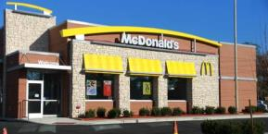

Type the first word that ‘pops to mind'.

‘Hamburger’ could be the first word that comes to mind.

[*Screen Three*]

Look at the picture below, and then type the first word that comes to mind

**

First word

[*Text*]

[*Screen Four*]

Remember, if you can't think of anything you can type the word 'none'.

[*Screen Five*]

Work quickly.

There is a time limit for each screen.

[*Header*]

Look at the picture below, and then type the first word that comes to mind

[*Cue*]

First word

[*Text*]

**Cues:** W2ADQ W2WAICue

(picture 2C_NoTobStore_WholeFoods)

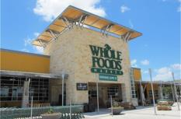

(picture 3C_NoTobStore_Target)

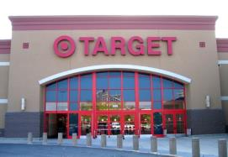

(picture 4T_TobStore_CircleK)

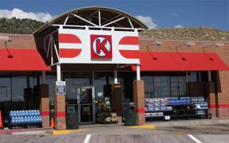

(picture 5T_TobStore_711)

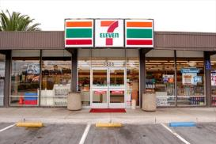

(picture 6C_NoTobStore_FreshEasy)

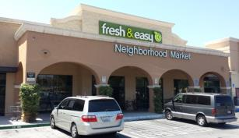

(picture 7T_TobStore_AMPM)

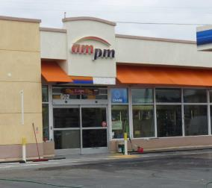

**Coding Instructions:**

[*Self-Coding Introduction*]

Please help us understand what you were thinking about during this task. Each of the following screens will show one of your typed responses and a list of categories. Check all of the categories that are close to the meaning of your typed response.

[*Self-Coding Header*]

Please tell us what you mean by checking all of the categories that apply to your typed response.

**Coding Categories:** 1 When Selected

caffeine (energy drinks, soda, coffee drinks) W2ADQCaf_1_W2ADQ1 W2WAIBCaf1

food or snacks W2ADQSnack_1_W2ADQ1 W2WAIBSnack1

cigarettes or cigars W2ADQTobCigCigar_1_W2ADQ1 W2WAIBTobCigCigar1

smokeless tobacco (chew, snuff, dip) W2ADQTobChew_1_W2ADQ1 W2WAIBTobChew1

electronic cigarettes, vaporizers, or vape pens W2ADQTobECig_1_W2ADQ1 W2WAIBTobECig1

marijuana (weed, pot, grass, chronic) W2ADQPot_1_W2ADQ1 W2WAIBPot1

alcohol (beer, wine, wine coolers, liquor) W2ADQAlco_1_W2ADQ1 W2WAIBAlco1

speed (crystal, meth, ice, amp) W2ADQMeth_1_W2ADQ1 W2WAIBMeth1

other drugs W2ADQOthDrug_1_W2ADQ1 W2WAIBOthDrug1

exercise, workout, or sports W2ADQExer_1_W2ADQ1 W2WAIBExer1

school W2ADQSch_1_W2ADQ1 W2WAIBSch1

party W2ADQParty_1_W2ADQ1 W2WAIBParty1

sleeping W2ADQSleep_1_W2ADQ1 W2WAIBSleep1

none of the above W2ADQNone_1_W2ADQ1 W2WAIBNone1

**Word Association (Slogan)**

**Instructions:**

[*Screen One*]

For the next set of questions, please type the very first PRODUCT or BRAND that comes to mind when you see a phrase on the screen. Products and brands are ‘things you can buy at a store’. If you can’t think of a product or brand, then type the first word that 'pops to mind'. If you still can't think of anything, type the word 'none'.

[*Screen Two*]

For example, suppose that the phrase was 'Do The Dew'

Type the PRODUCT or BRAND that ‘pops to mind'.

When you see the words

Do The Dew: ‘Soda’ or ‘Mountain Dew’ could be the first PRODUCT or BRAND that comes to mind.

[*Screen Three*]

Read the phrase below, and then type the first PRODUCT or BRAND that comes to mind

Do The Dew

First PRODUCT or BRAND

[*Text*]

[*Screen Four*]

Remember, if you can’t think of a product or brand, then you can type the first word that 'pops to mind'. If you still can't think of anything, you can type the word 'none'.

[*Screen Five*]

Work quickly.

There is a time limit for each screen.

[*Header*]

Read the phrase below, and then type the first PRODUCT or BRAND that comes to mind

[*Cue*]

First PRODUCT or BRAND

[*Text*]

**Cues (Slogans):** W2AEQ W2WAPCue

1. Here we go.
2. Come to where the flavor is.
3. Be Bold. Get Black.
4. Enjoy ice cold.
5. Grab and go.
6. Bold Flavor. Distinct Edge.

**Coding Instructions:**

[*Self-Coding Introduction*]

Please help us understand what you were thinking about during this task. Each of the following screens will show one of your typed responses and a list of categories. Check all of the categories that are close to the meaning of your typed response.

[*Self-Coding Header*]

Please tell us what you mean by checking all of the categories that apply to your typed response.

**Coding Categories:** 1 When Selected

food or snacks (sandwiches, chips, candy, ice cream) W2AEQSnack_1_W2AEQ1 W2WAPSnack1

drinks (energy drinks, soda, coffee drinks) W2AEQDrink_1_W2AEQ1 W2WAPDrink1

alcohol (beer, wine, wine coolers, liquor) W2AEQAlco_1_W2AEQ1 W2WAPAlco1

tobacco (cigarettes, cigars, cigarillos) W2AEQCigCigar_1_W2AEQ1 W2WAPCigCigar1

smokeless tobacco (chew, snuff, dip) W2AEQChew_1_W2AEQ1 W2WAPChew1

electronic cigarettes, vaporizers, or vape pens W2AEQEcig_1_W2AEQ1 W2WAPEcig1

clothes W2AEQClothes_1_W2AEQ1 W2WAPClothes1

electronic devices (cell phone, MP3 player, tablet) W2AEQEdev_1_W2AEQ1 W2WAPEdev1

none of the above W2AEQNone_1_W2AEQ1 W2WAPNone1

**Brand Recognition**

**Source:** Hanewinkel, R., Isensee, B, Sargent, J.D., & Morgenstern, M. (2011). Cigarette advertising and teen smoking initiation. *Pediatrics, 127*, e271-278.

Similar measures were also utilized in Dauphinee, A.L., Doxey, J.R., Schleicher, N.C., Fortmann, S.P., & Henriksen, L. (2013). Racial differences in cigarette brand recognition and impact on youth smoking. *BMC Public Health, 13*, 170-177.

**Designed For:** Adolescents

**Psychometrics**: Chronbach’s alpha = 0.74

**Cigarette Advertisements Found At Tobacco**

**Retail Outlets with Brand Name Removed**

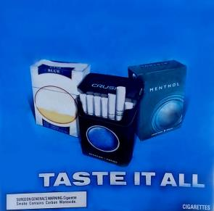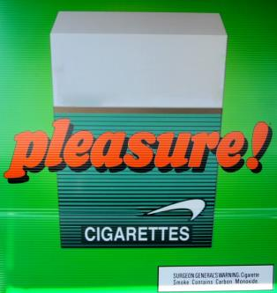

**Other Advertisements Found At Tobacco Retail**

**Outlets with Brand Name Removed**

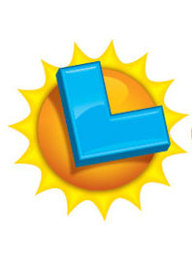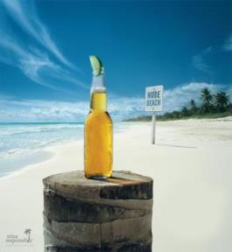



**Other Advertisements Found At Other Stores**

**with Brand Name Removed**

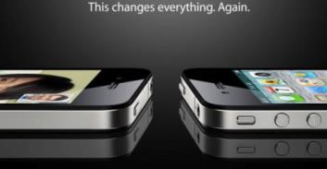

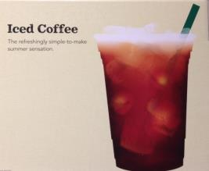

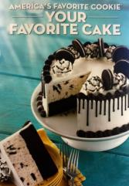

**Order:**







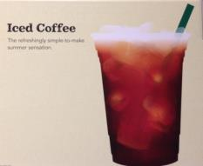

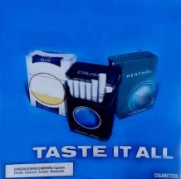

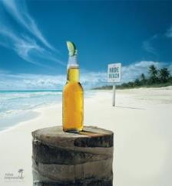

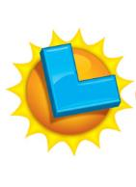

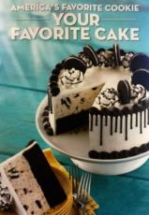

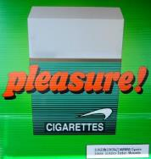

**Codebook:**

(picture 1C_NoTobStore_Apple.jpg)

1. How many times have you seen this advertisement? W2AFQ1 W2BrandRecogNoTobStoreAppleSeen1

Never 0

1-4 times 1

5-10 times 2

More than 10 times 3

1. What brand is being advertised? ____________________ W2AFQ2 W2BrandRecogNoTobStoreAppleName2

(picture 2C_TobStore_Good_Humor.jpg)

1. How many times have you seen this advertisement? W2AFQ3 W2BrandRecog1TobStoreNoTobGoodHumorSeen3

Never 0

1-4 times 1

5-10 times 2

More than 10 times 3

1. What brand is being advertised? ____________________ W2AFQ4 W2BrandRecogTobStoreNoTobGoodHumorName4

(picture 3T_TobStore_Marlboro.jpg)

1. How many times have you seen this advertisement? W2AFQ5 W2BrandRecogTobStoreTobMarlboroSeen5

Never 0

1-4 times 1

5-10 times 2

More than 10 times 3

1. What brand is being advertised? ____________________ W2AFQ6 W2BrandRecogTobStoreTobMarlboroName6

(picture 4C_NoTobStore_Starbucks.jpg)

1. How many times have you seen this advertisement? W2AFQ7 W2BrandRecogNoTobStoreStarbucksSeen7

Never 0

1-4 times 1

5-10 times 2

More than 10 times 3

1. What brand is being advertised? ____________________ W2AFQ8 W2BrandRecogNoTobStoreStarbucksName8

(picture 5T_TobStore_Camel.jpg)

1. How many times have you seen this advertisement? W2AFQ9 W2BrandRecogTobStoreTobCamelSeen9

Never 0

1-4 times 1

5-10 times 2

More than 10 times 3

1. What brand is being advertised? ____________________ W2AFQ10 W2BrandRecogTobStoreTobCamelName10

(picture 6C_TobStore_Corona.jpg)

1. How many times have you seen this advertisement? W2AFQ11 W2BrandRecogTobStoreNoTobCoronaSeen11

Never 0

1-4 times 1

5-10 times 2

More than 10 times 3

1. What brand is being advertised? ____________________ W2AFQ12 W2BrandRecogTobStoreNoTobCoronaName12

(picture 7C_TobStore_CalLotto.jpg)

1. How many times have you seen this advertisement? W2AFQ13 W2BrandRecogTobStoreNoTobCalLottoSeen13

Never 0

1-4 times 1

5-10 times 2

More than 10 times 3

1. What brand is being advertised? ____________________ W2AFQ14 W2BrandRecogTobStoreNoTobCalLottoName14

(picture 8C_NoTobStore_BaskinRobbins.jpg)

1. How many times have you seen this advertisement? W2AFQ15 W2BrandRecogNoTobStoreBaskinRobbinsSeen15

Never 0

1-4 times 1

5-10 times 2

More than 10 times 3

1. What brand is being advertised? ____________________ W2AFQ16 W2BrandRecogNoTobStoreBaskinRobbinsName16

(picture 9T_TobStore_Newport.jpg)

1. How many times have you seen this advertisement? W2AFQ17 W2BrandRecogTobStoreTobNewportSeen17

Never 0

1-4 times 1

5-10 times 2

More than 10 times 3

1. What brand is being advertised? ____________________ W2AFQ18 W2BrandRecogTobStoreTobNewportName18

**Tobacco Brand Recognition**

**Source:** Adapted from:

Centers for Disease Control and Prevention (CDC). (2014a). 2012 National youth tobacco survey (NYTS). Retrieved from: <http://www.cdc.gov/TOBACCO/data_statistics/surveys/NYTS/index.htm>

Centers for Disease Control and Prevention (CDC). (2014b). 2011 Youth tobacco survey (YTS). Retrieved from: <http://www.cdc.gov/tobacco/data_statistics/surveys/yts/index.htm>

**Designed For:** Adolescents

**Psychometrics**: Not provided

**Codebook**:

1. Which of the following cigarette brands have you heard of? (Check all that apply) W2AGQ1, W2TobBrandRecogCig1, 0 When Not Selected, 1 When Selected

American Spirit W2AGQ1option1 W2TobBrandRecogCigSpirit1

Camel W2AGQ1option2 W2TobBrandRecogCigCamel1

GPC, Basic, or Doral W2AGQ1option3 W2TobBrandRecogCigGPC1

Kool W2AGQ1option4 W2TobBrandRecogCigKool1

Lucky Strike W2AGQ1option5 W2TobBrandRecogCigLucky1

Marlboro W2AGQ1option6 W2TobBrandRecogCigMarlboro1

Newport W2AGQ1option7 W2TobBrandRecogCigNewport1

Parliament W2AGQ1option8 W2TobBrandRecogCigParliament1

Summit W2AGQ1option9 W2TobBrandRecogCigFake1

Virginia Slims W2AGQ1option10 W2TobBrandRecogCigVirginia1

None of the above W2AGQ1option11 W2TobBrandRecogCigNone1

1. Which of the following electronic cigarette, vaporizer, or vape pen brands have you heard of? (Check all that apply) W2AGQ2, W2TobBrandRecogECig2, 0 When Not Selected, 1 When Selected

Blu W2AGQ2option1 W2TobBrandRecogECigBlu2

Green Smart Living W2AGQ2option2 W2TobBrandRecogECigGreen2

MarkTen W2AGQ2option3 W2TobBrandRecogECigMarkTen2

NJOY W2AGQ2option4 W2TobBrandRecogECigNJOY2

Xcite W2AGQ2option5 W2TobBrandRecogECigFake2

Square W2AGQ2option6 W2TobBrandRecogECigSquare2

Vuse W2AGQ2option7 W2TobBrandRecogECigVuse2

V2 W2AGQ2option8 W2TobBrandRecogECigVTwo2

None of the above W2AGQ2option9 W2TobBrandRecogECigNone2

1. Which of the following cigar, cigarillo, or little cigar brands have you heard of? (Check all that apply) W2AGQ3, W2TobBrandRecogCigar3, 0 When Not Selected, 1 When Selected

Al Capone W2AGQ3option1 W2TobBrandRecogCigarCapone3

Backwoods W2AGQ3option2 W2TobBrandRecogCigarBackwoods3

Black and Mild W2AGQ3option3 W2TobBrandRecogCigarBlackMild3

Colonials W2AGQ3option4 W2TobBrandRecogCigarFake3

Dutch Masters W2AGQ3option5 W2TobBrandRecogCigarDutch3

Phillies W2AGQ3option6 W2TobBrandRecogCigarPhillies3

Prime Time W2AGQ3option7 W2TobBrandRecogCigarPrime3

Royal Comfort W2AGQ3option8 W2TobBrandRecogCigarRoyal3

Splitarillos W2AGQ3option9 W2TobBrandRecogCigarSplit3

Swisher Sweets W2AGQ3option10 W2TobBrandRecogCigarSwisher3

White Owl W2AGQ3option11 W2TobBrandRecogCigarOwl3

None of the above W2AGQ3option12 W2TobBrandRecogCigarNone3

1. Which of the following chewing tobacco, snuff, or dip brands have you heard of? (Check all that apply) W2AGQ4, W2TobBrandRecogChew4, 0 When Not Selected, 1 When Selected

Beechnut W2AGQ4option1 W2TobBrandRecogChewBeechnut4

Back Country W2AGQ4option2 W2TobBrandRecogChewFake4

Copenhagen W2AGQ4option3 W2TobBrandRecogChewCopen4

Grizzly W2AGQ4option4 W2TobBrandRecogChewGrizzly4

Kodiak W2AGQ4option5 W2TobBrandRecogChewKodiak4

Levi Garrett W2AGQ4option6 W2TobBrandRecogChewLevi4

Longhorn W2AGQ4option7 W2TobBrandRecogChewLonghorn4

Red Man W2AGQ4option8 W2TobBrandRecogChewRedman4

Skoal W2AGQ4option9 W2TobBrandRecogChewSkoal4

None of the above W2AGQ4option10 W2TobBrandRecogChewNone4

**25% Update**

[*A 25% Progress Bar Will Be Shown Here*]

Your Progress

Well done! You are making excellent progress.

Now we will ask you to complete a series of computer tasks. These can be challenging. Do the best that you can.

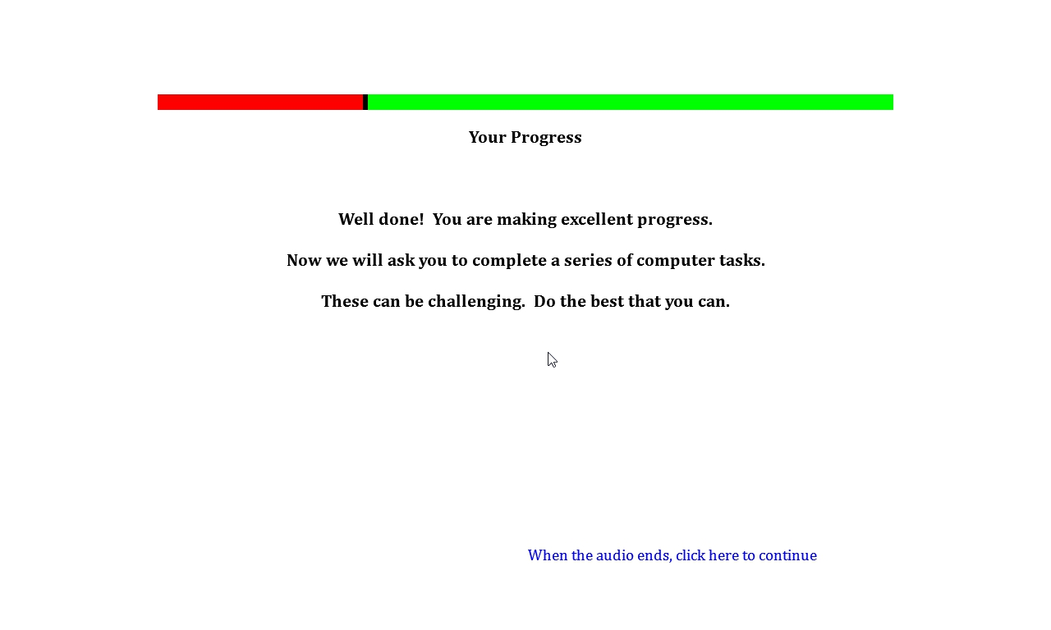

**Single Target Implicit Association Task**

**Source:** Bluemke, M., Friese, M. (2008). Reliability and validity of the single-target IAT (ST-IAT): Assessing automatic affect towards multiple attitude objects. *European Journal of Social Psychology, 38*, 977-997.

Greenwald, A.G., McGhee, D.E., & Schwartz, J.K. (1998). Measuring individual differences in implicit cognition: The implicit association test. *Journal Of Personality And Social Psychology*,*74*(6), 1464-1480.

Greenwald, A.G., Nosek, B.A., & Banaji, M.R. (2003). Understanding and using the Implicit Association Test: I. An improved scoring algorithm. *Journal Of Personality And Social Psychology*, *85*(2), 197-216

Karpinski, A., & Steinman, R.B. (2006). The single category implicit association test as a measure of implicit social cognition. *Journal of Personality and Social Psychology, 91*(1):16-32.

Conrey, F.R., Sherman, J.W., Gawronski, B., Hugenberg, K. & Groom, C.J. (2005). Separating multiple processes in implicit social cognition: The quad model of implicit task performance. *Journal of Personality and Social Psychology, 89*(4): 469-87.

Sherman, J. W., Gawronski, B., Gonsalkorale, K., Hugenberg, K., Allen, T. J., & Groom, C. J. (2008). The self-regulation of automatic associations and behavioral impulses. *Psychology Review, 115*(2): 314-35.

**Designed For:** Adolescents

**Psychometrics:** Internal consistency (.72)**,** Test-retest stability (Kendall’s W = .75)

#### Description: The Single Target Implicit Association Test assesses associations among three categories. The first trial utilizes the categories ‘Pleasant’, ‘Neutral’, and ‘Tobacco’. The second trial utilizes the categories ‘Unpleasant’, ‘Neutral’, and ‘Tobacco’.

**Items:**

W2AHQ

**Source for Tobacco Words:**

Huijding, J., de Jong, P.J., Wiers, R.W., & Verkooijen, K. (2005). Implicit and explicit attitudes toward smoking in a smoking and nonsmoking setting. *Addictive Behaviors, 30*, 949-961 was used as the source for the following words:

Tobacco

Smoking

Cigarettes

Nicotine

Smokers

Lighter

Butt

Ames, S.L., Grenard, J.L., Stacy, A.W., Xiao, L., He, Q., Wong, S.W., Xue, G., Wiers, R.W., Bechara, A. Functional imaging of implicit marijuana associations during performance on an Implicit Association Test (IAT). *Behavioural Brain Research, 256*, 494-502 was used as the source for the following words:

Ashes

Smokes

Cigs

**Source for Neutral Words:**

Houben, K., & Wiers, R.W. (2009). Beer makes the heart grow fonder: Single-target implicit attitudes toward beer but not alcohol are related to drinking behaviour in regular beer drinkers. *Netherlands Journal of Psychology, 65*, 10-21 was used as the source for the following words:

Truck

Machine

Window

Factory

Scissors

Letter

Paper

Square

Circle

Page

Magnet

The following word was also added:

Line

**Source for Pleasant Words:** Waters, A.J., Carter, B.L., Robinson, J.D., Wetter, D.W., Lam, C.Y., & Cinciripini, P.M. (2007). Implicit attitudes to smoking are associated with craving and dependence. *Drug and Alcohol Dependence, 91*, 178-186 was used as the source for the following words:

Calm

Cool

Friendly

Nice

Peaceful

Pleasant

Positive

Relaxing

Restful

Soothing

**Source for Unpleasant Words:** Waters, A.J., Carter, B.L., Robinson, J.D., Wetter, D.W., Lam, C.Y., & Cinciripini, P.M. (2007). Implicit attitudes to smoking are associated with craving and dependence. *Drug and Alcohol Dependence, 91*, 178-186 was used as the source for the following words:

Dirty

Foul

Harmful

Nasty

Negative

Smelly

Ugly

Unhealthy

Unpleasant

Ames, S.L., Grenard, J.L., Thush, C., Sussman, S., Wiers, R.W., & Stacy, A.W. (2007). Comparison of indirect assessments of association as predictors of marijuana use among at-risk adolescents. *Experimental and Clinical Psychopharmacology, 15*, 204-218 was used as the source for the following words:

Sad

**Rank, Hits, and Reading Level for Words:**

|  |  |  |  |
| --- | --- | --- | --- |
| **Word** | **Rank out of 86,800 Words (wordcount.org)** | **Hits (Google)** | **Reading Level (www.spellingcity.com)** |
| **Tobacco** | | | |
| Tobacco | 5335 | 44700000 | 4th |
| Smoking | 3224 | 128000000 | 5th |
| Cigarettes | 5830 | 26600000 | 4th (cigarette) |
| Nicotine | 20904 | 8120000 | 4th |
| Smokers | 10890 | 14000000 | 4th (smoke) |
| Lighter | 6539 | 46900000 | 2nd |
| Butt | 12108 | 111000000 | Not Listed |
| Ashes | 10825 | 20900000 | 4th |
| Smokes | 23915 | 9050000 | 4th (smoke) |
| Cigs | 52497 | 3380000 | Not Listed |
| **Pleasant** | | | |
| Calm | 3205 | 82500000 | 4th |
| Cool | 2520 | 650000000 | 2nd |
| Friendly | 2465 | 396000000 | 3rd |
| Nice | 743 | 680000000 | 1st |
| Peaceful | 4947 | 47400000 | 3rd |
| Pleasant | 3427 | 88500000 | 4th |
| Positive | 1220 | 340000000 | 4th |
| Relaxing | 9088 | 54100000 | 4th (relax) |
| Restful | 25994 | 7920000 | 3rd |
| Soothing | 12833 | 17300000 | 6th |
| **Unpleasant** | | | |
| Dirty | 3364 | 190000000 | 4th |
| Foul | 6875 | 23500000 | 3rd |
| Harmful | 8076 | 33600000 | 3rd |
| Nasty | 4673 | 84800000 | 3rd |
| Negative | 2132 | 171000000 | 4th |
| Smelly | 16396 | 6540000 | 3rd (smell) |
| Ugly | 5716 | 78100000 | 1st |
| Unhealthy | 16048 | 12300000 | 3rd |
| Unpleasant | 5902 | 11900000 | 4th |
| Sad | 2847 | 2750000000 | 1st |
| **Neutral** | | | |
| Truck | 6325 | 225000000 | 1st |
| Machine | 1145 | 415000000 | 4th |
| Window | 960 | 1590000000 | 4th |
| Factory | 2195 | 278000000 | 4th |
| Scissors | 12220 | 22900000 | 5th |
| Letter | 722 | 225000000 | 2nd |
| Magnet | 14955 | 14500000 | 4th |
| Line | 408 | 243000000 | 2nd |
| Circle | 2761 | 212000000 | 2nd |
| Page | 931 | 4500000000 | 1st |

#### Counterbalancing:

|  |  |  |  |  |  |  |  |
| --- | --- | --- | --- | --- | --- | --- | --- |
| **Version One** | | | | | | | |
|  | **# of Trials** | **Practice/Real** | **Categories on Left** | **Categories on Right** | **Unpleasant Words** | **Neutral Words** | **Tobacco Words** |
| **Block 1** | 20 | Practice (Red X) | Unpleasant | Neutral | 10 | 10 | 0 |
| **Block 2** | 20 | Practice (No Red X) | Unpleasant | Neutral | 10 | 10 | 0 |
| **Block 3** | 30 | Real | Unpleasant+Tobacco | Neutral | 10 | 10 | 10 |
| **Block 4** | 30 | Real | Unpleasant+Tobacco | Neutral | 10 | 10 | 10 |
| **Block 5** | 30 | Real | Unpleasant | Neutral+Tobacco | 10 | 10 | 10 |
| **Block 6** | 30 | Real | Unpleasant | Neutral+Tobacco | 10 | 10 | 10 |
| **Total** | 160 |  |  |  | 60 | 60 | 40 |
|  | **# of Trials** | **Practice/Real** | **Categories on Left** | **Categories on Right** | **Pleasant Words** | **Neutral Words** | **Tobacco Words** |
| **Block 1** | 20 | Practice (Red X) | Pleasant | Neutral | 10 | 10 | 0 |
| **Block 2** | 20 | Practice (No Red X) | Pleasant | Neutral | 10 | 10 | 0 |
| **Block 3** | 30 | Real | Pleasant+Tobacco | Neutral | 10 | 10 | 10 |
| **Block 4** | 30 | Real | Pleasant+Tobacco | Neutral | 10 | 10 | 10 |
| **Block 5** | 30 | Real | Pleasant | Neutral+Tobacco | 10 | 10 | 10 |
| **Block 6** | 30 | Real | Pleasant | Neutral+Tobacco | 10 | 10 | 10 |
| **Total** | 160 |  |  |  | 60 | 60 | 40 |

|  |  |  |  |  |  |  |  |
| --- | --- | --- | --- | --- | --- | --- | --- |
| **Version Two** | | | | | | | |
|  | **# of Trials** | **Practice/Real** | **Categories on Left** | **Categories on Right** | **Pleasant Words** | **Neutral Words** | **Tobacco Words** |
| **Block 1** | 20 | Practice (Red X) | Pleasant | Neutral | 10 | 10 | 0 |
| **Block 2** | 20 | Practice (No Red X) | Pleasant | Neutral | 10 | 10 | 0 |
| **Block 3** | 30 | Real | Pleasant+Tobacco | Neutral | 10 | 10 | 10 |
| **Block 4** | 30 | Real | Pleasant+Tobacco | Neutral | 10 | 10 | 10 |
| **Block 5** | 30 | Real | Pleasant | Neutral+Tobacco | 10 | 10 | 10 |
| **Block 6** | 30 | Real | Pleasant | Neutral+Tobacco | 10 | 10 | 10 |
| **Total** | 160 |  |  |  | 60 | 60 | 40 |
|  | **# of Trials** | **Practice/Real** | **Categories on Left** | **Categories on Right** | **Unpleasant Words** | **Neutral Words** | **Tobacco Words** |
| **Block 1** | 20 | Practice (Red X) | Unpleasant | Neutral | 10 | 10 | 0 |
| **Block 2** | 20 | Practice (No Red X) | Unpleasant | Neutral | 10 | 10 | 0 |
| **Block 3** | 30 | Real | Unpleasant+Tobacco | Neutral | 10 | 10 | 10 |
| **Block 4** | 30 | Real | Unpleasant+Tobacco | Neutral | 10 | 10 | 10 |
| **Block 5** | 30 | Real | Unpleasant | Neutral+Tobacco | 10 | 10 | 10 |
| **Block 6** | 30 | Real | Unpleasant | Neutral+Tobacco | 10 | 10 | 10 |
| **Total** | 160 |  |  |  | 60 | 60 | 40 |

|  |  |  |  |  |  |  |  |
| --- | --- | --- | --- | --- | --- | --- | --- |
|  |  |  |  |  |  |  |  |
| **Version Three** | | | | | | | |
|  | **# of Trials** | **Practice/Real** | **Categories on Left** | **Categories on Right** | **Pleasant Words** | **Neutral Words** | **Tobacco Words** |
| **Block 1** | 20 | Practice (Red X) | Neutral | Pleasant | 10 | 10 | 0 |
| **Block 2** | 20 | Practice (No Red X) | Neutral | Pleasant | 10 | 10 | 0 |
| **Block 3** | 20 | Real | Neutral | Pleasant+Tobacco | 10 | 10 | 10 |
| **Block 4** | 40 | Real | Neutral | Pleasant+Tobacco | 10 | 10 | 10 |
| **Block 5** | 20 | Real | Neutral+Tobacco | Pleasant | 10 | 10 | 10 |
| **Block 6** | 40 | Real | Neutral+Tobacco | Pleasant | 10 | 10 | 10 |
| **Total** | 160 |  |  |  | 60 | 60 | 40 |
|  | **# of Trials** | **Practice/Real** | **Categories on Left** | **Categories on Right** | **Unpleasant Words** | **Neutral Words** | **Tobacco Words** |
| **Block 1** | 20 | Practice (Red X) | Neutral | Unpleasant | 10 | 10 | 0 |
| **Block 2** | 20 | Practice (No Red X) | Neutral | Unpleasant | 10 | 10 | 0 |
| **Block 3** | 20 | Real | Neutral | Unpleasant+Tobacco | 10 | 10 | 10 |
| **Block 4** | 40 | Real | Neutral | Unpleasant+Tobacco | 10 | 10 | 10 |
| **Block 5** | 20 | Real | Neutral+Tobacco | Unpleasant | 10 | 10 | 10 |
| **Block 6** | 40 | Real | Neutral+Tobacco | Unpleasant | 10 | 10 | 10 |
| **Total** | 160 |  |  |  | 60 | 60 | 40 |
|  |  |  |  |  |  |  |  |
| **Version Four** | | | | | | | |
|  | **# of Trials** | **Practice/Real** | **Categories on Left** | **Categories on Right** | **Unpleasant Words** | **Neutral Words** | **Tobacco Words** |
| **Block 1** | 20 | Practice (Red X) | Neutral | Unpleasant | 10 | 10 | 0 |
| **Block 2** | 20 | Practice (No Red X) | Neutral | Unpleasant | 10 | 10 | 0 |
| **Block 3** | 20 | Real | Neutral | Unpleasant+Tobacco | 10 | 10 | 10 |
| **Block 4** | 40 | Real | Neutral | Unpleasant+Tobacco | 10 | 10 | 10 |
| **Block 5** | 20 | Real | Neutral+Tobacco | Unpleasant | 10 | 10 | 10 |
| **Block 6** | 40 | Real | Neutral+Tobacco | Unpleasant | 10 | 10 | 10 |
| **Total** | 160 |  |  |  | 60 | 60 | 40 |
|  | **# of Trials** | **Practice/Real** | **Categories on Left** | **Categories on Right** | **Pleasant Words** | **Neutral Words** | **Tobacco Words** |
| **Block 1** | 20 | Practice (Red X) | Neutral | Pleasant | 10 | 10 | 0 |
| **Block 2** | 20 | Practice (No Red X) | Neutral | Pleasant | 10 | 10 | 0 |
| **Block 3** | 30 | Real | Neutral | Pleasant+Tobacco | 10 | 10 | 10 |
| **Block 4** | 30 | Real | Neutral | Pleasant+Tobacco | 10 | 10 | 10 |
| **Block 5** | 30 | Real | Neutral+Tobacco | Pleasant | 10 | 10 | 10 |
| **Block 6** | 30 | Real | Neutral+Tobacco | Pleasant | 10 | 10 | 10 |
| **Total** | 160 |  |  |  | 60 | 60 | 40 |

#### Instructions:

#### *First Set*

#### *Transition*

For the next task, you will be sorting words that appear in the middle of the computer screen into categories which appear on the upper left and right of the screen.

#### *Screen One*

Put your middle or index fingers on the ‘E’ and ‘I’ keys of your keyboard.

Words representing the categories at the top will appear one-by-one in the middle of the screen.

When the item belongs to a category on the left, PRESS THE ‘E’ KEY.

When the item belongs to a category on the right, PRESS THE ‘I’ KEY.

Items fit best in one of the categories.

During the practice trials we will provide feedback in the form of a red X when you make a mistake. We will not provide this feedback during the actual task trials.

This is a timed sorting task. GO AS FAST AS YOU CAN while making as few mistakes as possible.

This task will take about 5 minutes to complete.

#### *Screen Two*

There will not be any feedback (NO RED X) for the rest of this task.

Continue to keep your middle or index fingers on the ‘E’ and ‘I’ keys of your keyboard. Continue to work quickly.

#### *Screen Three*

See above, a new category now appears together with one of the previous categories you saw.

Remember, each item fits best in one group.

For example:

If the categories pleasant and tobacco appear on separate sides above – pleasant words would go in the pleasant category, not the tobacco category.

Use the ‘E’ and ‘I’ keys to categorize items into groups.

#### *Screen Four*

Sort the same items again.

Remember to go as fast as you can while making as few mistakes as possible.

Use the ‘E’ and ‘I’ keys to categorize items into the groups.

#### *Screen Five*

See above, the three categories now appear together in a new configuration.

Remember, each item fits best in one group.

Use the ‘E’ and ‘I’ keys to categorize items into groups.

#### *Screen Six*

Sort the same items again.

Remember to go as fast as you can while making as few mistakes as possible.

Use the ‘E’ and ‘I’ keys to categorize items into the groups.

#### *Second Set*

#### *Transition*

Now you will do the same task again but with different categories.

GO AS FAST AS YOU CAN while making as few mistakes as possible.

#### *Screen One*

See above, the categories have changed.

Use the ‘E’ and ‘I’ keys to categorize items into the groups.

Remember to go as fast as you can while making as few mistakes as possible.

During the practice trials we will provide feedback in the form of a red X when you make a mistake. We will not provide this feedback during the actual task trials.

This task will take about 5 minutes to complete.

#### *Screen Two*

There will not be any feedback (NO RED X) for the rest of this task.

Continue to keep your middle or index fingers on the ‘E’ and ‘I’ keys of your keyboard. Continue to work quickly.

#### *Screen Three*

See above, a new category now appears together with one of the previous categories you saw.

Remember, each item fits best in one group.

For example:

If the categories unpleasant and tobacco appear on separate sides above – unpleasant words would go in the unpleasant category, not the tobacco category.

Use the ‘E’ and ‘I’ keys to categorize items into groups.

#### *Screen Four*

Sort the same items again.

Remember to go as fast as you can while making as few mistakes as possible.

Use the ‘E’ and ‘I’ keys to categorize items into the groups.

#### *Screen Five*

See above, the three categories now appear together in a new configuration.

Remember, each item fits best in one group.

Use the ‘E’ and ‘I’ keys to categorize items into groups.

#### *Screen Six*

Sort the same items again.

Remember to go as fast as you can while making as few mistakes as possible.

Use the ‘E’ and ‘I’ keys to categorize items into the groups.

#### Example:

tobacco

*pleasant*

*neutral*

cigarette

#### Stimuli:

**Tobacco Words**

1. Tobacco
2. Smoking
3. Cigarettes
4. Nicotine
5. Smokers
6. Lighter
7. Butt
8. Ashes
9. Smokes
10. Cigs

**Pleasant Words**

1. Calm
2. Cool
3. Friendly
4. Nice
5. Peaceful
6. Pleasant
7. Positive
8. Relaxing
9. Restful
10. Soothing

**Unpleasant Words**

1. Dirty
2. Foul
3. Harmful
4. Nasty
5. Negative
6. Smelly
7. Ugly
8. Unhealthy
9. Unpleasant
10. Sad

**Neutral Words**

1. Truck
2. Machine
3. Window
4. Factory
5. Scissors
6. Letter
7. Magnet
8. Line
9. Circle
10. Page

#### Example Screens:

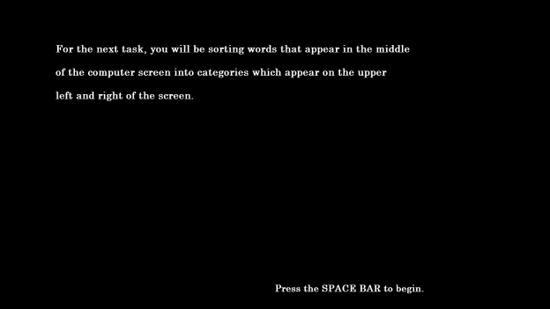

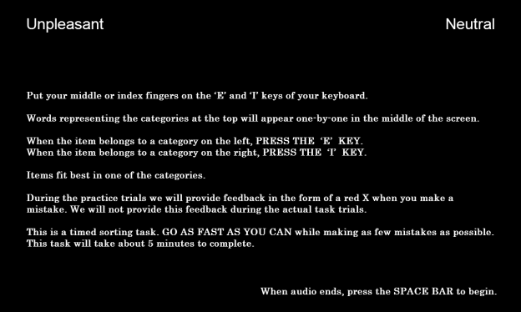

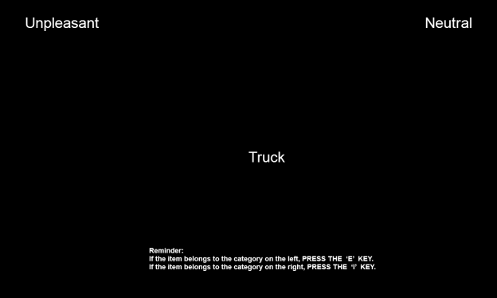

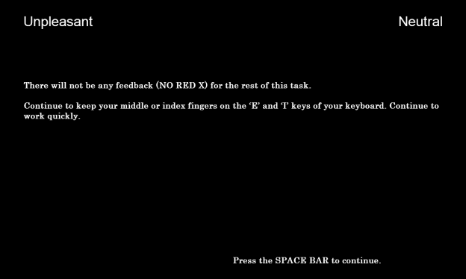

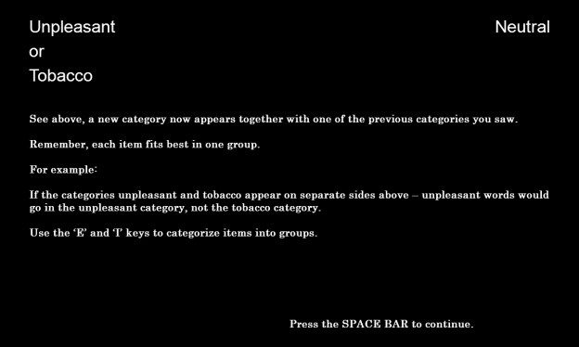

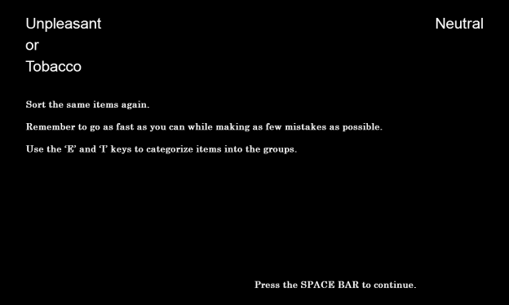

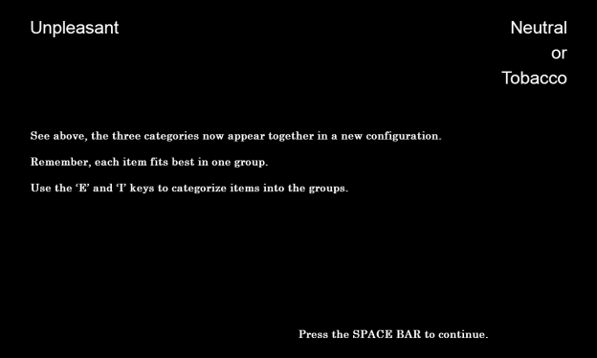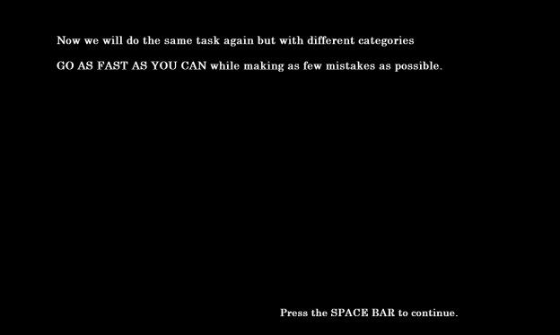

**Flicker Paradigm (Image One)**

**Primary Source:**

Rensink, R.A. (1997). To see or not to see: The need for attention to perceive changes in scenes. *Psychological Science, 8*, 368-373.

**Additional Sources:**

Beck, M.R., & Levin, D.T. (2003). The role of representational volatility in recognizing pre- and postchange objects. *Perception & Psychophysics, 65*, 458-468.

Hollingworth, A., & Henderson, J.M. (2002). Accurate visual memory for previously attended objects in natural scenes. *Journal of Experimental Psychology: Human Perception and Performance, 28*, 113-136.

Hollingworth, A., Williams, C.C., & Henderson, J.M. (2001). To see and remember: Visually specific information is retained in memory from previously attended objects in natural scenes. *Psychonomic Bulletin & Review, 8*, 761-768.

Simons, D. J. & Rensink, R. A. (2005). Change blindness: past, present, and future. *TRENDS in Cognitive Sciences, 9*(1), 16-20.

**Sources for Attentional Bias:**

Chanon, V.W., Sours, C.R., & Boettiger, C.A. (2010). Attentional bias toward cigarette cues in active smokers. *Psychopharmacology, 212*, 309-320.

Hobson, J., Bruce, G., & Butler, S.H. (2012). A flicker change blindness task employing eye tracking reveals an association with levels of craving not consumption. *Journal of Psychopharmacology, 27*, 93-97.

Schoenmakers, T.M., & Wiers, R.W. (2010). Craving and attentional bias respond differently to alcohol priming: A field study in the pub. *European Addiction Research, 16*, 9-16.

Jones, B.T., Bruce, G., Livingstone, S., & Reed, E. (2006). Alcohol-related attentional bias in problem drinkers with the flicker change blindness paradigm. *Psychology of Addictive Behaviors, 20*, 171-177.

Jones, B.C., Jones, B.T., Blundell, L., & Bruce, G. (2002). Social users of alcohol and cannabis who detect substance-related changes in a change blindness paradigm report higher levels of use than those detecting substance-neutral changes. *Psychopharmacology, 165*, 93-96.

Tibboel, H., De Houwer, J., & Field, M. (2009). Reduced attentional blink for alcohol-related stimuli in heavy social drinkers. *Journal of Psychopharmacology, 0*, 1-8.

**Sources for Presenting Only One Image:**

Jones, B.T., Bruce, G., Livingstone, S., & Reed, E. (2006). Alcohol-related attentional bias in problem drinkers with the flicker change blindness paradigm. *Psychology of Addictive Behaviors, 20*, 171-177.

Jones, B.C., Jones, B.T., Blundell, L., & Bruce, G. (2002). Social users of alcohol and cannabis who detect substance-related changes in a change blindness paradigm report higher levels of use than those detecting substance-neutral changes. *Psychopharmacology, 165*, 93-96.

**Designed For:** Adults

**Instructions:**

This task will ask you to detect changes in different pictures.

Press the SPACE BAR to continue.

In a moment, you will be shown a very fast flickering picture. The same picture is shown all the time. But half the time there is one change in the picture. The change can be the addition or removal of something in the picture or the replacement of something.

Press the SPACE BAR to continue.

Press the SPACE BAR as soon as you notice the change. You will then be asked to describe the change.

If you didn't notice any change, the picture will stop flickering after one minute.

Press the SPACE BAR to begin.

**Codebook:**

[*Flickering Images*]

Original

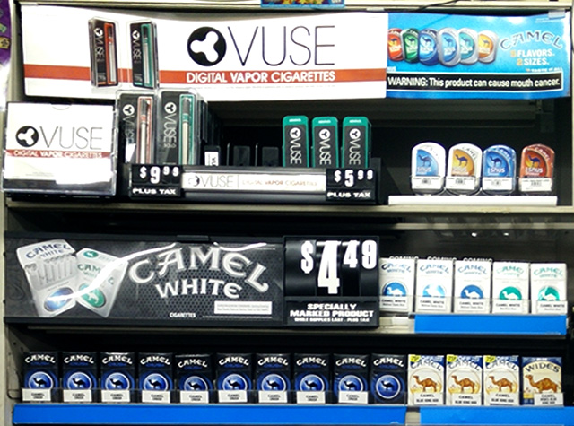

Modified

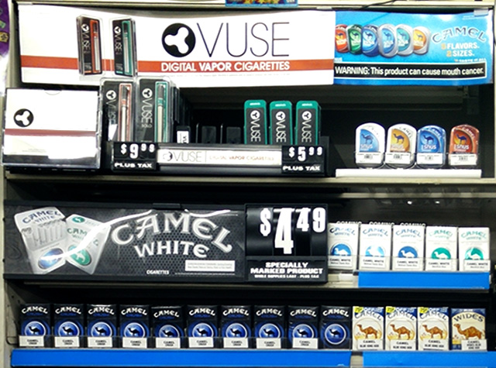

[*Page 1*]

Please describe what changed in the textbox below. Be as specific as you can.

If you didn’t notice any chance, type ‘No change.’

[*Text Box*]

W2AL1Q_textboxresponse1 W2FlickerChange1

[*Page 2*]

How difficult was it to detect the change? W2AI1Q2 W2FlickerDifficulty2

Very Easy 1 Somewhat Easy 2 Somewhat Difficult 3 Very Difficult 4

[*Page 3*]



How often do you visit stores that have displays that look like the one above? W2AI1Q3 W2FlickerStoreVisit3

Never 0

Once a month or less 1

2-3 times a month 2

Once a week 3

2-3 times a week 4

Almost every day or every day 5

[*Page 4*]



How often have you seen this advertisement at a store? W2AI1Q4 W2FlickerAdvertisementSeen4

Never 0

Once a month or less 1

2-3 times a month 2

Once a week 3

2-3 times a week 4

Almost every day or every day 5

**Additional Information:**

* There will be no practice images.
* There will be one manipulated image.
* There will be no clues or suggested fixation points.
* Each image will be displayed for 240 milliseconds followed by a black screen for 80 milliseconds. This will continue for 60 seconds.
* The original image will be displayed twice followed by the manipulated image

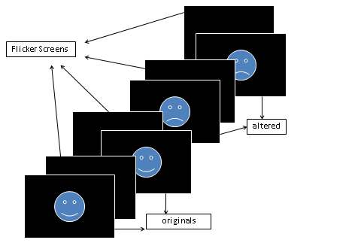

**Data Provided:**

* Date
* Time
* Count_cycles - counts the number of cycles started until a response occurs
* Responsepoint - determines the stimulus in the response cycle (the cycle that participant made a positive response) that was presented when participant made response: "StimA1", "flicker_AA", "StimA2", "flicker_AB", "StimB1", "flicker_BB", "StimB2", "flicker_BA" or "N/A" (if no response was given)
* Alternations - Determines the number of alternations between original and altered pictures until response occurs. Each switch between originals and altered pictures as well as each switch between altered pictures and original pictures is counted as an alternation. For each completed cycle, participants go through 2 alternations. If the response occurs AFTER the change from original to altered pic in the last cycle, one more alternation is added to the count.
* Cycle_rt - stores the combined trial latencies across the entire cycle until response occurs
* Textboxresponse - stores the open-ended response
* Textboxresponse_rt - stores the time it took participant to work on the openended response until pressing the button

**Disposable Income**

**Source:** Items 1-3 adapted from West, P., Sweeting, H., Young, R., & Robins, M. (2006). A material paradox: Socioeconomic status, young people's disposable income and consumer culture. *Journal Of Youth Studies, 9*(4), 437-462.

Items 4-8 adapted from Darling, H., Reeder, A.I., McGee, R., & Williams, S. (2006). Brief report: Disposable income, and spending on fast food, alcohol, cigarettes, and gambling by New Zealand secondary school students. *Journal Of Adolescence, 29*(5), 837-843.

Response options adapted from Johnston, L.D., O’Malley, P.M., Bachman, J.G., & Schulenberg, J.E. (2014) 2011 Monitoring the future survey (MTF). Retrieved from <http://www.monitoringthefuture.org/>. Ann Arbor: Institute for Social Research, The University of Michigan.

**Designed For:** Adolescents

**Psychometrics:** Not provided

**Codebook:**

In an average week, how much money do you receive from…

1. Your Family W2AJQ1 W2DisIncFamily1

$0 0

$1-5 1

$6-10 2

$11-20 3

$21-35 4

$36-50 5

$51-75 6

$76-125 7

$126-175 8

$176+ 9

1. A Job W2AJQ2 W2DisIncJob2

$0 0

$1-5 1

$6-10 2

$11-20 3

$21-35 4

$36-50 5

$51-75 6

$76-125 7

$126-175 8

$176+ 9

1. Other Sources W2AJQ3 W2DisIncOther3

$0 0

$1-5 1

$6-10 2

$11-20 3

$21-35 4

$36-50 5

$51-75 6

$76-125 7

$126-175 8

$176+ 9

In an average week, how much money do you spend on…

1. Snack Foods W2AKQ1 W2DisSpendSnack1

$0 0

$1-5 1

$6-10 2

$11-20 3

$21-35 4

$36-50 5

$51-75 6

$76-125 7

$126-175 8

$176+ 9

1. Soda or Energy Drinks W2AKQ2 W2DisSpendSoda2

$0 0

$1-5 1

$6-10 2

$11-20 3

$21-35 4

$36-50 5

$51-75 6

$76-125 7

$126-175 8

$176+ 9

1. Alcohol W2AKQ3 W2DisSpendAlcohol3

$0 0

$1-5 1

$6-10 2

$11-20 3

$21-35 4

$36-50 5

$51-75 6

$76-125 7

$126-175 8

$176+ 9

1. Tobacco Products W2AKQ4 W2DisSpendTobacco4

$0 0

$1-5 1

$6-10 2

$11-20 3

$21-35 4

$36-50 5

$51-75 6

$76-125 7

$126-175 8

$176+ 9

1. Other W2AKQ5 W2DisSpendOther5

$0 0

$1-5 1

$6-10 2

$11-20 3

$21-35 4

$36-50 5

$51-75 6

$76-125 7

$126-175 8

$176+ 9

**Store Visit Frequency**

**Source:** Feighery, E.C., Henriksen, L., Wang, Y., Schleicher, N.C., & Fortmann, S.P. (2006). An evaluation of four measures of adolescents' exposure to cigarette marketing in stores. *Nicotine & Tobacco Research, 8*(6), 751-759.

Feighery, E.C, Ribisl, K.M., Schleicher, N., Lee, R., & Halvorson, S. (2001). Cigarette advertising and promotional strategies in retail outlets: Results of a statewide survey in California. *Tobacco Control, 10*, 184-188.

Feighery, E.C, Ribisl, K.M., Schleicher, N., & Clark, P.I. (2004). Retailer participation in cigarette company incentive programs is related to increased levels of cigarette advertising and cheaper cigarette prices in stores. *Preventive Medicine, 38*, 876-884.

Henriksen, L., Feighery, E.C., Schleicher, N.C., Haladjian, H.H., & Fortmann, S.P. (2004). Reaching youth at the point of sale: cigarette marketing is more prevalent in stores where adolescents shop frequently. *Tobacco Control, 13*, 315–318.

Henriksen, L., Feighery, E.C., Wang, Y., Fortmann, S.P. Association of retail tobacco marketing with adolescent smoking. (2004). *American Journal of Public Health, 94*(12), 2081-2083.

Schleicher, N., Johnson, T.O., Dauphinee, A.L., Henriksen, L. (2011). Tobacco Marketing in California’s Retail Environment (2008-2011), Final report for the California Tobacco Advertising Survey.

**Designed For:** Adolescents

**Psychometrics**: Not reported

**Codebook:**

[*Screen One*]

1. How often do you go to large supermarkets? W2ALQ1 W2StoreVisitSuperMark1

Never 0

Once a month 1

2-3 times a month 2

Once a week 3

2-3 times a week 4

Almost every day 5

1. How often do you go to small grocery stores? W2ALQ2 W2StoreVisitSmallMark2

Never 0

Once a month 1

2-3 times a month 2

Once a week 3

2-3 times a week 4

Almost every day 5

1. How often do you go to convenience stores? W2ALQ3 W2StoreVisitConvenience3

Never 0

Once a month 1

2-3 times a month 2

Once a week 3

2-3 times a week 4

Almost every day 5

1. How often do you go to gas stations? W2ALQ4 W2StoreVisitGas4

Never 0

Once a month 1

2-3 times a month 2

Once a week 3

2-3 times a week 4

Almost every day 5

[*Screen Two*]

1. How often do you go to drug stores? W2ALQ5 W2StoreVisitDrug5

Never 0

Once a month 1

2-3 times a month 2

Once a week 3

2-3 times a week 4

Almost every day 5

1. How often do you go to liquor stores? W2ALQ6 W2StoreVisitLiquor6

Never 0

Once a month 1

2-3 times a month 2

Once a week 3

2-3 times a week 4

Almost every day 5

1. How often do you go to tobacco stores? W2ALQ7 W2StoreVisitTobacco7

Never 0

Once a month 1

2-3 times a month 2

Once a week 3

2-3 times a week 4

Almost every day 5

**School Tailored Items:**

[*Skip Pattern Question*]

1. Are you currently a student at [Name of School Based on Entered ID]? W2ALQ9 W2StoreVisitAttendSchool9

Yes 1

No 0

**School IDs:**

105 = Tracy High School

108 = Desert Winds High School

109 = R. Rex Parris High School

111 = North Park High School

112 = Somerset High School

113 = Chaparral High School

114 = Monterey High School

115 = Centinela Valley High School

116 = R. K. Lloyde High School

117 = Fairvalley High School

139 = Jack London High School

161 = Youth Opportunities High School

165 = Canyon Oaks High School

171 = Rose City High School

174 = Kurt T. Shery High School

181 = Santana High School

186 = Buena Park High School

195 = Valley Vista High School

197 = Back Bay High School

206 = Hillview High School

208 = Alvord High School

214 = Amistad High School

223 = Abraham Lincoln High School

224 = Mountain View High School

226 = Ortega High School

229 = Val Verde High School

232 = Central High School

244 = Mountain High School

246 = Middle College High School

250 = Oak View High School

254 = Mojave High School

261 = Abraxas High School

276 = Pacific High School

278 = Conejo Valley High School

280 = Community High School

282 = Phoenix High School

283 = Phoenix High School

(If Yes…)

**Abraham Lincoln (ID: 223)**

(picture 223-56778.jpg)

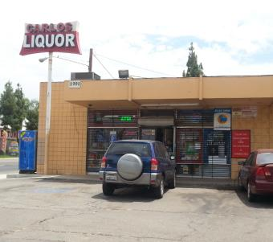

CARLOS LIQUOR at 2990 14TH STREET, RIVERSIDE, CA

How often do you go to the store at THIS ADDRESS?

Never 0

Once a month 1

2-3 times a month 2

Once a week 3

2-3 times a week 4

Almost every day 5

(picture 223-56786.jpg)

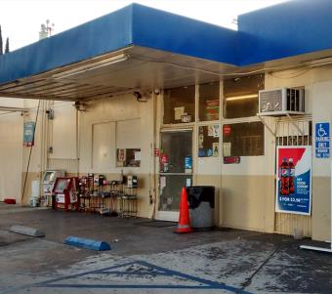

ARCO at 2720 14TH STREET, RIVERSIDE, CA

How often do you go to the store at THIS ADDRESS?

Never 0

Once a month 1

2-3 times a month 2

Once a week 3

2-3 times a week 4

Almost every day 5

(picture 223-56806.jpg)

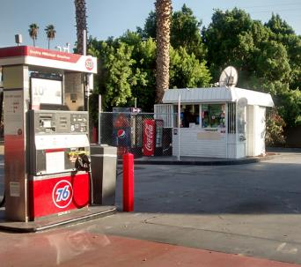

76 at 2658 UNIVERSITY AVENUE, RIVERSIDE, CA

How often do you go to the store at THIS ADDRESS?

Never 0

Once a month 1

2-3 times a month 2

Once a week 3

2-3 times a week 4

Almost every day 5

(picture 223-67635.jpg)

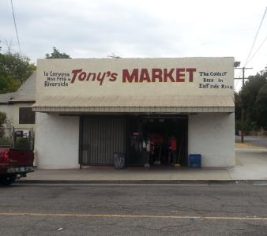

TONY'S MARKET at 4098 PARK AVENUE, RIVERSIDE, CA

How often do you go to the store at THIS ADDRESS?

Never 0

Once a month 1

2-3 times a month 2

Once a week 3

2-3 times a week 4

Almost every day 5

(picture 223-70332.jpg)

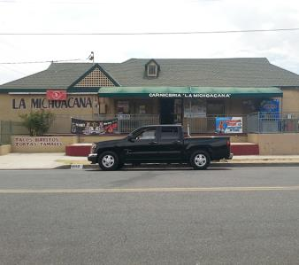

LA MICHOACANA MARKET at 4110 VICTORIA AVENUE, RIVERSIDE, CA

How often do you go to the store at THIS ADDRESS?

Never 0

Once a month 1

2-3 times a month 2

Once a week 3

2-3 times a week 4

Almost every day 5

(picture fake.jpg)

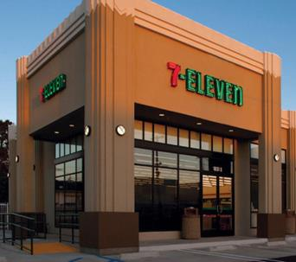

7-ELEVEN at 4495 HOWARD AVENUE, RIVERSIDE, CA

How often do you go to the store at THIS ADDRESS?

Never 0

Once a month 1

2-3 times a month 2

Once a week 3

2-3 times a week 4

Almost every day 5

(If Yes…)

**Abraxas (ID: 261)**

(picture 261-56472.jpg)

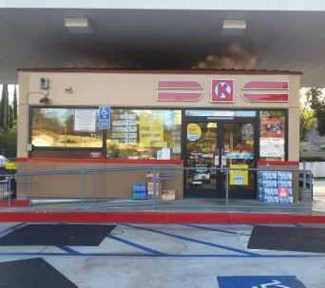

CIRCLE K at 14713 POMERADO ROAD, POWAY, CA

How often do you go to the store at THIS ADDRESS?

Never 0

Once a month 1

2-3 times a month 2

Once a week 3

2-3 times a week 4

Almost every day 5

(picture fake.jpg)

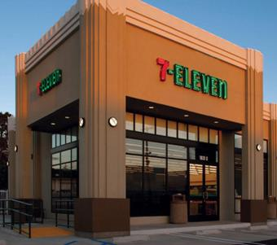

7-ELEVEN at 14551 POMERADO ROAD, POWAY, CA

How often do you go to the store at THIS ADDRESS?

Never 0

Once a month 1

2-3 times a month 2

Once a week 3

2-3 times a week 4

Almost every day 5

(If Yes…)

**Alvord (ID: 208)**

(picture 208-70116.jpg)

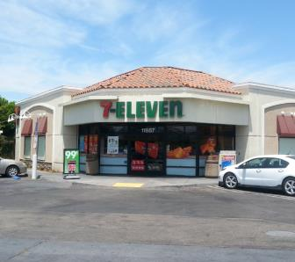

7-ELEVEN at 11887 MAGNOLIA AVENUE, RIVERSIDE, CA

How often do you go to the store at THIS ADDRESS?

Never 0

Once a month 1

2-3 times a month 2

Once a week 3

2-3 times a week 4

Almost every day 5

(picture fake.jpg)

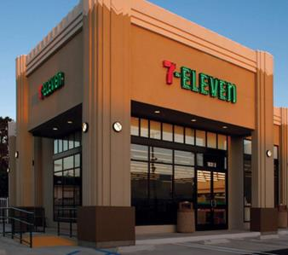

7-ELEVEN at 11860 MAGNOLIA AVENUE, RIVERSIDE, CA

How often do you go to the store at THIS ADDRESS?

Never 0

Once a month 1

2-3 times a month 2

Once a week 3

2-3 times a week 4

Almost every day 5

(If Yes…)

**Amistad (ID: 214)**

(picture fake.jpg)



7-ELEVEN at 44320 JACKSON STREET, INDIO, CA

How often do you go to the store at THIS ADDRESS?

Never 0

Once a month 1

2-3 times a month 2

Once a week 3

2-3 times a week 4

Almost every day 5

(If Yes…)

**Back Bay (ID: 197)**

(picture fake.jpg)

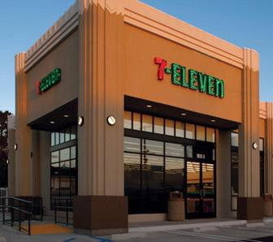

7-ELEVEN at 2651 IRVINE AVENUE, COSTA MESA, CA

How often do you go to the store at THIS ADDRESS?

Never 0

Once a month 1

2-3 times a month 2

Once a week 3

2-3 times a week 4

Almost every day 5

(If Yes…)

**Buena Park (ID: 186)**

(picture 186-58872.jpg)

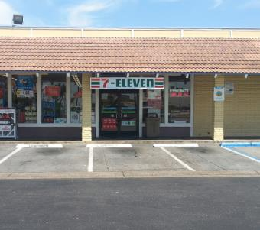

7-ELEVEN at 8725 ORANGETHORPE AVENUE, BUENA PARK, CA

How often do you go to the store at THIS ADDRESS?

Never 0

Once a month 1

2-3 times a month 2

Once a week 3

2-3 times a week 4

Almost every day 5

(picture 186-58873.jpg)

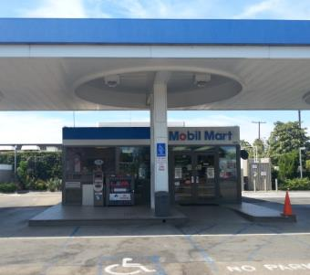

MOBIL at 8991 ORANGETHORPE AVENUE, BUENA PARK, CA

How often do you go to the store at THIS ADDRESS?

Never 0

Once a month 1

2-3 times a month 2

Once a week 3

2-3 times a week 4

Almost every day 5

(picture fake.jpg)



7-ELEVEN at 2627 WEST ORANGETHORPE AVENUE, FULLERTON, CA

How often do you go to the store at THIS ADDRESS?

Never 0

Once a month 1

2-3 times a month 2

Once a week 3

2-3 times a week 4

Almost every day 5

(If Yes…)

**Canyon Oaks (ID: 165)**

(picture 165-59571.jpg)

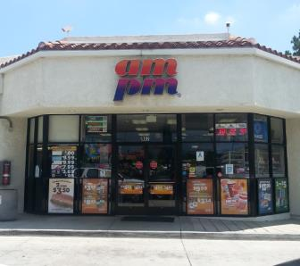

AM/PM at 902 HUNTINGTON DRIVE, DUARTE, CA

How often do you go to the store at THIS ADDRESS?

Never 0

Once a month 1

2-3 times a month 2

Once a week 3

2-3 times a week 4

Almost every day 5

(picture 165-59575.jpg)

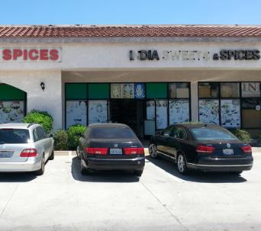

INDIA SWEETS & SPICES at 1208 HUNTINGTON DRIVE, DUARTE, CA

How often do you go to the store at THIS ADDRESS?

Never 0

Once a month 1

2-3 times a month 2

Once a week 3

2-3 times a week 4

Almost every day 5

(picture 165-62797.jpg)

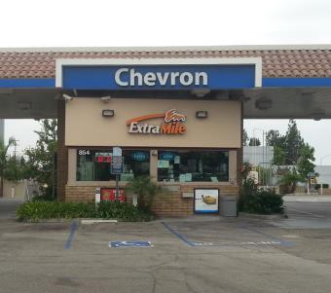

CHEVRON at 854 EAST HUNTINGTON DRIVE, MONROVIA, CA

How often do you go to the store at THIS ADDRESS?

Never 0

Once a month 1

2-3 times a month 2

Once a week 3

2-3 times a week 4

Almost every day 5

(picture 165-62798.jpg)

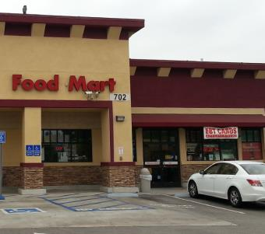

SHELL at 702 EAST HUNTINGTON DRIVE, MONROVIA, CA

How often do you go to the store at THIS ADDRESS?

Never 0

Once a month 1

2-3 times a month 2

Once a week 3

2-3 times a week 4

Almost every day 5

(picture 165-68622.jpg)

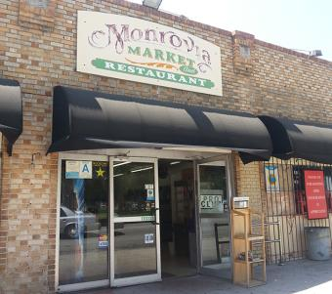

MONROVIA MARKET AND RESTAURANT at 525 SOUTH SHAMROCK AVENUE, MONROVIA, CA

How often do you go to the store at THIS ADDRESS?

Never 0

Once a month 1

2-3 times a month 2

Once a week 3

2-3 times a week 4

Almost every day 5

(picture fake.jpg)



7-ELEVEN at 831 EAST HUNTINGTON DRIVE, MONROVA, CA

How often do you go to the store at THIS ADDRESS?

Never 0

Once a month 1

2-3 times a month 2

Once a week 3

2-3 times a week 4

Almost every day 5

(If Yes…)

**Centinela Valley (ID: 115)**

(picture 115-60856.jpg)

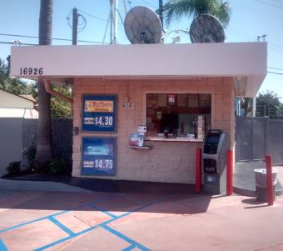

76 at 16926 HAWTHORNE BOULEVARD, LAWNDALE, CA

How often do you go to the store at THIS ADDRESS?

Never 0

Once a month 1

2-3 times a month 2

Once a week 3

2-3 times a week 4

Almost every day 5

(picture 115-60872.jpg)

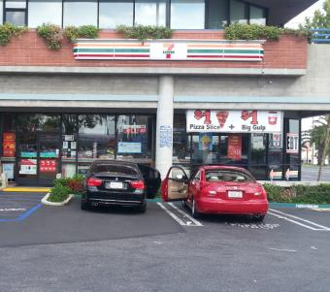

7-ELEVEN at 4401 REDONDO BEACH BOULEVARD, LAWNDALE, CA

How often do you go to the store at THIS ADDRESS?

Never 0

Once a month 1

2-3 times a month 2

Once a week 3

2-3 times a week 4

Almost every day 5

(picture fake.jpg)



7-ELEVEN at 4641 ARTESIA BOULEVARD, LAWNDALE, CA

How often do you go to the store at THIS ADDRESS?

Never 0

Once a month 1

2-3 times a month 2

Once a week 3

2-3 times a week 4

Almost every day 5

(If Yes…)

**Central (ID: 232)**

(picture 232-68687.jpg)

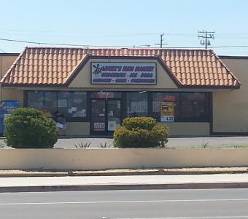

BUZZ'S MINI MARKET at 100 EAST MAIN STREET, BARSTOW, CA

How often do you go to the store at THIS ADDRESS?

Never 0

Once a month 1

2-3 times a month 2

Once a week 3

2-3 times a week 4

Almost every day 5

(picture 232-70528.jpg)

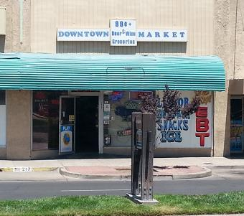

DOWNTOWN MARKET at 219 EAST MAIN STREET, BARSTOW, CA

How often do you go to the store at THIS ADDRESS?

Never 0

Once a month 1

2-3 times a month 2

Once a week 3

2-3 times a week 4

Almost every day 5

(picture 232-70809.jpg)

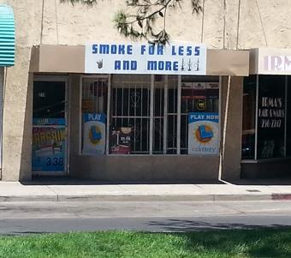

SMOKE FOR LESS AND MORE at 217 EAST MAIN STREET, BARSTOW, CA

How often do you go to the store at THIS ADDRESS?

Never 0

Once a month 1

2-3 times a month 2

Once a week 3

2-3 times a week 4

Almost every day 5

(picture fake.jpg)



7-ELEVEN at 524 EAST MAIN STREET, BARSTOW, CA

How often do you go to the store at THIS ADDRESS?

Never 0

Once a month 1

2-3 times a month 2

Once a week 3

2-3 times a week 4

Almost every day 5

(If Yes…)

**Chaparral (ID: 113)**

(picture 113-63814.jpg)

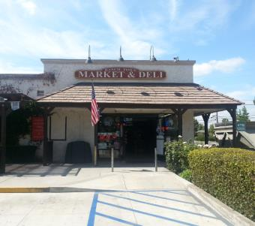

RANCH TOWN MARKET & DELI at 1112 NORTH SAN DIMAS AVENUE, SAN DIMAS, CA

How often do you go to the store at THIS ADDRESS?

Never 0

Once a month 1

2-3 times a month 2

Once a week 3

2-3 times a week 4

Almost every day 5

(picture fake.jpg)



7-ELEVEN at 409 WEST ALLEN AVENUE, SAN DIMAS, CA

How often do you go to the store at THIS ADDRESS?

Never 0

Once a month 1

2-3 times a month 2

Once a week 3

2-3 times a week 4

Almost every day 5

(If Yes…)

**Community (ID: 280)**

(picture fake.jpg)



7-ELEVEN at 6144 CONDOR DRIVE, MOORPARK, CA

How often do you go to the store at THIS ADDRESS?

Never 0

Once a month 1

2-3 times a month 2

Once a week 3

2-3 times a week 4

Almost every day 5

(If Yes…)

**Conejo Valley (ID: 278)**

(picture 278-52693.jpg)

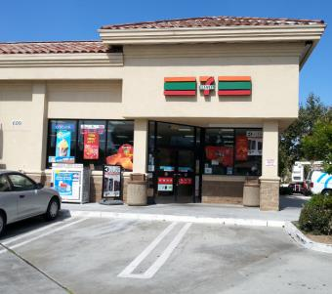

7-ELEVEN at 609 RANCHO CONEJO BOULEVARD, THOUSAND OAKS, CA

How often do you go to the store at THIS ADDRESS?

Never 0

Once a month 1

2-3 times a month 2

Once a week 3

2-3 times a week 4

Almost every day 5

(picture 278-52695.jpg)

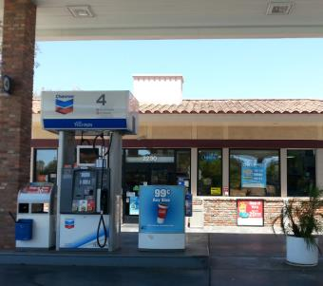

CHEVRON at 2290 BORCHARD ROAD, NEWBURY PARK, CA

How often do you go to the store at THIS ADDRESS?

Never 0

Once a month 1

2-3 times a month 2

Once a week 3

2-3 times a week 4

Almost every day 5

(picture 278-52697.jpg)

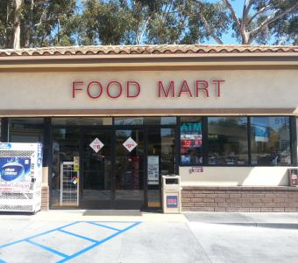

FOOD MART at 518 RANCHO CONEJO BOULEVARD, NEWBURY PARK, CA

How often do you go to the store at THIS ADDRESS?

Never 0

Once a month 1

2-3 times a month 2

Once a week 3

2-3 times a week 4

Almost every day 5

(picture 278-52700.jpg)

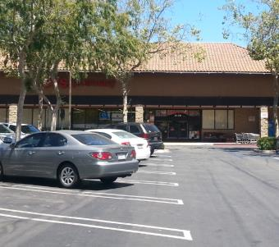

CVS at 2120 NEWBURY ROAD, NEWBURY PARK, CA

How often do you go to the store at THIS ADDRESS?

Never 0

Once a month 1

2-3 times a month 2

Once a week 3

2-3 times a week 4

Almost every day 5

(picture 278-52703.jpg)

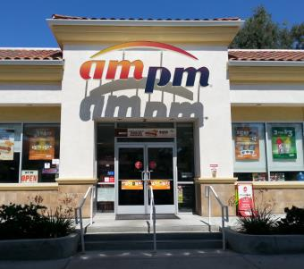

AM/PM at 2305 BORCHARD ROAD, NEWBURY PARK, CA

How often do you go to the store at THIS ADDRESS?

Never 0

Once a month 1

2-3 times a month 2

Once a week 3

2-3 times a week 4

Almost every day 5

(picture fake.jpg)



7-ELEVEN at 1620 NEWBURY ROAD, NEWBURY PARK, CA

How often do you go to the store at THIS ADDRESS?

Never 0

Once a month 1

2-3 times a month 2

Once a week 3

2-3 times a week 4

Almost every day 5

(If Yes…)

**Desert Winds (ID: 108)**

(picture 108-54276.jpg)

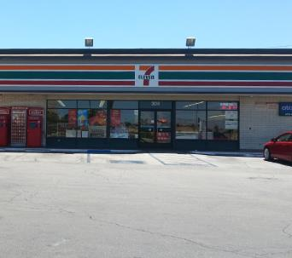

7-ELEVEN at 304 EAST AVENUE I, LANCASTER, CA

How often do you go to the store at THIS ADDRESS?

Never 0

Once a month 1

2-3 times a month 2

Once a week 3

2-3 times a week 4

Almost every day 5

(picture 108-65625.jpg)

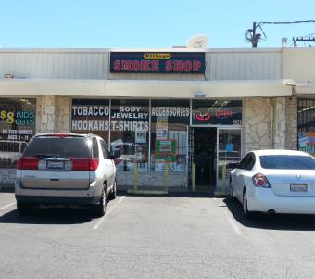

SMOKE SHOP at 326 EAST AVENUE I, LANCASTER, CA

How often do you go to the store at THIS ADDRESS?

Never 0

Once a month 1

2-3 times a month 2

Once a week 3

2-3 times a week 4

Almost every day 5

(picture 108-68457.jpg)

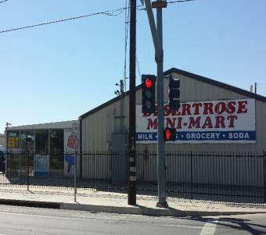

DESERT ROSE MINI MART at 106 WEST AVENUE I, LANCASTER, CA

How often do you go to the store at THIS ADDRESS?

Never 0

Once a month 1

2-3 times a month 2

Once a week 3

2-3 times a week 4

Almost every day 5

(picture 108-69149.jpg)

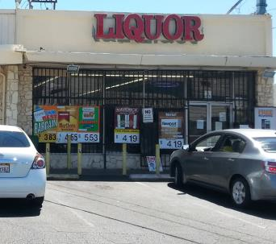

VILLAGE LIQUOR at 332 EAST AVENUE I, LANCASTER, CA

How often do you go to the store at THIS ADDRESS?

Never 0

Once a month 1

2-3 times a month 2

Once a week 3

2-3 times a week 4

Almost every day 5

(picture fake.jpg)



7-ELEVEN at 105 WEST AVENUE I, LANCASTER, CA

How often do you go to the store at THIS ADDRESS?

Never 0

Once a month 1

2-3 times a month 2

Once a week 3

2-3 times a week 4

Almost every day 5

(If Yes…)

**Fairvalley (ID: 117)**

(picture 117-53969.jpg)

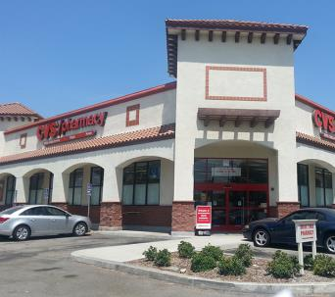

CVS at 915 EAST ARROW HIGHWAY, AZUSA, CA

How often do you go to the store at THIS ADDRESS?

Never 0

Once a month 1

2-3 times a month 2

Once a week 3

2-3 times a week 4

Almost every day 5

(picture 117-59375.jpg)

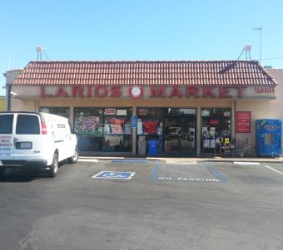

LARIOS MARKET at 19004 EAST ARROW HIGHWAY, COVINA, CA

How often do you go to the store at THIS ADDRESS?

Never 0

Once a month 1

2-3 times a month 2

Once a week 3

2-3 times a week 4

Almost every day 5

(picture 117-59383.jpg)

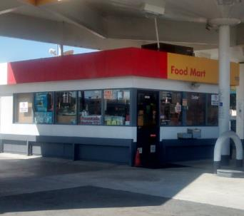

SHELL at 110 WEST ARROW HIGHWAY, COVINA, CA

How often do you go to the store at THIS ADDRESS?

Never 0

Once a month 1

2-3 times a month 2

Once a week 3

2-3 times a week 4

Almost every day 5

(picture fake.jpg)



7-ELEVEN at 1385 NORTH CITRUS AVENUE, COVINA, CA

How often do you go to the store at THIS ADDRESS?

Never 0

Once a month 1

2-3 times a month 2

Once a week 3

2-3 times a week 4

Almost every day 5

(If Yes…)

**Hillview (ID: 206)**

(picture 206-68332.jpg)

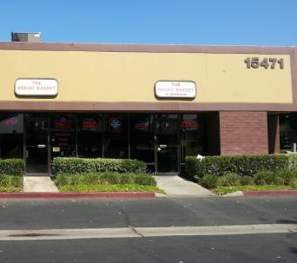

THE BREAD BASKET at 15471 RED HILL AVENUE, TUSTIN, CA

How often do you go to the store at THIS ADDRESS?

Never 0

Once a month 1

2-3 times a month 2

Once a week 3

2-3 times a week 4

Almost every day 5

(picture fake.jpg)



7-ELEVEN at 15052 RED HILL AVENUE, TUSTIN, CA

How often do you go to the store at THIS ADDRESS?

Never 0

Once a month 1

2-3 times a month 2

Once a week 3

2-3 times a week 4

Almost every day 5

(If Yes…)

**Jack London (ID: 139)**

(picture fake.jpg)



7-ELEVEN at 12500 OXNARD STREET, VAN NUYS, CA

How often do you go to the store at THIS ADDRESS?

Never 0

Once a month 1

2-3 times a month 2

Once a week 3

2-3 times a week 4

Almost every day 5

(If Yes…)

**Middle College (ID: 246)**

(picture 246-55040.jpg)

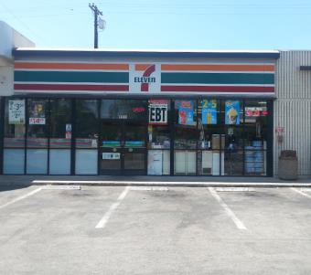

7-ELEVEN at 1511 NORTH MOUNT VERNON AVENUE, COLTON, CA

How often do you go to the store at THIS ADDRESS?

Never 0

Once a month 1

2-3 times a month 2

Once a week 3

2-3 times a week 4

Almost every day 5

(picture 246-56972.jpg)

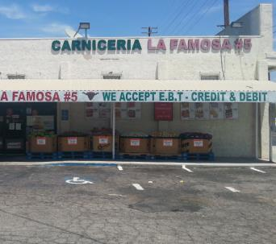

LA FAMOSA MARKET at 390 SOUTH MOUNT VERNON AVENUE, SAN BERNARDINO, CA

How often do you go to the store at THIS ADDRESS?

Never 0

Once a month 1

2-3 times a month 2

Once a week 3

2-3 times a week 4

Almost every day 5

(picture 246-67442.jpg)

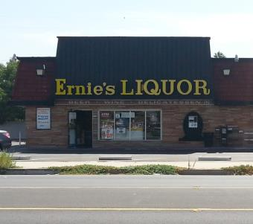

ERNIE'S LIQUOR at 539 SOUTH MOUNT VERNON AVENUE, SAN BERNARDINO, CA

How often do you go to the store at THIS ADDRESS?

Never 0

Once a month 1

2-3 times a month 2

Once a week 3

2-3 times a week 4

Almost every day 5

(picture 246-69891.jpg)

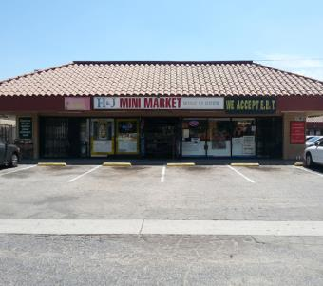

H&J MINI MARKET at 509 SOUTH MOUNT VERNON AVENUE, SAN BERNARDINO, CA

How often do you go to the store at THIS ADDRESS?

Never 0

Once a month 1

2-3 times a month 2

Once a week 3

2-3 times a week 4

Almost every day 5

(picture 246-70973.jpg)

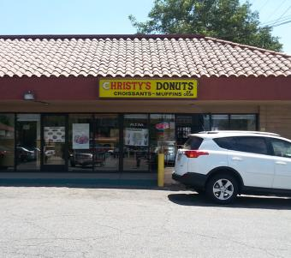

CHRISTY'S DONUTS at 1292 WEST MILL STREET, SAN BERNARDINO, CA

How often do you go to the store at THIS ADDRESS?

Never 0

Once a month 1

2-3 times a month 2

Once a week 3

2-3 times a week 4

Almost every day 5

(picture fake.jpg)



7-ELEVEN at 1791 NORTH MOUNT VERNON AVENUE, COLTON, CA

How often do you go to the store at THIS ADDRESS?

Never 0

Once a month 1

2-3 times a month 2

Once a week 3

2-3 times a week 4

Almost every day 5

(If Yes…)

**Mojave (ID: 254)**

(picture fake.jpg)



7-ELEVEN at 10924 HESPERIA ROAD, HESPERIA, CA

How often do you go to the store at THIS ADDRESS?

Never 0

Once a month 1

2-3 times a month 2

Once a week 3

2-3 times a week 4

Almost every day 5

(If Yes…)

**Monterey (ID: 114)**

(picture 114-58945.jpg)

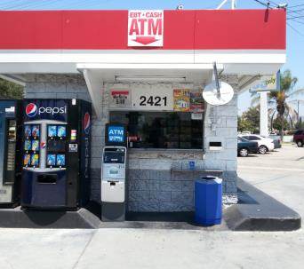

76 at 2421 WEST VICTORY BOULEVARD, BURBANK, CA

How often do you go to the store at THIS ADDRESS?

Never 0

Once a month 1

2-3 times a month 2

Once a week 3

2-3 times a week 4

Almost every day 5

(picture fake.jpg)



7-ELEVEN at 2457 WEST VICTORY BOULEVARD, BURBANK, CA

How often do you go to the store at THIS ADDRESS?

Never 0

Once a month 1

2-3 times a month 2

Once a week 3

2-3 times a week 4

Almost every day 5

(If Yes…)

**Mountain (ID: 244)**

(picture fake.jpg)



7-ELEVEN at 24835 LAKE DRIVE, CRESTLINE, CA

How often do you go to the store at THIS ADDRESS?

Never 0

Once a month 1

2-3 times a month 2

Once a week 3

2-3 times a week 4

Almost every day 5

(If Yes…)

**Mountain View (ID: 224)**

(picture 224-57859.jpg)

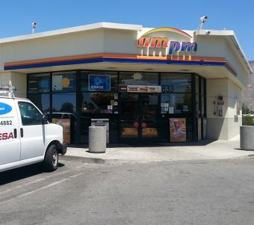

AM/PM at 833 NORTH RAMONA BOULEVARD, SAN JACINTO, CA

How often do you go to the store at THIS ADDRESS?

Never 0

Once a month 1

2-3 times a month 2

Once a week 3

2-3 times a week 4

Almost every day 5

(picture 224-57860.jpg)

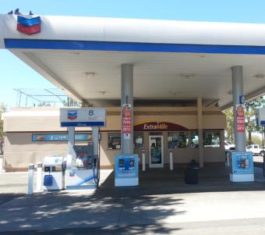

CHEVRON at 720 WEST RAMONA EXPRESSWAY, SAN JACINTO, CA

How often do you go to the store at THIS ADDRESS?

Never 0

Once a month 1

2-3 times a month 2

Once a week 3

2-3 times a week 4

Almost every day 5

(picture 224-57868.jpg)

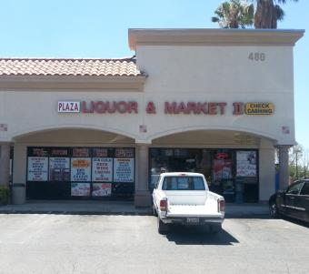

PLAZA LIQUOR & MARKET II at 480 NORTH STATE STREET, SAN JACINTO, CA

How often do you go to the store at THIS ADDRESS?

Never 0

Once a month 1

2-3 times a month 2

Once a week 3

2-3 times a week 4

Almost every day 5

(picture 224-65367.jpg)

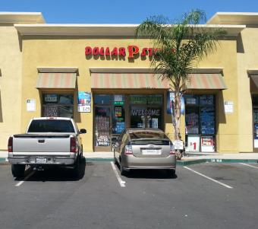

DOLLAR STORE at 651 NORTH STATE STREET, SAN JACINTO, CA

How often do you go to the store at THIS ADDRESS?

Never 0

Once a month 1

2-3 times a month 2

Once a week 3

2-3 times a week 4

Almost every day 5

(picture 224-66693.jpg)

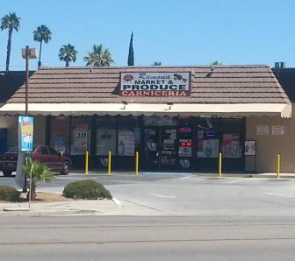

RAMONA MARKET AND PRODUCE at 794 NORTH RAMONA BOULEVARD, SAN JACINTO, CA

How often do you go to the store at THIS ADDRESS?

Never 0

Once a month 1

2-3 times a month 2

Once a week 3

2-3 times a week 4

Almost every day 5

(picture fake.jpg)



7-ELEVEN at 464 NORTH STATE STREET, SAN JACINTO, CA

How often do you go to the store at THIS ADDRESS?

Never 0

Once a month 1

2-3 times a month 2

Once a week 3

2-3 times a week 4

Almost every day 5

(If Yes…)

**North Park (ID: 111)**

(picture 111-58637.jpg)

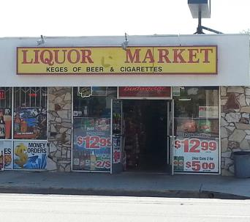

LIQUOR MARKET at 4503 MAINE AVENUE, BALDWIN PARK, CA

How often do you go to the store at THIS ADDRESS?

Never 0

Once a month 1

2-3 times a month 2

Once a week 3

2-3 times a week 4

Almost every day 5

(picture 111-58651.jpg)

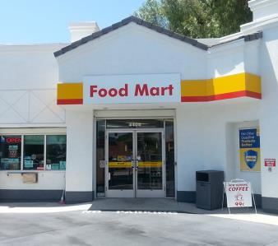

SHELL at 4405 MAINE AVENUE, BALDWIN PARK, CA

How often do you go to the store at THIS ADDRESS?

Never 0

Once a month 1

2-3 times a month 2

Once a week 3

2-3 times a week 4

Almost every day 5

(picture 111-58653.jpg)

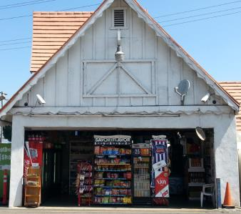

ROCKVIEW DAIRY at 4390 MAINE AVENUE, BALDWIN PARK, CA

How often do you go to the store at THIS ADDRESS?

Never 0

Once a month 1

2-3 times a month 2

Once a week 3

2-3 times a week 4

Almost every day 5

(picture 111-58681.jpg)

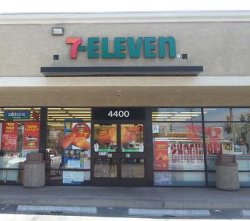

7-ELEVEN at 4400 MAINE AVENUE, BALDWIN PARK, CA

How often do you go to the store at THIS ADDRESS?

Never 0

Once a month 1

2-3 times a month 2

Once a week 3

2-3 times a week 4

Almost every day 5

(picture 111-58682.jpg)

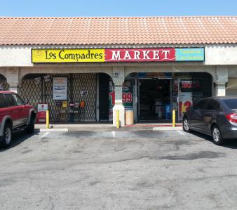

LOS COMPADRES MARKET at 4801 MAINE AVENUE, BALDWIN PARK, CA

How often do you go to the store at THIS ADDRESS?

Never 0

Once a month 1

2-3 times a month 2

Once a week 3

2-3 times a week 4

Almost every day 5

(picture 111-68637.jpg)

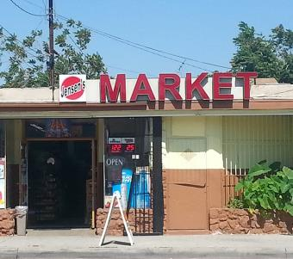

JENSEN'S MARKET at 4724 MAINE AVENUE, BALDWIN PARK, CA

How often do you go to the store at THIS ADDRESS?

Never 0

Once a month 1

2-3 times a month 2

Once a week 3

2-3 times a week 4

Almost every day 5

(picture fake.jpg)



7-ELEVEN at 14394 CLARK STREET, BALDWIN PARK, CA

How often do you go to the store at THIS ADDRESS?

Never 0

Once a month 1

2-3 times a month 2

Once a week 3

2-3 times a week 4

Almost every day 5

(If Yes…)

**Oak View (ID: 250)**

(picture fake.jpg)



7-ELEVEN at 12137 5TH STREET YUCAIPA, CA

How often do you go to the store at THIS ADDRESS?

Never 0

Once a month 1

2-3 times a month 2

Once a week 3

2-3 times a week 4

Almost every day 5

(If Yes…)

**Ortega (ID: 226)**

(picture fake.jpg)



7-ELEVEN at 31295 CHANEY STREET, LAKE ELSINORE, CA

How often do you go to the store at THIS ADDRESS?

Never 0

Once a month 1

2-3 times a month 2

Once a week 3

2-3 times a week 4

Almost every day 5

(If Yes…)

**Pacific (ID: 276)**

(picture 276-53784.jpg)

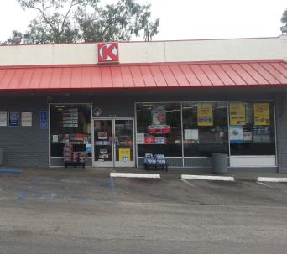

CIRCLE K at 3506 EAST MAIN STREET, VENTURA, CA

How often do you go to the store at THIS ADDRESS?

Never 0

Once a month 1

2-3 times a month 2

Once a week 3

2-3 times a week 4

Almost every day 5

(picture 276-53811.jpg)

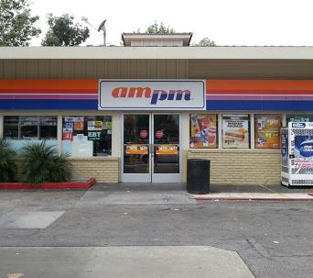

AM/PM at 605 SOUTH MILLS ROAD, VENTURA, CA

How often do you go to the store at THIS ADDRESS?

Never 0

Once a month 1

2-3 times a month 2

Once a week 3

2-3 times a week 4

Almost every day 5

(picture 276-66640.jpg)

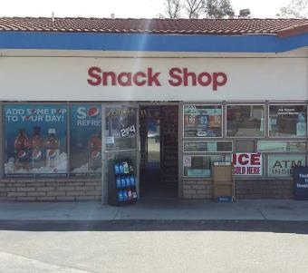

MOBIL at 3500 EAST MAIN STREET, VENTURA, CA

How often do you go to the store at THIS ADDRESS?

Never 0

Once a month 1

2-3 times a month 2

Once a week 3

2-3 times a week 4

Almost every day 5

(picture fake.jpg)



7-ELEVEN at 3748 TELEGRAPH ROAD, VENTURA, CA

How often do you go to the store at THIS ADDRESS?

Never 0

Once a month 1

2-3 times a month 2

Once a week 3

2-3 times a week 4

Almost every day 5

(If Yes…)

**Phoenix (North) (ID: 283)**

(picture fake.jpg)



7-ELEVEN at 220 WEST AVENUE H6, LANCASTER, CA

How often do you go to the store at THIS ADDRESS?

Never 0

Once a month 1

2-3 times a month 2

Once a week 3

2-3 times a week 4

Almost every day 5

(If Yes…)

**Phoenix (South) (ID: 282)**

(picture fake.jpg)



7-ELEVEN at 38815 20TH STREET EAST, PALMDALE, CA

How often do you go to the store at THIS ADDRESS?

Never 0

Once a month 1

2-3 times a month 2

Once a week 3

2-3 times a week 4

Almost every day 5

(If Yes…)

**R. K. Lloyde (ID: 116)**

(picture 116-60858.jpg)

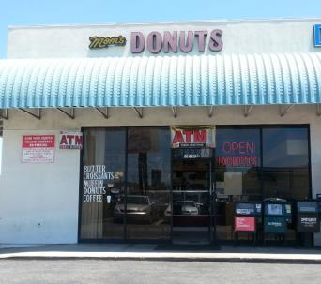

MOM'S DONUTS at 15102 INGLEWOOD AVENUE, LAWNDALE, CA

How often do you go to the store at THIS ADDRESS?

Never 0

Once a month 1

2-3 times a month 2

Once a week 3

2-3 times a week 4

Almost every day 5

(picture 116-63733.jpg)

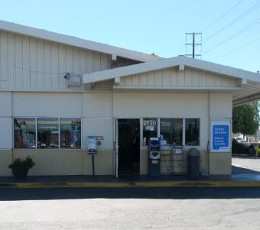

ARCO at 2730 MARINE AVENUE, REDONDO BEACH, CA

How often do you go to the store at THIS ADDRESS?

Never 0

Once a month 1

2-3 times a month 2

Once a week 3

2-3 times a week 4

Almost every day 5

(picture 116-67948.jpg)

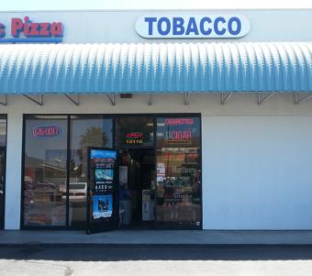

INTERNATIONAL TOBACCO at 15116 INGLEWOOD AVENUE, LAWNDALE, CA

How often do you go to the store at THIS ADDRESS?

Never 0

Once a month 1

2-3 times a month 2

Once a week 3

2-3 times a week 4

Almost every day 5

(picture fake.jpg)



7-ELEVEN at 3859 INGLEWOOD AVENUE, REDONDO BEACH, CA

How often do you go to the store at THIS ADDRESS?

Never 0

Once a month 1

2-3 times a month 2

Once a week 3

2-3 times a week 4

Almost every day 5

(If Yes…)

**Rex Parris (ID: 109)**

(picture fake.jpg)



7-ELEVEN at 38712 6TH STREET E, PALMDALE, CA

How often do you go to the store at THIS ADDRESS?

Never 0

Once a month 1

2-3 times a month 2

Once a week 3

2-3 times a week 4

Almost every day 5

(If Yes…)

**Rose City (ID: 171)**

(picture 171-63364.jpg)

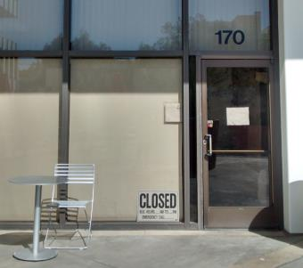

PLAZA CAFE at 251 SOUTH LAKE AVENUE, PASADENA, CA

How often do you go to the store at THIS ADDRESS?

Never 0

Once a month 1

2-3 times a month 2

Once a week 3

2-3 times a week 4

Almost every day 5

(picture 171-63365.jpg)

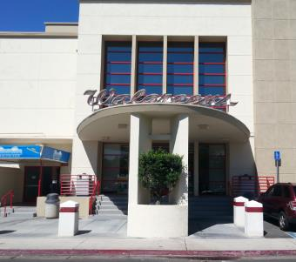

WALGREENS at 310 SOUTH LAKE AVENUE, PASADENA, CA

How often do you go to the store at THIS ADDRESS?

Never 0

Once a month 1

2-3 times a month 2

Once a week 3

2-3 times a week 4

Almost every day 5

(picture 171-63367.jpg)

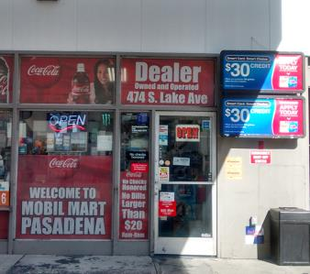

MOBIL at 474 SOUTH LAKE AVENUE, PASADENA, CA

How often do you go to the store at THIS ADDRESS?

Never 0

Once a month 1

2-3 times a month 2

Once a week 3

2-3 times a week 4

Almost every day 5

(picture 171-65547.jpg)

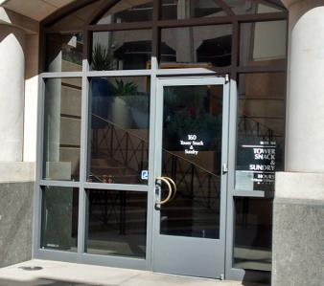

TOWER SNACK & SUNDRY at 55 SOUTH LAKE AVENUE, PASADENA, CA

How often do you go to the store at THIS ADDRESS?

Never 0

Once a month 1

2-3 times a month 2

Once a week 3

2-3 times a week 4

Almost every day 5

(picture 171-67504.jpg)

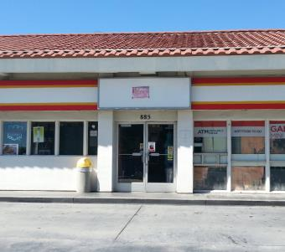

GARY'S MINI MART at 885 EAST CALIFORNIA BOULEVARD, PASADENA, CA

How often do you go to the store at THIS ADDRESS?

Never 0

Once a month 1

2-3 times a month 2

Once a week 3

2-3 times a week 4

Almost every day 5

(picture fake.jpg)

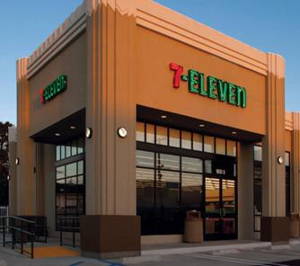

7-ELEVEN at 805 EAST COLORADO BOULEVARD, CA

How often do you go to the store at THIS ADDRESS?

Never 0

Once a month 1

2-3 times a month 2

Once a week 3

2-3 times a week 4

Almost every day 5

(If Yes…)

**Santana (ID: 181)**

(picture fake.jpg)



7-ELEVEN at 627 LA SEDA ROAD, LA PUENTE, CA

How often do you go to the store at THIS ADDRESS?

Never 0

Once a month 1

2-3 times a month 2

Once a week 3

2-3 times a week 4

Almost every day 5

(If Yes…)

**Sherry (ID: 174)**

(picture fake.jpg)



7-ELEVEN at 22511 CRENSHAW BOULEVARD, TORRANCE, CA

How often do you go to the store at THIS ADDRESS?

Never 0

Once a month 1

2-3 times a month 2

Once a week 3

2-3 times a week 4

Almost every day 5

(If Yes…)

**Somerset (ID: 112)**

(picture 112-58780.jpg)

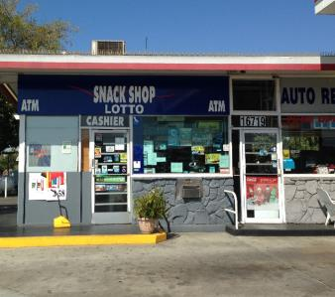

76 at 16719 LAKEWOOD BOULEVARD, BELLFLOWER, CA

How often do you go to the store at THIS ADDRESS?

Never 0

Once a month 1

2-3 times a month 2

Once a week 3

2-3 times a week 4

Almost every day 5

(picture 112-65767.jpg)

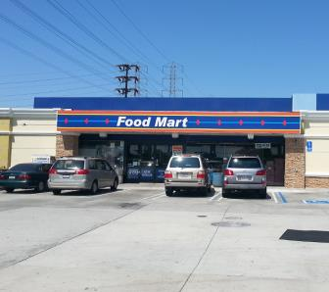

ARCO at 17020 LAKEWOOD BOULEVARD, BELLFLOWER, CA

How often do you go to the store at THIS ADDRESS?

Never 0

Once a month 1

2-3 times a month 2

Once a week 3

2-3 times a week 4

Almost every day 5

(picture 112-70582.jpg)

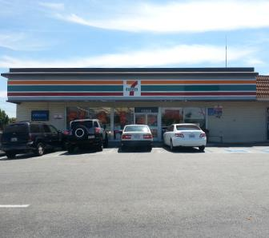

7-ELEVEN at 16852 LAKEWOOD BOULEVARD, BELLFLOWER, CA

How often do you go to the store at THIS ADDRESS?

Never 0

Once a month 1

2-3 times a month 2

Once a week 3

2-3 times a week 4

Almost every day 5

(picture fake.jpg)



7-ELEVEN at 16917 LAKEWOOD BOULEVARD, BELLFLOWER, CA

How often do you go to the store at THIS ADDRESS?

Never 0

Once a month 1

2-3 times a month 2

Once a week 3

2-3 times a week 4

Almost every day 5

(If Yes…)

**Tracy (ID: 105)**

(picture 105-59005.jpg)

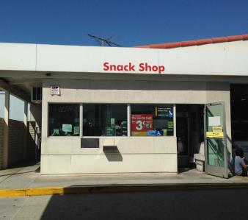

SHELL at 16821 NORWALK BOULEVARD, CERRITOS, CA

How often do you go to the store at THIS ADDRESS?

Never 0

Once a month 1

2-3 times a month 2

Once a week 3

2-3 times a week 4

Almost every day 5

(picture 105-59012.jpg)

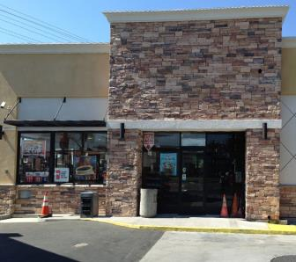

ARCO at 12157 ARTESIA BOULEVARD, CERRITOS, CA

How often do you go to the store at THIS ADDRESS?

Never 0

Once a month 1

2-3 times a month 2

Once a week 3

2-3 times a week 4

Almost every day 5

(picture 105-59021.jpg)

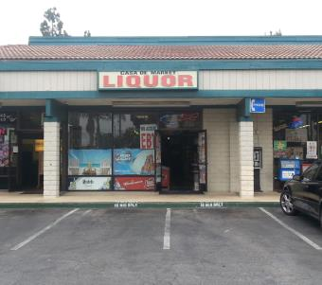

CASA DE MARKET at 16432 NORWALK BOULEVARD, CERRITOS, CA

How often do you go to the store at THIS ADDRESS?

Never 0

Once a month 1

2-3 times a month 2

Once a week 3

2-3 times a week 4

Almost every day 5

(picture 105-68957.jpg)

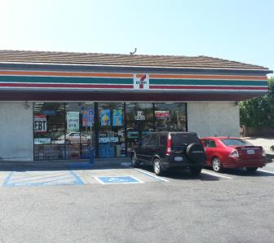

7-ELEVEN at 12200 ARTESIA BOULEVARD, ARTESIA, CA

How often do you go to the store at THIS ADDRESS?

Never 0

Once a month 1

2-3 times a month 2

Once a week 3

2-3 times a week 4

Almost every day 5

(picture fake.jpg)



7-ELEVEN at 17198 NORWALK BOULEVARD, CERRITOS, CA

How often do you go to the store at THIS ADDRESS?

Never 0

Once a month 1

2-3 times a month 2

Once a week 3

2-3 times a week 4

Almost every day 5

(If Yes…)

**Val Verde (ID: 229)**

(picture fake.jpg)



7-ELEVEN at 3601 BRENNAN AVENUE, PERRIS, CA

How often do you go to the store at THIS ADDRESS?

Never 0

Once a month 1

2-3 times a month 2

Once a week 3

2-3 times a week 4

Almost every day 5

(If Yes…)

**Valley Vista (ID: 195)**

(picture 195-59665.jpg)

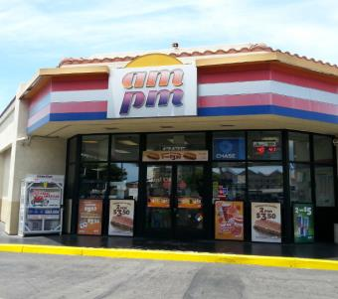

AM/PM at 17475 BROOKHURST STREET, FOUNTAIN VALLEY, CA

How often do you go to the store at THIS ADDRESS?

Never 0

Once a month 1

2-3 times a month 2

Once a week 3

2-3 times a week 4

Almost every day 5

(picture 195-59666.jpg)



ARCO at 17520 BROOKHURST STREET, FOUNTAIN VALLEY, CA

How often do you go to the store at THIS ADDRESS?

Never 0

Once a month 1

2-3 times a month 2

Once a week 3

2-3 times a week 4

Almost every day 5

(picture fake.jpg)



7-ELEVEN at 10000 SLATER AVENUE, FOUNTAIN VALLEY, CA

How often do you go to the store at THIS ADDRESS?

Never 0

Once a month 1

2-3 times a month 2

Once a week 3

2-3 times a week 4

Almost every day 5

(If Yes…)

**Youth Opportunities (ID: 161)**

(picture 161-62403.jpg)

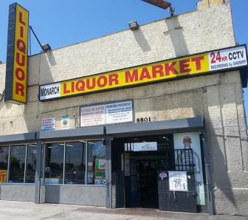

LIQUOR MARKET at 8801 SOUTH VERMONT AVENUE, LOS ANGELES, CA

How often do you go to the store at THIS ADDRESS?

Never 0

Once a month 1

2-3 times a month 2

Once a week 3

2-3 times a week 4

Almost every day 5

(picture 161-62407.jpg)

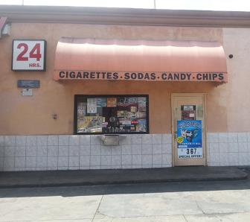

ARCO at 800 WEST MANCHESTER AVENUE, LOS ANGELES, CA

How often do you go to the store at THIS ADDRESS?

Never 0

Once a month 1

2-3 times a month 2

Once a week 3

2-3 times a week 4

Almost every day 5

(picture 161-67145.jpg)

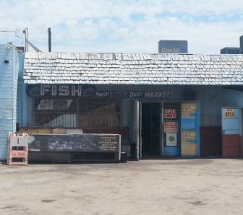

MANCHESTER FISH at 1059 WEST MANCHESTER AVENUE, LOS ANGELES, CA

How often do you go to the store at THIS ADDRESS?

Never 0

Once a month 1

2-3 times a month 2

Once a week 3

2-3 times a week 4

Almost every day 5

(picture 161-67603.jpg)

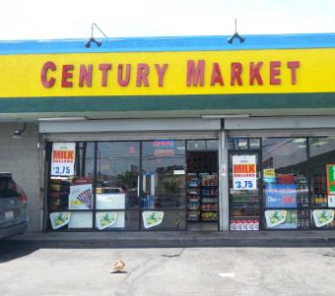

CENTURY MARKET at 8453 SOUTH FIGUEROA STREET, LOS ANGELES, CA

How often do you go to the store at THIS ADDRESS?

Never 0

Once a month 1

2-3 times a month 2

Once a week 3

2-3 times a week 4

Almost every day 5

(picture 161-67613.jpg)

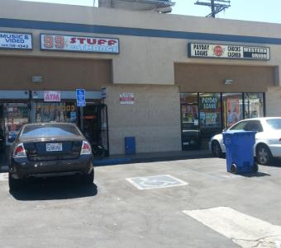

99 CENT STUFF & THANGS at 8608 SOUTH VERMONT AVENUE, LOS ANGELES, CA

How often do you go to the store at THIS ADDRESS?

Never 0

Once a month 1

2-3 times a month 2

Once a week 3

2-3 times a week 4

Almost every day 5

(picture 161-67932.jpg)

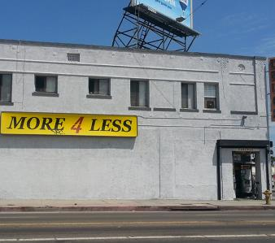

MORE 4 LESS at 1011 WEST MANCHESTER AVENUE, LOS ANGELES, CA

How often do you go to the store at THIS ADDRESS?

Never 0

Once a month 1

2-3 times a month 2

Once a week 3

2-3 times a week 4

Almost every day 5

(picture 161-68042.jpg)

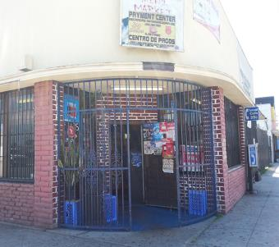

ANGELS MINI-MARKET at 8500 SOUTH HOOVER STREET, LOS ANGELES, CA

How often do you go to the store at THIS ADDRESS?

Never 0

Once a month 1

2-3 times a month 2

Once a week 3

2-3 times a week 4

Almost every day 5

(picture 161-68422.jpg)

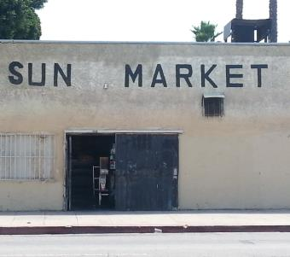

SUN MARKET at 8107 SOUTH HOOVER STREET, LOS ANGELES, CA

How often do you go to the store at THIS ADDRESS?

Never 0

Once a month 1

2-3 times a month 2

Once a week 3

2-3 times a week 4

Almost every day 5

(picture 161-69978.jpg)

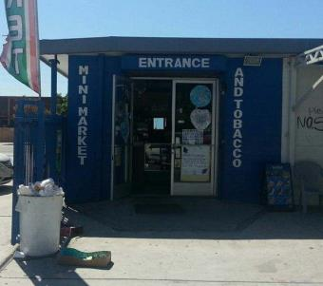

LUCKY MINI MARKET & TOBACCO at 1111 WEST MANCHESTER AVENUE, LOS ANGELES, CA

How often do you go to the store at THIS ADDRESS?

Never 0

Once a month 1

2-3 times a month 2

Once a week 3

2-3 times a week 4

Almost every day 5

(picture 161-70307.jpg)

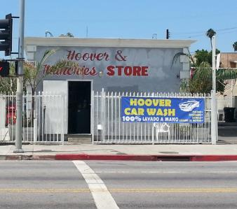

HOOVER & MUNCHIES STORE at 803 WEST 83RD STREET, LOS ANGELES, CA

How often do you go to the store at THIS ADDRESS?

Never 0

Once a month 1

2-3 times a month 2

Once a week 3

2-3 times a week 4

Almost every day 5

(picture 161-70361.jpg)

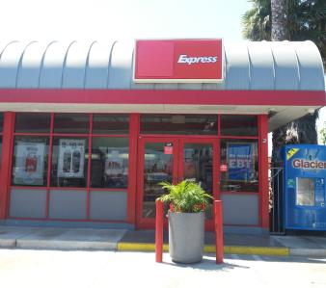

76 at 400 WEST MANCHESTER AVENUE, LOS ANGELES, CA

How often do you go to the store at THIS ADDRESS?

Never 0

Once a month 1

2-3 times a month 2

Once a week 3

2-3 times a week 4

Almost every day 5

(picture 161-70615.jpg)

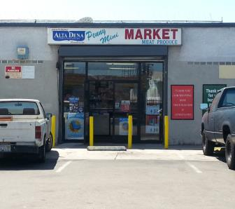

PENNY MINI MARKET at 1001-1023 WEST 89TH STREET, LOS ANGELES, CA

How often do you go to the store at THIS ADDRESS?

Never 0

Once a month 1

2-3 times a month 2

Once a week 3

2-3 times a week 4

Almost every day 5

(picture 161-72452.jpg)

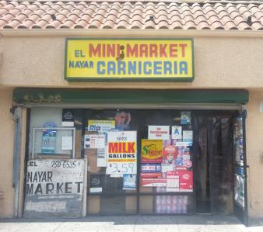

EL NAYAR MINI MARKET at 8301 SOUTH VERMONT AVENUE, LOS ANGELES, CA

How often do you go to the store at THIS ADDRESS?

Never 0

Once a month 1

2-3 times a month 2

Once a week 3

2-3 times a week 4

Almost every day 5

(picture fake.jpg)



7-ELEVEN at 8310 SOUTH VERMONT AVENUE, LOS ANGELES, CA

How often do you go to the store at THIS ADDRESS?

Never 0

Once a month 1

2-3 times a month 2

Once a week 3

2-3 times a week 4

Almost every day 5

**Tobacco Initiation - Part 1**

**Source:** Adapted from Centers for Disease Control and Prevention (CDC). (2014a). 2012 National youth tobacco survey (NYTS). Retrieved from: <http://www.cdc.gov/TOBACCO/data_statistics/surveys/NYTS/index.htm>

**Designed For:** Adolescents

**Psychometrics**: Not reported

**Codebook**:

1. Which of the following tobacco products have you ever tried, even just one time? (Check all that apply) W2AMQ1, W2TobEverUse1, 0 When Not Selected, 1 When Selected

Cigarettes (Marlboro, Camel, Newport, American Spirit, etc.) W2AMQ1option1 W2TobEverUseCig1

Electronic Cigarettes (Blu, NJOY, MarkTen, etc.) W2AMQ1option2 W2TobEverUseECig1

Cigars, Cigarillos, or Little Cigars (Black and Mild, Swisher Sweets, Dutch Masters, etc.)

W2AMQ1option3 W2TobEverUseCigar1

Chewing Tobacco, Snuff, or Dip (Copenhagen, Grizzly, Skoal, etc.) W2AMQ1option4 W2TobEverUseChew1

Tobacco smoked out of a traditional pipe (Captain Black, Lane Limited, etc.)

W2AMQ1option5 W2TobEverUsePipe1

Hookah or Shisha (Starbuzz, Fantasia, Fumari, etc.) W2AMQ1option6 W2TobEverUseHookah1

I have never tried any of these tobacco products W2AMQ1option7 W2TobEverUseNever1

**Cigarette Use**

**Source:** Adapted from:

Centers for Disease Control and Prevention (CDC). (2014a). 2012 National youth tobacco survey (NYTS). Retrieved from: <http://www.cdc.gov/TOBACCO/data_statistics/surveys/NYTS/index.htm>

Centers for Disease Control and Prevention (CDC). (2014b). 2011 Youth tobacco survey (YTS). Retrieved from: <http://www.cdc.gov/tobacco/data_statistics/surveys/yts/index.htm>

Methods for classifying the various smoker types are depicted in IARC Working Group on Methods for Evaluating Tobacco Control Policies. (2008). Methods for evaluating tobacco control policies. International Agency for Research on Cancer.

Additional classification information is also provided in Mayhew, K.P., Flay, B.R., Mott J.A. (2000). Stages in the development of adolescent smoking. *Drug and Alcohol Dependence, 1* (59), S61-81.

**Designed For:** Adolescents

**Psychometrics**: Not reported

**Codebook**:

1. About how many cigarettes have you smoked in your entire life? W2ANQ1 W2CigUseLife1

None 0

1 or more puffs but never a whole cigarette 1

1 cigarette 2

2 to 5 cigarettes 3

6 to 15 cigarettes 4

16 to 25 cigarettes (about 1 pack) 5

26 to 99 cigarettes (more than 1 pack, but less than 5 packs) 6

100 or more cigarettes (5 or more packs) 7

1. Have you ever smoked cigarettes daily, that is, at least one cigarette every day for 30 days? W2ANQ2 W2CigUseDaily2

Yes 1

No 0

1. During the past 30 days, how many cigarettes did you smoke per day? W2ANQ3 W2CigUsePastMonth3

I did not smoke cigarettes during the past 30 days 0

Less than 1 cigarette per day 1

1 cigarette per day 2

2 to 5 cigarettes per day 3

6 to 10 cigarettes per day 4

11 to 20 cigarettes per day 5

More than 20 cigarettes per day 6

**Tobacco Initiation - Part 2**

**Source:** Adapted from Centers for Disease Control and Prevention (CDC). (2014a). 2012 National youth tobacco survey (NYTS). Retrieved from: <http://www.cdc.gov/TOBACCO/data_statistics/surveys/NYTS/index.htm>

**Designed For:** Adolescents

**Psychometrics**: Not reported

**Codebook**:

1. How old were you when you first smoked a cigarette? W2AOQ1 W2TobFirstUseCig1

Never tried 0

8 years old or younger 8

9 years old 9

10 years old 10

11 years old 11

12 years old 12

13 years old 13

14 years old 14

15 years old 15

16 years old 16

17 years old 17

18 years old 18

19 years old or older 19

1. How old were you when you first smoked a WHOLE cigarette? W2AOQ2 W2TobFirstUseWholeCig2

Never tried 0

8 years old or younger 8

9 years old 9

10 years old 10

11 years old 11

12 years old 12

13 years old 13

14 years old 14

15 years old 15

16 years old 16

17 years old 17

18 years old 18

19 years old or older 19

1. How old were you when you first smoked an electronic cigarette, vaporizer, or vape pen? W2AOQ3 W2TobFirstUseECig3

Never tried 0

8 years old or younger 8

9 years old 9

10 years old 10

11 years old 11

12 years old 12

13 years old 13

14 years old 14

15 years old 15

16 years old 16

17 years old 17

18 years old 18

19 years old or older 19

1. How old were you when you smoked a cigar, cigarillo, or little cigar? W2AOQ4 W2TobFirstUseCigar4

Never tried 0

8 years old or younger 8

9 years old 9

10 years old 10

11 years old 11

12 years old 12

13 years old 13

14 years old 14

15 years old 15

16 years old 16

17 years old 17

18 years old 18

19 years old or older 19

1. How old were you when you first had chewing tobacco, snuff, or dip? W2AOQ5 W2TobFirstUseChew5

Never tried 0

8 years old or younger 8

9 years old 9

10 years old 10

11 years old 11

12 years old 12

13 years old 13

14 years old 14

15 years old 15

16 years old 16

17 years old 17

18 years old 18

19 years old or older 19

**Tobacco Initiation - Part 3**

**Source:** Adapted from Centers for Disease Control and Prevention (CDC). (2014a). 2012 National youth tobacco survey (NYTS). Retrieved from: <http://www.cdc.gov/TOBACCO/data_statistics/surveys/NYTS/index.htm>

**Designed For:** Adolescents

**Psychometrics**: Not reported

**Codebook**:

1. What was the first brand of cigarettes you tried? W2APQ1 W2TobFirstBrandCig1

Never tried cigarettes 0

American Spirit 1

Camel 2

GPC, Basic, or Doral 3

Kool 4

Lucky Strike 5

Marlboro 6

Newport 7

Parliament 8

Summit -5

Virginia Slims 9

I don’t know -7

Another brand (please specify): 10 _________ W2APQ1other W2TobFirstBrandCigOther1

1. What was the first brand of electronic cigarettes, vaporizers, or vape pens you tried? W2APQ2 W2TobFirstBrandECig2

Never tried electronic cigarettes, vaporizers, or vape pens 0

Blu 1

Green Smart Living 2

MarkTen 3

NJOY 4

Xcite* -5

Square 5

Vuse 6

V2 7

I don’t know -7

Another brand (please specify): 8 ___________ W2APQ2other W2TobFirstBrandECigOther2

1. What was the first brand of cigars, cigarillos, or little cigars you tried? W2APQ3 W2TobFirstBrandCigar3

Never tried cigars, cigarillos, or little cigars 0

Al Capone 1

Backwoods 2

Black and Mild 3

Colonials -5

Dutch Masters 4

Phillies 5

Prime Time 6

Royal Comfort 7

Splitarillos 8

Swisher Sweets 9

White Owl 10

I don’t know -7

Another brand (please specify): 11 ___________ W2APQ3other W2TobFirstBrandCigarOther3

1. What was the first brand of chewing tobacco, snuff, or dip you tried? W2APQ4 W2TobFirstBrandChew4

Never tried chewing tobacco, snuff, or dip 0

Beechnut 1

Back Country -5

Copenhagen 2

Grizzly 3

Kodiak 4

Levi Garrett 5

Longhorn 6

Red Man 7

Skoal 8

I don’t know -7

Another brand (please specify): 9 ___________ W2APQ4other W2TobFirstBrandChewOther4

**Recent Tobacco Use - Part 1**

**Source:** Adapted from Centers for Disease Control and Prevention (CDC). (2014a). 2012 National youth tobacco survey (NYTS). Retrieved from: <http://www.cdc.gov/TOBACCO/data_statistics/surveys/NYTS/index.htm>

Methods for classifying the various smoker types are depicted in IARC Working Group on Methods for Evaluating Tobacco Control Policies. (2008). Methods for evaluating tobacco control policies. International Agency for Research on Cancer.

Additional classification information is also provided in Mayhew, K.P., Flay, B.R., Mott J.A. (2000). Stages in the development of adolescent smoking. *Drug and Alcohol Dependence, 1* (59), S61-81.

**Designed For:** Adolescents

**Psychometrics**: Not reported

**Codebook**:

When was the last time you used…

1. Cigarettes W2AQQ1 W2TobLastUseCig1

Never tried 0

Earlier today 7

1 to 6 days ago 6

7 to 30 days ago 5

1 to 5 months ago 4

6 to 11 months ago 3

1 to 4 years ago 2

5 or more years ago 1

1. Electronic Cigarettes, Vaporizers, or Vape Pens W2AQQ2 W2TobLastUseEcig2

Never tried 0

Earlier today 7

1 to 6 days ago 6

7 to 30 days ago 5

1 to 5 months ago 4

6 to 11 months ago 3

1 to 4 years ago 2

5 or more years ago 1

1. Cigars, Cigarillos, or Little Cigars W2AQQ3 W2TobLastUseCigar3

Never tried 0

Earlier today 7

1 to 6 days ago 6

7 to 30 days ago 5

1 to 5 months ago 4

6 to 11 months ago 3

1 to 4 years ago 2

5 or more years ago 1

1. Chewing Tobacco, Snuff, or Dip W2AQQ4 W2TobLastUseChew4

Never tried 0

Earlier today 7

1 to 6 days ago 6

7 to 30 days ago 5

1 to 5 months ago 4

6 to 11 months ago 3

1 to 4 years ago 2

5 or more years ago 1

1. Pipe Tobacco W2AQQ5 W2TobLastUsePipe5

Never tried 0

Earlier today 7

1 to 6 days ago 6

7 to 30 days ago 5

1 to 5 months ago 4

6 to 11 months ago 3

1 to 4 years ago 2

5 or more years ago 1

1. Hookah or Shisha W2AQQ6 W2TobLastUseHookah6

Never tried 0

Earlier today 7

1 to 6 days ago 6

7 to 30 days ago 5

1 to 5 months ago 4

6 to 11 months ago 3

1 to 4 years ago 2

5 or more years ago 1

**Recent Tobacco Use - Part 2**

**Source:** Adapted from Centers for Disease Control and Prevention (CDC). (2014a). 2012 National youth tobacco survey (NYTS). Retrieved from: <http://www.cdc.gov/TOBACCO/data_statistics/surveys/NYTS/index.htm>

Methods for classifying the various smoker types are depicted in IARC Working Group on Methods for Evaluating Tobacco Control Policies. (2008). Methods for evaluating tobacco control policies. International Agency for Research on Cancer.

Additional classification information is also provided in Mayhew, K.P., Flay, B.R., Mott J.A. (2000). Stages in the development of adolescent smoking. *Drug and Alcohol Dependence, 1* (59), S61-81.

**Designed For:** Adolescents

**Psychometrics**: Not reported

**Codebook**:

During the past 30 days, on how many days did you use each of the tobacco products below?

|  |  |  |  |  |  |  |  |
| --- | --- | --- | --- | --- | --- | --- | --- |
|  | 0  days | 1 or 2  days | 3 to 5  days | 6 to 9  days | 10 to 19  days | 20 to 29  days | All 30 days |
| ***Cigarettes***  W2ARQ1 W2Tob30DayUseCig1 | ❑0 | ❑1 | ❑2 | ❑3 | ❑4 | ❑5 | ❑6 |
| ***Electronic Cigarettes, Vaporizers, or Vape Pens***  W2ARQ2 W2Tob30DayUseEcig2 | ❑0 | ❑1 | ❑2 | ❑3 | ❑4 | ❑5 | ❑6 |
| ***Cigars, Cigarillos, or Little Cigars***  W2ARQ3 W2Tob30DayUseCigar3 | ❑0 | ❑1 | ❑2 | ❑3 | ❑4 | ❑5 | ❑6 |
| ***Chewing Tobacco, Snuff, or Dip***  W2ARQ4 W2Tob30DayUseChew4 | ❑0 | ❑1 | ❑2 | ❑3 | ❑4 | ❑5 | ❑6 |
| ***Pipe Tobacco***  W2ARQ5 W2Tob30DayUsePipe5 | ❑0 | ❑1 | ❑2 | ❑3 | ❑4 | ❑5 | ❑6 |
| ***Hookah or Shisha***  W2ARQ6 W2Tob30DayUseHookah6 | ❑0 | ❑1 | ❑2 | ❑3 | ❑4 | ❑5 | ❑6 |

**Tobacco Quantity - Part 1**

**Source:** Adapted from Centers for Disease Control and Prevention (CDC). (2014a). 2012 National youth tobacco survey (NYTS). Retrieved from: <http://www.cdc.gov/TOBACCO/data_statistics/surveys/NYTS/index.htm>

**Designed For:** Adolescents

**Psychometrics**: Not reported

**Codebook**:

1. On a typical day, which tobacco products do you use? (Check all that apply) W2ASQ1, W2TobConcurrentUse1, 0 When Not Selected, 1 When Selected

Cigarettes W2ASQ1option1 W2TobConcurrentUseCig1

Electronic Cigarettes, Vaporizers, or Vape Pens W2ASQ1option2 W2TobConcurrentUseEcig1

Cigars, Cigarillos, or Little Cigars W2ASQ1option3 W2TobConcurrentUseCigar1

Chewing Tobacco, Snuff, or Dip W2ASQ1option4 W2TobConcurrentUseChew1

Pipe Tobacco W2ASQ1option5 W2TobConcurrentUsePipe1

Hookah or Shisha W2ASQ1option6 W2TobConcurrentUseHookah1

None of the above W2ASQ1option7 W2TobConcurrentUseNone1

**Modified Fagerstrom Tolerance Questionnaire (mFTQ) for Adolescents**

**Source:** Prokhorov, A.V., Pallonen, U.E., Fava, J.L., Ding, L., & Niaura, R. (1996). Measuring nicotine dependence among high-risk adolescent smokers. *Addictive Behaviors*, *21*(1), 117-127.

Prokhorov, A.V., De Moor, C., Pallonen, U.E., Suchanek Hudmon, K., Koehly, L., & Hu, S. (2000). Validation of the modified Fagerström Tolerance Questionnaire with salivary cotinine among adolescents. *Addictive Behaviors, 25*(3), 429-433.

**Designed For:** Adolescents

**Psychometrics**: Not reported

**Codebook**:

1. How many cigarettes a day do you smoke? W2ATQ1 W2FagerCigs1

Over 26 cigarettes a day 4

About 16-25 cigarettes a day 3

About 1-15 cigarettes a day 2

Less than 1 a day 1

1. Do you inhale? W2ATQ2 W2FagerInhale2

Always 4

Quite often 3

Seldom 2

Never 1

1. How soon after you wake up do you smoke your first cigarette? W2ATQ3 W2FagerWakeUp3

Within the first 30 minutes 4

More than 30 minutes after waking but before noon 3

In the afternoon 2

In the evening 1

I currently don’t smoke cigarettes 0

1. Which cigarette would you hate to give up? W2ATQ4 W2FagerHateToGiveUp4

First cigarette in the morning 4

Any other cigarette before noon 3

Any other cigarette after noon 2

Any other cigarette in the evening 1

I currently don’t smoke cigarettes 0

1. Do you find it difficult to refrain from smoking in places where it is forbidden (church, library, movies etc.)? W2ATQ5 W2FagerRefrainSmoking5

Yes, very difficult 4

Yes, somewhat difficult 3

No, not usually difficult 2

No, not at all difficult 1

1. Do you smoke if you are so ill that you are in bed most of the day? W2ATQ6 W2FagerSmokeIll6

Yes, always 4

Yes, quite often 3

No, not usually 2

No, never 1

1. Do you smoke more during the first 2 hours than during the rest of the day? W2ATQ7 W2FagerFirst2Hours7

Yes 1

No 0

**Tobacco Quantity - Part 2**

**Source:** Adapted from Centers for Disease Control and Prevention (CDC). (2014a). 2012 National youth tobacco survey (NYTS). Retrieved from: <http://www.cdc.gov/TOBACCO/data_statistics/surveys/NYTS/index.htm>

**Designed For:** Adolescents

**Psychometrics**: Not reported

**Codebook**:

On a typical day when you smoke, how many puffs do you take from each tobacco product?

|  |  |  |  |  |  |
| --- | --- | --- | --- | --- | --- |
|  | 0 | 1-10 puffs | 11-50 puffs | 51-200 puffs | 201+ puffs |
| ***Cigarettes***  W2AUQ1 W2TobQuantCig1 | ❑0 | ❑1 | ❑2 | ❑3 | ❑4 |
| ***Electronic Cigarettes, Vaporizers, or Vape Pens***  W2AUQ2 W2TobQuantEcig2 | ❑0 | ❑1 | ❑2 | ❑3 | ❑4 |
| ***Cigars, Cigarillos, or Little Cigars***  W2AUQ3 W2TobQuantCigar3 | ❑0 | ❑1 | ❑2 | ❑3 | ❑4 |

On a typical day when you have chewing tobacco, snuff, or dip, how much do you use? W2AUQ4 W2TobQuantChew4

None 0

About 10% of a tin 1

About a quarter of a tin 2

About half of a tin 3

About three-quarters of a tin 4

A full tin 5

More than one tin 6

**Access to Tobacco Products - Part 1**

**Source:** Adapted from:

Centers for Disease Control and Prevention (CDC). (2014a). 2012 National youth tobacco survey (NYTS). Retrieved from: <http://www.cdc.gov/TOBACCO/data_statistics/surveys/NYTS/index.htm>

Centers for Disease Control and Prevention (CDC). (2014b). 2011 Youth tobacco survey (YTS). Retrieved from: http://www.cdc.gov/tobacco/data_statistics/surveys/yts/index.htm

**Designed For:** Adolescents

**Psychometrics**: Not reported

**Codebook**:

1. During the past 30 days, where did you get your own tobacco products? (Check all that apply) W2AVQ1, W2TobAccessLocation1, 0 When Not Selected, 1 When Selected

I did not buy tobacco products during the past 30 days W2AVQ1option1 W2TobAccessLocationNoBuy1

A gas station W2AVQ1option2 W2TobAccessLocationGas1

A convenience store W2AVQ1option3 W2TobAccessLocationConvenience1

A grocery store W2AVQ1option4 W2TobAccessLocationGrocery1

A drugstore or pharmacy W2AVQ1option5 W2TobAccessDrug1

A vending machine W2AVQ1option6 W2TobAccessVending1

Over the Internet W2AVQ1option7 W2TobAccessInternet1

Through the mail W2AVQ1option8 W2TobAccessMail1

A friend W2AVQ1option9 W2TobAccessFriend1

A family member W2AVQ1option10 W2TobAccessFamily1

None of the above W2AVQ1option11 W2TobAccessNone1

Other (please specify) W2AVQ1option12 W2TobAccessOther1 ____________ W2AVQ1other W2TobAccessOtherSpecify1

1. During the past 30 days, where did you get MOST of your tobacco products? W2AVQ4, W2TobAccessLocationMost1

I did not buy tobacco products during the past 30 days 0

A gas station 1

A convenience store 2

A grocery store 3

A drugstore or pharmacy 4

A vending machine 5

Over the Internet 6

Through the mail 7

A friend 8

A family member 9

Other (please specify): 10 ___________ W2AVQ4other

1. What is the CHEAPEST way to buy tobacco products? W2AVQ5, W2TobAccessLocationCheap1

At a gas station 1

At a convenience store 2

At a grocery store 3

At a drugstore or pharmacy 4

At a vending machine 5

Over the Internet 6

Through the mail 7

Other (please specify): 8 ___________ W2AVQ5other

1. What is the CHEAPEST tobacco product to buy? W2AVQ6, W2TobAccessTypeCheap1

Cigarettes 1

Electronic Cigarettes, Vaporizers, or Vape Pens 2

Cigars, Cigarillos, or Little Cigars 3

Chewing Tobacco, Snuff, or Dip 4

Pipe Tobacco 5

Hookah or Shisha 6

Other (please specify): 7 ___________ W2AVQ6other

1. Have you ever bought the following from a store near [Name of School Based on Entered ID]? (Check all that apply) W2AVQ7, W2TobAccessNearSchool1, 0 When Not Selected, 1 When Selected

Cigarettes W2AVQ7option1 W2TobAccessNearSchoolCig1

Electronic Cigarettes, Vaporizers, or Vape Pens W2AVQ7option2 W2TobAccessNearSchoolECig1

Cigars, Cigarillos, or Little Cigars W2AVQ7option3 W2TobAccessNearSchoolCigar1

Chewing Tobacco, Snuff, or Dip W2AVQ7option4 W2TobAccessNearSchoolChew1

Pipe Tobacco W2AVQ7option5 W2TobAccessNearSchoolPipe1

Hookah or Shisha W2AVQ7option6 W2TobAccessNearSchoolHookah1

None of the above W2AVQ7option7 W2TobAccessNearSchoolNone1

**School IDs:**

105 = Tracy High School

108 = Desert Winds High School

109 = R. Rex Parris High School

111 = North Park High School

112 = Somerset High School

113 = Chaparral High School

114 = Monterey High School

115 = Centinela Valley High School

116 = R. K. Lloyde High School

117 = Fairvalley High School

139 = Jack London High School

161 = Youth Opportunities High School

165 = Canyon Oaks High School

171 = Rose City High School

174 = Kurt T. Shery High School

181 = Santana High School

186 = Buena Park High School

195 = Valley Vista High School

197 = Back Bay High School

206 = Hillview High School

208 = Alvord High School

214 = Amistad High School

223 = Abraham Lincoln High School

224 = Mountain View High School

226 = Ortega High School

229 = Val Verde High School

232 = Central High School

244 = Mountain High School

246 = Middle College High School

250 = Oak View High School

254 = Mojave High School

261 = Abraxas High School

276 = Pacific High School

278 = Conejo Valley High School

280 = Community High School

282 = Phoenix High School

283 = Phoenix High School

1. During the past 30 days, did anyone ever refuse to sell you a tobacco product (cigarettes, cigars, electronic cigarettes, chewing tobacco, etc.) because of your age? W2AVQ2 W2TobAccessRefuseSale2

I did not try to buy a tobacco product in a store during the past 30 days -1

Yes, someone refused to sell me a tobacco product because of my age 1

No, no one refused to sell me a tobacco product because of my age 0

1. If you bought or tried to buy a tobacco product in a store during the past 30 days, were you ever asked to show proof of age? W2AVQ3 W2TobAccessProofAge3

I did not try to buy a tobacco product in a store during the past 30 days -1

Yes, I was asked to show proof of age 1

No, I was not asked to show proof of age 0

**Tobacco Cessation**

**Source:** Adapted from Centers for Disease Control and Prevention (CDC). (2014a). 2012 National youth tobacco survey (NYTS). Retrieved from: <http://www.cdc.gov/TOBACCO/data_statistics/surveys/NYTS/index.htm>

**Designed For:** Adolescents

**Psychometrics**: Not reported

**Codebook**:

1. Have you ever thought about quitting or planning to quit using tobacco? W2AWQ1 W2TobQuitThought1

No 0

I thought about it but did not want to 1

I thought about it but have not made up my mind 2

I plan to quit in the next 30 days 4

I plan to quit in the next 6 months 3

1. How many times during the past 12 months have you stopped using tobacco for one day or longer because you were trying to quit? W2AWQ2 W2TobQuitTimes2

I have not tried to quit 0

1 time 1

2 times 2

3 to 5 times 3

6 to 9 times 4

10 or more times 5

1. When you last tried to quit tobacco, how long did you last? W2AWQ3 W2TobQuitDaysLast3

Less than a day 1

1 to 7 days 2

More than 7 days but less than 30 days 3

30 days or more but less than 6 months 4

6 months or more but less than a year 5

1 year or more 6

**Tobacco Use Willingness**

**Source:** Adapted from Gerrard, M., Gibbons, F.X., Houlihan, A.E., Stock, M.L., & Pomery, E.A. (2008). A dual-process approach to health risk decision making: The prototype willingness model. *Developmental Review, 28*(1), 29-61.

Response options adapted from Centers for Disease Control and Prevention (CDC). (2014) 2012 National youth tobacco survey (NYTS). Retrieved from <http://www.cdc.gov/TOBACCO/data_statistics/surveys/NYTS/index.htm>.

**Designed For:** Adolescents

**Psychometrics**: Not reported

**Codebook**:

Suppose you were with a group of friends at a party and there were tobacco products there that you could try if you wanted.

If it were offered by one of your friends, how willing would you be to try…

|  |  |  |  |  |
| --- | --- | --- | --- | --- |
|  | Definitely  Yes | Probably  Yes | Probably  No | Definitely  No |
| ***Cigarettes***  W2AXQ1 W2TobWillingCig1 | ❑4 | ❑3 | ❑2 | ❑1 |
| ***Electronic Cigarettes, Vaporizers, or Vape Pens***  W2AXQ2 W2TobWillingEcig2 | ❑4 | ❑3 | ❑2 | ❑1 |
| ***Cigars, Cigarillos, or Little Cigars***  W2AXQ3 W2TobWillingCigar3 | ❑4 | ❑3 | ❑2 | ❑1 |
| ***Chewing Tobacco, Snuff, or Dip***  W2AXQ4 W2TobWillingChew4 | ❑4 | ❑3 | ❑2 | ❑1 |
| ***Pipe Tobacco***  W2AXQ5 W2TobWillingPipe5 | ❑4 | ❑3 | ❑2 | ❑1 |
| ***Hookah or Shisha***  W2AXQ6 W2TobWillingHookah6 | ❑4 | ❑3 | ❑2 | ❑1 |

**Tobacco Initiation - Part 4**

**Source:** Adapted from Centers for Disease Control and Prevention (CDC). (2014a). 2012 National youth tobacco survey (NYTS). Retrieved from: <http://www.cdc.gov/TOBACCO/data_statistics/surveys/NYTS/index.htm>

**Designed For:** Adolescents

**Psychometrics**: Not reported

**Codebook**:

1. Which of the following tobacco products have you ever tried, even just one time? (Check all that apply) W2AYQ1, W2TobOtherTry1, 0 When Not Selected, 1 When Selected

Roll-your-own cigarettes, such as Bugler, American Spirit, and BaliShag W2AYQ1option1 W2TobOtherTryRYO1

Bidis (small brown cigarettes wrapped in a leaf) W2AYQ1option2 W2TobOtherTryBidis1

Clove cigarettes (kreteks) W2AYQ1option3 W2TobOtherTryClove1

Snus, such as Camel, Marlboro, or Skoal Snus W2AYQ1option4 W2TobOtherTrySnus1

Dissolvable tobacco products, such as Ariva, Stonewall, Camel orbs, Camel sticks, Marlboro sticks, or Camel strips W2AYQ1option5 W2TobOtherTryDissolvable1

Some other new tobacco product not listed here W2AYQ1option6 W2TobOtherTryNew1

I have never tried any of the products listed above or any new tobacco product

W2AYQ1option7 W2TobOtherTryNever1

**Access to Tobacco Products - Part 2**

**Source:** Adapted from:

Centers for Disease Control and Prevention (CDC). (2014a). 2012 National youth tobacco survey (NYTS). Retrieved from: <http://www.cdc.gov/TOBACCO/data_statistics/surveys/NYTS/index.htm>

Centers for Disease Control and Prevention (CDC). (2014b). 2011 Youth tobacco survey (YTS). Retrieved from: http://www.cdc.gov/tobacco/data_statistics/surveys/yts/index.htm

**Designed For:** Adolescents

**Psychometrics**: Not reported

**Codebook**:

1. If you wanted to, how easy or hard do you think it would be for you to purchase tobacco products in a store? W2AZQ1 W2TobPurchaseEase1

Very easy 4

Sort of easy 3

Sort of hard 2

Very hard 1

**Perception of Peer Tobacco Use**

**Source:** Adapted from Johnston, L.D., O’Malley, P.M., Bachman, J.G., & Schulenberg, J.E. (2014) 2011 Monitoring the future survey (MTF). Retrieved from <http://www.monitoringthefuture.org/>. Ann Arbor: Institute for Social Research, The University of Michigan.

**Designed For:** Adolescents

**Psychometrics**: Not reported

**Codebook for Students Attending School**:

1. These days, how many students in your school would you guess are regular CIGARETTE smokers? W2BAQ1 W2TobEstPeerUseCig1

0% to 10% 0

11% to 30% 1

31% to 50% 2

51% to 70% 3

71% to 90% 4

91% to 100% 5

Have no idea -7

1. These days, how many students in your school would you guess are regular smokers of electronic cigarettes, vaporizers, or vape pens? W2BAQ2 W2TobEstPeerUseECig2

0% to 10% 0

11% to 30% 1

31% to 50% 2

51% to 70% 3

71% to 90% 4

91% to 100% 5

Have no idea -7

**Codebook for Students *NOT* Attending School**:

1. These days, how many people around your age would you guess are regular CIGARETTE smokers? W2BAQ3 W2TobEstPeerUseCig3

0% to 10% 0

11% to 30% 1

31% to 50% 2

51% to 70% 3

71% to 90% 4

91% to 100% 5

Have no idea -7

1. These days, how many people around your age would you guess are regular smokers of electronic cigarettes, vaporizers, or vape pens? W2BAQ4 W2TobEstPeerUseECig4

0% to 10% 0

11% to 30% 1

31% to 50% 2

51% to 70% 3

71% to 90% 4

91% to 100% 5

Have no idea -7

**Tobacco Brand Preference**

**Source:** Adapted from:

Centers for Disease Control and Prevention (CDC). (2014a). 2012 National youth tobacco survey (NYTS). Retrieved from: <http://www.cdc.gov/TOBACCO/data_statistics/surveys/NYTS/index.htm>

Centers for Disease Control and Prevention (CDC). (2014b). 2011 Youth tobacco survey (YTS). Retrieved from: <http://www.cdc.gov/tobacco/data_statistics/surveys/yts/index.htm>

**Designed For:** Adolescents

**Psychometrics**: Not reported

**Codebook**:

1. If you were going to have a tobacco product, would you prefer… W2BBQ1 W2TobPreference1

Regular 1

Menthol 2

Flavored (chocolate, mint, cherry, etc.) 3

1. If you were going to smoke a cigarette, what brand would you choose? W2BBQ2 W2TobBrandPrefCig2

American Spirit 1

Camel 2

GPC, Basic, or Doral 3

Kool 4

Lucky Strike 5

Marlboro 6

Newport 7

Parliament 8

Summit -5

Virginia Slims 9

I would never choose any brand -7

Another brand (please specify): 10 _________ W2BBQ2other W2TobBrandPrefCigOther2

1. If you were going to smoke an electronic cigarette, vaporizer, or vape pen, what brand would you choose? W2BBQ3 W2TobBrandPrefEcig3

Blu 1

Green Smart Living 2

MarkTen 3

NJOY 4

Xcite* -5

Square 5

Vuse 6

V2 7

I would never choose any brand -7

Another brand (please specify): 8 ___________ W2BBQ3other W2TobBrandPrefEcigOther3

1. If you were going to smoke a cigar, cigarillo, or little cigar, what brand would you choose? W2BBQ4 W2TobBrandPrefCigar4

Al Capone 1

Backwoods 2

Black and Mild 3

Colonials -5

Dutch Masters 4

Phillies 5

Prime Time 6

Royal Comfort 7

Splitarillos 8

Swisher Sweets 9

White Owl 10

I would never choose any brand -7

Another brand (please specify): 11 ___________ W2BBQ4other W2TobBrandPrefCigarOther4

1. If you were going to use chewing tobacco, snuff, or dip what brand would you choose? W2BBQ5 W2TobBrandPrefChew5

Beechnut 1

Back Country -5

Copenhagen 2

Grizzly 3

Kodiak 4

Levi Garrett 5

Longhorn 6

Red Man 7

Skoal 8

I would never choose any brand -7

Another brand (please specify): 9 ___________ W2BBQ5other W2TobBrandPref4ChewOther5

**Tobacco Brand Preference (Purchases)**

**Source:** Adapted from:

Centers for Disease Control and Prevention (CDC). (2014a). 2012 National youth tobacco survey (NYTS). Retrieved from: <http://www.cdc.gov/TOBACCO/data_statistics/surveys/NYTS/index.htm>

Centers for Disease Control and Prevention (CDC). (2014b). 2011 Youth tobacco survey (YTS). Retrieved from: <http://www.cdc.gov/tobacco/data_statistics/surveys/yts/index.htm>

**Designed For:** Adolescents

**Psychometrics**: Not reported

**Items**:

1. In the past year when you bought cigarettes, what brand did you purchase the most? (Choose only one answer) W2CAQ1 W2TobBrandPurchCig1

American Spirit 1

Camel 2

GPC, Basic, or Doral 3

Kool 4

Lucky Strike 5

Marlboro 6

Newport 7

Parliament 8

Summit -5

Virginia Slims 9

I did not buy cigarettes in the past year -7

Another brand (please specify): 10 _________ W2CAQ1other W2TobBrandPurchCigOther1

1. In the past year when you bought electronic cigarettes, vaporizers, or vape pens, what brand did you purchase the most? W2CAQ2 W2TobBrandPurchEcig2

Blu 1

Green Smart Living 2

MarkTen 3

NJOY 4

Xcite* -5

Square 5

Vuse 6

V2 7

I did not buy electronic cigarettes, vaporizers, or vape pens in the past year -7

Another brand (please specify): 8 ___________ W2CAQ2other W2TobBrandPurchEcigOther2

1. In the past year when you bought cigars, cigarillos, or little cigars, what brand did you purchase the most? W2CAQ3 W2TobBrandPurchCigar3

Al Capone 1

Backwoods 2

Black and Mild 3

Colonials -5

Dutch Masters 4

Phillies 5

Prime Time 6

Royal Comfort 7

Splitarillos 8

Swisher Sweets 9

White Owl 10

I did not buy cigars, cigarillos, or little cigars in the past year -7

Another brand (please specify): 11 ___________ W2CAQ3other W2TobBrandPurchCigarOther3

1. In the past year when you bought chewing tobacco, snuff, or dip, what brand did you purchase the most? W2CAQ4 W2TobBrandPurch4Chew4

Beechnut 1

Back Country -5

Copenhagen 2

Grizzly 3

Kodiak 4

Levi Garrett 5

Longhorn 6

Red Man 7

Skoal 8

I did not buy chewing tobacco, snuff, or dip in the past year -7

Another brand (please specify): 9 ___________ W2CAQ4other W2TobBrandPurch4ChewOther4

**Second-Hand Smoke Exposure**

**Source:** Adapted from Centers for Disease Control and Prevention (CDC). (2014b). 2011 Youth tobacco survey (YTS). Retrieved from: <http://www.cdc.gov/tobacco/data_statistics/surveys/yts/index.htm>

**Designed For:** Adolescents

**Psychometrics**: Not reported

**Codebook**:

1. During the past 7 days, on how many days were you in the same room or vehicle with someone who was smoking tobacco? W2BCQ1 W2TobExposureSamePlace1

0 days 0

1 or 2 days 1

3 or 4 days 2

5 or 6 days 3

7 days 4

1. Which of these best describes the rules about smoking in your family? Smoking is… W2BCQ2 W2TobExposureRules2

Never allowed inside my home or inside the car 0

Allowed only at some times or in some places 1

Always allowed inside my home or inside the car 2

There are no rules about smoking 3

**Health Professional Warnings**

**Source:** Adapted from Centers for Disease Control and Prevention (CDC). (2014b). 2011 Youth tobacco survey (YTS). Retrieved from: <http://www.cdc.gov/tobacco/data_statistics/surveys/yts/index.htm>

**Designed For:** Adolescents

**Psychometrics**: Not reported

**Codebook**:

1. During the past 12 months, did any doctor, dentist, nurse, or other health professional ask you if you smoke or use tobacco products? W2BDQ1 W2TobHealthWarnAsk1

Yes 1

No 0

Don’t know / not sure -7

1. During the past 12 months, did any doctor, dentist, nurse, or other health professional advise you not to smoke or use tobacco products? W2BDQ2 W2TobHealthWarnAdvise2

Yes 1

No 0

Don’t know / not sure -7

**General Health Perceptions**

**Source:** Modeled on Popova, L., & Ling, P.M. (2013). Perceptions of relative risk of snus and cigarettes among US smokers. *American Journal of Public Health*, *103*(11), 21-23.

Response options adapted from Centers for Disease Control and Prevention (CDC). (2014). 2012 National youth tobacco survey (NYTS). Retrieved from: <http://www.cdc.gov/TOBACCO/data_statistics/surveys/NYTS/index.htm>.

**Designed For:** Adult

**Psychometrics**: Not reported

**Codebook**:

In your opinion, how harmful are using the following tobacco products to your health?

1. Cigarettes W2BEQ1 W2TobHarmfulCig1

Not Harmful 1 A Little Harmful 2 Somewhat Harmful 3 Very Harmful 4

1. Electronic Cigarettes, Vaporizers, or Vape Pens W2BEQ2 W2TobHarmfulEcig2

Not Harmful 1 A Little Harmful 2 Somewhat Harmful 3 Very Harmful 4

1. Cigars, Cigarillos, or Little Cigars W2BEQ3 W2TobHarmfulCigar3

Not Harmful 1 A Little Harmful 2 Somewhat Harmful 3 Very Harmful 4

1. Chewing Tobacco, Snuff, or Dip W2BEQ4 W2TobHarmfulChew4

Not Harmful 1 A Little Harmful 2 Somewhat Harmful 3 Very Harmful 4

**Flicker Paradigm (Image Two)**

**Primary Source:**

Rensink, R.A. (1997). To see or not to see: The need for attention to perceive changes in scenes. *Psychological Science, 8*, 368-373.

**Additional Sources:**

Beck, M.R., & Levin, D.T. (2003). The role of representational volatility in recognizing pre- and postchange objects. *Perception & Psychophysics, 65*, 458-468.

Hollingworth, A., & Henderson, J.M. (2002). Accurate visual memory for previously attended objects in natural scenes. *Journal of Experimental Psychology: Human Perception and Performance, 28*, 113-136.

Hollingworth, A., Williams, C.C., & Henderson, J.M. (2001). To see and remember: Visually specific information is retained in memory from previously attended objects in natural scenes. *Psychonomic Bulletin & Review, 8*, 761-768.

Simons, D. J. & Rensink, R. A. (2005). Change blindness: past, present, and future. *TRENDS in Cognitive Sciences, 9*(1), 16-20.

**Sources for Attentional Bias:**

Chanon, V.W., Sours, C.R., & Boettiger, C.A. (2010). Attentional bias toward cigarette cues in active smokers. *Psychopharmacology, 212*, 309-320.

Hobson, J., Bruce, G., & Butler, S.H. (2012). A flicker change blindness task employing eye tracking reveals an association with levels of craving not consumption. *Journal of Psychopharmacology, 27*, 93-97.

Schoenmakers, T.M., & Wiers, R.W. (2010). Craving and attentional bias respond differently to alcohol priming: A field study in the pub. *European Addiction Research, 16*, 9-16.

Jones, B.T., Bruce, G., Livingstone, S., & Reed, E. (2006). Alcohol-related attentional bias in problem drinkers with the flicker change blindness paradigm. *Psychology of Addictive Behaviors, 20*, 171-177.

Jones, B.C., Jones, B.T., Blundell, L., & Bruce, G. (2002). Social users of alcohol and cannabis who detect substance-related changes in a change blindness paradigm report higher levels of use than those detecting substance-neutral changes. *Psychopharmacology, 165*, 93-96.

Tibboel, H., De Houwer, J., & Field, M. (2009). Reduced attentional blink for alcohol-related stimuli in heavy social drinkers. *Journal of Psychopharmacology, 0*, 1-8.

**Sources for Presenting Only One Image:**

Jones, B.T., Bruce, G., Livingstone, S., & Reed, E. (2006). Alcohol-related attentional bias in problem drinkers with the flicker change blindness paradigm. *Psychology of Addictive Behaviors, 20*, 171-177.

Jones, B.C., Jones, B.T., Blundell, L., & Bruce, G. (2002). Social users of alcohol and cannabis who detect substance-related changes in a change blindness paradigm report higher levels of use than those detecting substance-neutral changes. *Psychopharmacology, 165*, 93-96.

**Designed For:** Adults

**Instructions:**

This task will ask you to detect changes in different pictures.

Press the SPACE BAR to continue.

In a moment, you will be shown a very fast flickering picture. The same picture is shown all the time. But half the time there is one change in the picture. The change can be the addition or removal of something in the picture or the replacement of something.

Press the SPACE BAR to continue.

Press the SPACE BAR as soon as you notice the change. You will then be asked to describe the change.

If you didn't notice any change, the picture will stop flickering after one minute.

Press the SPACE BAR to begin.

**Codebook:**

[*Flickering Images*]

Original

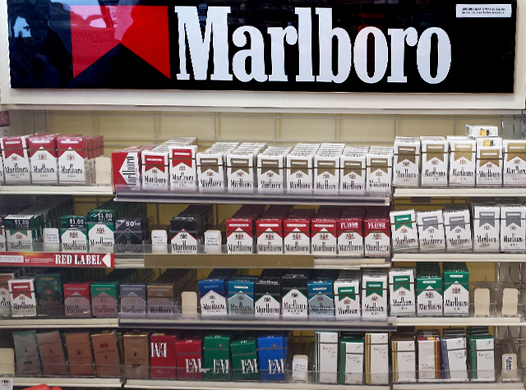

Modified

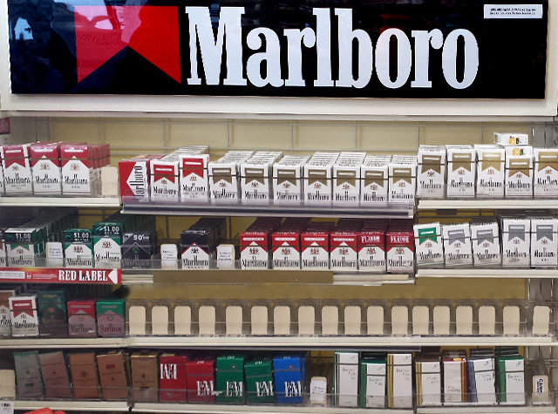

[*Page 1*]

Please describe what changed in the textbox below. Be as specific as you can.

If you didn’t notice any chance, type ‘No change.’

[*Text Box*]

W2AL2Q_textboxresponse1 W2FlickerChange1

[*Page 2*]

How difficult was it to detect the change? W2AI2Q2 W2FlickerDifficulty2

Very Easy 1 Somewhat Easy 2 Somewhat Difficult 3 Very Difficult 4

[*Page 3*]



How often do you visit stores that have displays that look like the one above? W2AI2Q3 W2FlickerStoreVisit3

Never 0

Once a month or less 1

2-3 times a month 2

Once a week 3

2-3 times a week 4

Almost every day or every day 5

[*Page 4*]

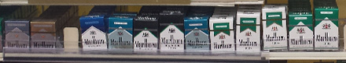

How often do you see these products at a store? W2AI2Q4 W2FlickerAdvertisementSeen4

Never 0

Once a month or less 1

2-3 times a month 2

Once a week 3

2-3 times a week 4

Almost every day or every day 5

**Additional Information:**

* There will be no practice images.
* There will be one manipulated image.
* There will be no clues or suggested fixation points.
* Each image will be displayed for 240 milliseconds followed by a black screen for 80 milliseconds. This will continue for 60 seconds.
* The original image will be displayed twice followed by the manipulated image



**Data Provided:**

* Date
* Time
* Count_cycles - counts the number of cycles started until a response occurs
* Responsepoint - determines the stimulus in the response cycle (the cycle that participant made a positive response) that was presented when participant made response: "StimA1", "flicker_AA", "StimA2", "flicker_AB", "StimB1", "flicker_BB", "StimB2", "flicker_BA" or "N/A" (if no response was given)
* Alternations - Determines the number of alternations between original and altered pictures until response occurs. Each switch between originals and altered pictures as well as each switch between altered pictures and original pictures is counted as an alternation. For each completed cycle, participants go through 2 alternations. If the response occurs AFTER the change from original to altered pic in the last cycle, one more alternation is added to the count.
* Cycle_rt - stores the combined trial latencies across the entire cycle until response occurs
* Textboxresponse - stores the open-ended response
* Textboxresponse_rt - stores the time it took participant to work on the openended response until pressing the button

**Symmetry Span Task**

**Source:** Kane, M.J., Hambrick, D.Z., Tuholski, S.W., Wilhelm, O., Payne, T.W., & Engle, R.W. (2004). The generality of working memory capacity: A latent variable approach to verbal and visuospatial memory span and reasoning. *Journal of Experimental Psychology: General, 133*, 189-217.

Heitz, R.P. & Engle, R.W. (2007). Focusing the spotlight: Individual differences in visual attention control. *Journal of Experimental Psychology: General, 136*, 217 - 240.

Redick, T.S., Broadway, J.M., Meier, M.E., Kuriakose, P.S., Unsworth, N., Kane, M.J., Engle, R.W. (2012). Measuring working memory capacity with automated complex span tasks. *European Journal of Psychological Assessment, 28*(3), 164-171.

**Designed For:** Adolescents

**Psychometrics:** Cronbach’s alpha = .76 and test-retest reliability r = .77

**Items:**

W2BFQ

**Scoring:** The program reports five values at the conclusion of the experiment.

The first, SSPAN score, uses the traditional "absolute sspan" scoring method. It is the sum of all perfectly recalled sets. So, for example, if an individual recalled correctly 2 squares in a set size of 2, 3 squares in a set size of 3, and 3 squares in a set size of 4, their SSPAN score would be 5 (2 + 3 + 0).

Total number correct is the total number of squares recalled in the correct position (2 + 3 + 3 = 8 in the above example).

Symmetry errors are reported as total number of errors, accuracy errors where the subject solved the operation incorrectly, and speed errors in which the subject ran out of time in attempting to solve a given operation.

**Instructions:**

#### *Screen One*

In this task, squares will appear on the screen one at a time. Try to remember where each square is on the screen.

FIRST SCREEN SECOND SCREEN

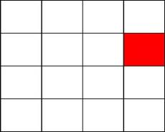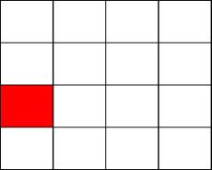

Your job is to select each square in the order it appears.

Click NEXT at the bottom right of the screen when you finish selecting the squares.

If you forget one, click BLANK to mark that position.

Click CLEAR if you need to start over.

It is very important to select the squares in the same order you saw them.

Click the mouse button to try some practice problems.

#### *Screen Two*

Now you will have to decide if different pictures are symmetrical. A picture is symmetrical if you can fold it in half and the picture on the left lines up with the picture on the right. Below are two examples.

SYMMETRICAL NOT SYMMETRICAL

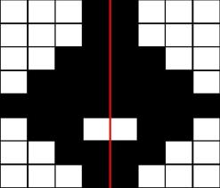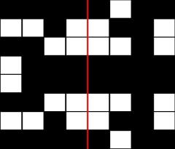

If the picture is symmetrical click YES.

If the picture is NOT symmetrical click NO.

The computer will tell you if you made the right choice.

Click the mouse button to try some practice problems.

#### *Screen Three*

Now you will practice doing both parts of the task at the same time.

The computer will automatically move to the next screen if you take too long.

It is VERY important to solve the problems as quickly and as accurately as possible.

A red number will appear in the top right of the screen. This indicates your percent correct on the symmetry part of the task. Keep this percentage as high as possible while doing your best to get the squares in the correct order.

Click the mouse to try some practice problems.

#### *Screen Four*

That is the end of the practice.

The real task will be just like the practice, but it will be longer and may be harder.

It is important that you do your best.

Click the mouse to begin the task.

#### *Final Screen*

This concludes this task.

Click the mouse to continue.

#### Example:

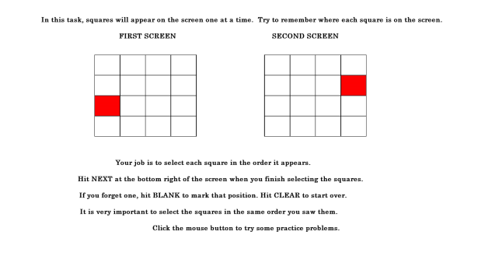

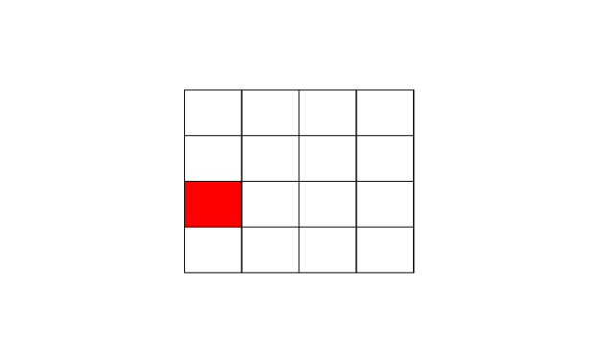

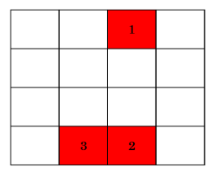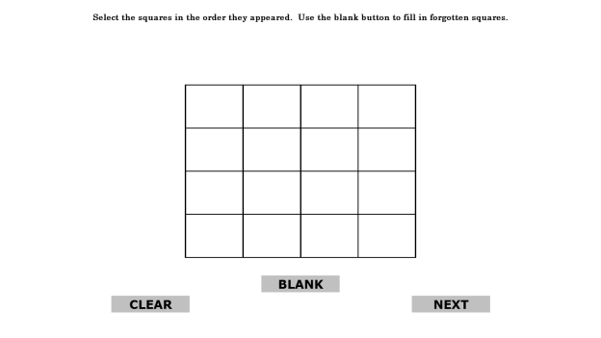

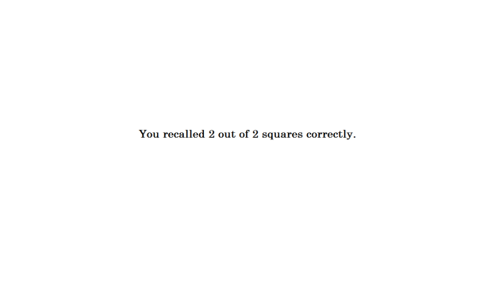

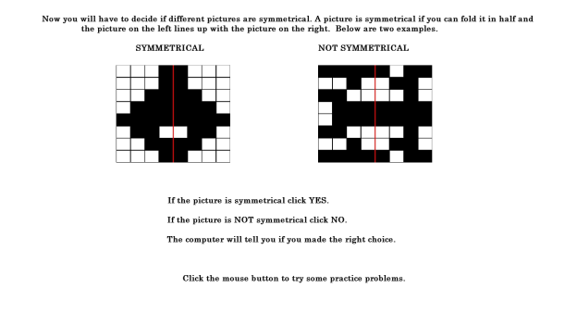

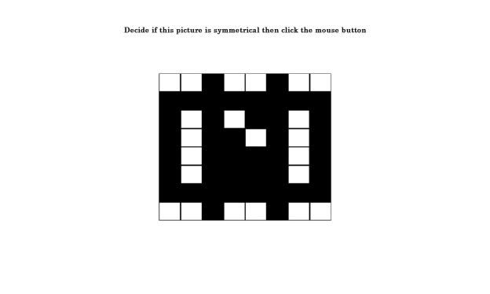

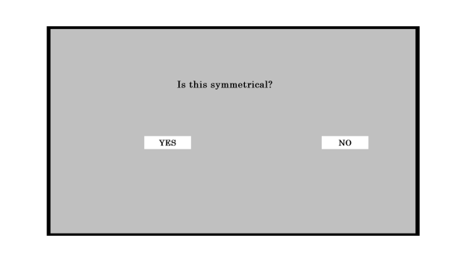

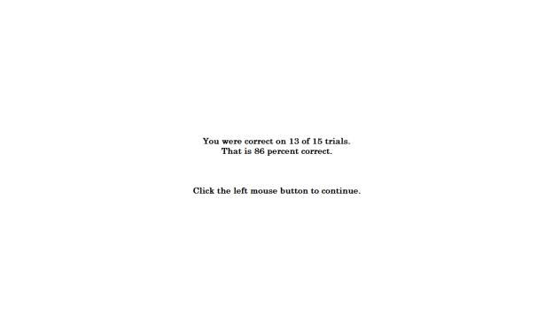

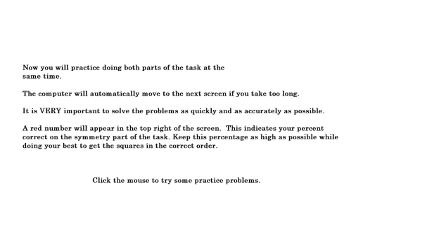

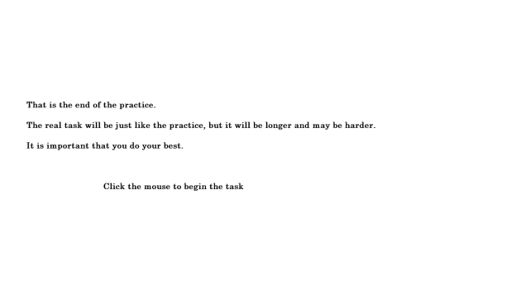

**Go/No-Go Task**

**Source:** Fillmore, M.T., Ostling, E.W., Martin, C.A., Kelly, T.H. (2009). Acute effects of alcohol on inhibitory control and information processing in high and low sensation-seekers. *Drug and Alcohol Dependence, 100*(1-2), 91-99.

Fillmore, M.T., Rush, C.R., and Hays, L. (2006). Acute effects of cocaine in two models of inhibitory control: Implications of non-linear dose effects. Addiction, 101, 1323-1332.

Finn, P.R., Justus, A., Mazas, C., Steinmetz, J.E. (1999). Working memory, executive processes and the effects of alcohol on Go/No-go learning: Testing a model of behavioral regulation and impulsivity. *Psychopharmacology, 146*(4), 465-472.

Mostofsky, S.H., Simmonds, D.J. (2008). Response inhibition and response selection: Two sides of the same coin. *Journal of Cognitive Neuroscience, 20*(5), 751-761.

Simmonds, D.J., Pekar, J.J., Mostofsky, S.H. (2008).Meta-analysis of go/no-go tasks demonstrating that fMRI activation associated with response inhibition is task-dependent. *Neuropsychologia, 46*(1), 224-232.

Weafer, J., Fillmore, M.T., & Milich, R. (2009). Increased sensitivity to the disinhibiting effects of alcohol in adults with ADHD. *Experimental And Clinical Psychopharmacology*, *17*(2), 113-121.

Little, T.D., Cunningham, W.A., Shahar, G., & Widaman, K.F. (2002). To parcel or not to parcel: Exploring the question, weighing the merits. *Structural Equation Modeling*, *9*(2), 151-173.

**Designed For:** Adults and Adolescents

**Items:**

W2BGQ

**Instructions:**

The next task will ask you to respond as quickly as possible while making as few errors as possible.

Please do the best that you can.

Please place your finger on the spacebar.

First, you will see a plus sign in the middle of the screen.

Then you will see an empty rectangle.

Next the rectangle will fill with a color.

When you see the color GREEN, press the spacebar.

When you see the color BLUE, DO NOT press the spacebar.

Respond as quickly as possible and make as few errors as possible.

If you make a mistake the screen will say ‘Incorrect’.

The task takes about 10 minutes to complete.

**Additional Information:**

* There will be 0 practice trials.
* There will be 160 trials for the main task.
* The fixation point, i.e. the plus sign, will be displayed for 500 milliseconds.
* The cue, a blank rectangle, will be displayed for 100 milliseconds, 200 milliseconds, 300 milliseconds, 400 milliseconds, or 500 milliseconds.
* A Go cue, i.e. a green rectangle, will be displayed for 1000 milliseconds 70% of the time.
* A No-Go cue, i.e. a blue rectangle, will be displayed for 1000 milliseconds 30% of the time.
* The orientation of the rectangle, i.e. horizontal or vertical, will signal the probability that a go or no-go cue will be displayed.
  + Vertical rectangles precede a Go cue 70% of the time.
  + Horizontal rectangles precede a No-Go cue 70% of the time.
  + Vertical rectangles were presented 50% of the time.
  + Horizontal rectangles were presented 50% of the time.
* After the trial is complete, a blank screen will be displayed for 300 milliseconds.
* There will be no breaks.
* If a participant presses a key in response to a Go cue, the reaction time in milliseconds will be displayed for 500 milliseconds.
* If a study participant presses a key in response to a No Go cue, the word ‘Incorrect’ will appear for 500 milliseconds.
* If a study participant does not respond after 1000 milliseconds, the word ‘Incorrect’ will appear for 500 milliseconds.

**65% Update**

[*A 65% Progress Bar Will Be Shown Here*]

Your Progress

Nice work! You have completed all of the tasks in the survey. From here, all you have to do is answer a series of questions.

Remember that your opinion matters. Be as honest as possible. Your answers will be kept confidential.

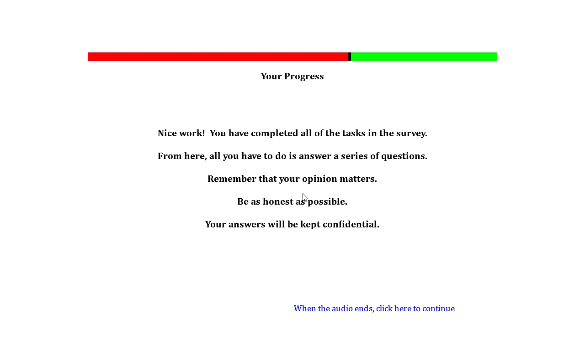

**Short Form Smoking Consequences Questionnaire (S-SCQ)**

**Source:** Myers, M.G., MacPherson, L., McCarthy, D.M., & Brown, S.A. (2003). Constructing a short form of the Smoking Consequences Questionnaire with adolescents and young adults. *Psychological* *Assessment*, *15*(2), 163-172.

Penzes, M., Czégledi, E., Balázs, P., & Foley, K.L. (2012). Factors associated with tobacco smoking and the belief about weight control effect of smoking among hungarian adolescents. *Cent Eur J Public Health, 20*, 11-17.

Urbán, R., & Demetrovics, Z. (2010). Smoking outcome expectancies: A multiple indicator and multiple cause (MIMIC) model. *Addictive Behaviors*, *35*(6), 632-635.

Urbán, R. (2010). Smoking outcome expectancies mediate the association between sensation seeking, peer smoking, and smoking among young adolescents. *Nicotine & Tobacco Research*, *12*(1), 59-68.

Response options are based on Ajzen, I. & Fishbein, M. (1980). *Understanding Attitudes and Predicting Social Behavior.* Englewood Cliffs, NJ: Prentice-Hall, Inc.

**Designed For:** Use with adolescents and young adults, derived from Smoking Consequences Questionnaire (Brandon & Baker, 1991)

**Psychometrics:** Internal consistencies for four-factor model solution: Negative Consequences (.84), Negative Reinforcement (.92), Positive Reinforcement (.95), and Appetite-Weight Control (.93)

**Codebook:**For each statement, please indicate how LIKELY or UNLIKELY you believe each statement is for you when you smoke. If you have never smoked, answer according to your personal beliefs, regardless of what other people might think.

1. Cigarettes taste good. W2BHQ1 W2OutExpecPosRe1

Extremely Likely 5 Somewhat Likely 4 Neutral 3 Somewhat Unlikely 2 Extremely Unlikely1

2. Smoking controls my appetite. W2BHQ2 W2OutExpecAppWeight2

Extremely Likely 5 Somewhat Likely 4 Neutral 3 Somewhat Unlikely 2 Extremely Unlikely1

3. Cigarettes help me deal with anxiety or worry. W2BHQ3 W2OutExpecNegRe3

Extremely Likely 5 Somewhat Likely 4 Neutral 3 Somewhat Unlikely 2 Extremely Unlikely1

4. I enjoy the taste sensations while smoking. W2BHQ4 W2OutExpecPosRe4

Extremely Likely 5 Somewhat Likely 4 Neutral 3 Somewhat Unlikely 2 Extremely Unlikely1

5. Smoking helps me deal with depression. W2BHQ5 W2OutExpecNegRe5

Extremely Likely 5 Somewhat Likely 4 Neutral 3 Somewhat Unlikely 2 Extremely Unlikely1

6. Cigarettes keep me from overeating. W2BHQ6 W2OutExpecAppWeight6

Extremely Likely 5 Somewhat Likely 4 Neutral 3 Somewhat Unlikely 2 Extremely Unlikely1

7. Cigarettes help me deal with anger. W2BHQ7 W2OutExpecNegRe7

Extremely Likely 5 Somewhat Likely 4 Neutral 3 Somewhat Unlikely 2 Extremely Unlikely1

8. When I smoke the taste is pleasant. W2BHQ8 W2OutExpecPosRe8

Extremely Likely 5 Somewhat Likely 4 Neutral 3 Somewhat Unlikely 2 Extremely Unlikely1

9. I will enjoy the flavor of a cigarette. W2BHQ9 W2OutExpecPosRe9

Extremely Likely 5 Somewhat Likely 4 Neutral 3 Somewhat Unlikely 2 Extremely Unlikely1

10. I will enjoy feeling a cigarette on my tongue and lips. W2BHQ10 W2OutExpecPosRe10

Extremely Likely 5 Somewhat Likely 4 Neutral 3 Somewhat Unlikely 2 Extremely Unlikely1

11. By smoking I risk heart disease and lung cancer. W2BHQ11 W2OutExpecNegCon11

Extremely Likely 5 Somewhat Likely 4 Neutral 3 Somewhat Unlikely 2 Extremely Unlikely1

12. Cigarettes help me reduce or handle tension. W2BHQ12 W2OutExpecNegRe12

Extremely Likely 5 Somewhat Likely 4 Neutral 3 Somewhat Unlikely 2 Extremely Unlikely1

13. Smoking helps me control my weight. W2BHQ13 W2OutExpecAppWeight13

Extremely Likely 5 Somewhat Likely 4 Neutral 3 Somewhat Unlikely 2 Extremely Unlikely1

14. When I'm upset with someone, a cigarette helps me cope. W2BHQ14 W2OutExpecNegRe14

Extremely Likely 5 Somewhat Likely 4 Neutral 3 Somewhat Unlikely 2 Extremely Unlikely1

15. The more I smoke, the more I risk my health. W2BHQ15 W2OutExpecNegCon15

Extremely Likely 5 Somewhat Likely 4 Neutral 3 Somewhat Unlikely 2 Extremely Unlikely1

16. Cigarettes keep me from eating more than I should. W2BHQ16 W2OutExpecAppWeight16

Extremely Likely 5 Somewhat Likely 4 Neutral 3 Somewhat Unlikely 2 Extremely Unlikely1

17. Smoking keeps my weight down. W2BHQ17 W2OutExpecAppWeight17

Extremely Likely 5 Somewhat Likely 4 Neutral 3 Somewhat Unlikely 2 Extremely Unlikely1

18. Smoking is hazardous to my health. W2BHQ18 W2OutExpecNegCon18

Extremely Likely 5 Somewhat Likely 4 Neutral 3 Somewhat Unlikely 2 Extremely Unlikely1

19. Smoking calms me down when I feel nervous. W2BHQ19 W2OutExpecNegRe19

Extremely Likely 5 Somewhat Likely 4 Neutral 3 Somewhat Unlikely 2 Extremely Unlikely1

20. When I'm angry a cigarette can calm me down. W2BHQ20 W2OutExpecNegRe20

Extremely Likely 5 Somewhat Likely 4 Neutral 3 Somewhat Unlikely 2 Extremely Unlikely1

21. Smoking is taking years off my life. W2BHQ21 W2OutExpecNegCon21

Extremely Likely 5 Somewhat Likely 4 Neutral 3 Somewhat Unlikely 2 Extremely Unlikely1

**Family and Peer Smoking**

**Source:** Items 1-4 are optional questions from:

Centers for Disease Control and Prevention (CDC). (2014a). 2012 National youth tobacco survey (NYTS). Retrieved from: <http://www.cdc.gov/TOBACCO/data_statistics/surveys/NYTS/index.htm>

Centers for Disease Control and Prevention (CDC). (2014b). 2011 Youth tobacco survey (YTS). Retrieved from: <http://www.cdc.gov/tobacco/data_statistics/surveys/yts/index.htm>

Item 1 was expanded to assess tobacco use by older brothers, older sisters, younger brothers, and younger sisters. Item 3 was added to assess the use electronic cigarettes. Item 3 was added to assess the use of smokeless tobacco. Item 4 was expanded to include smokeless tobacco, electronic cigarettes, hookah/shisha, pipe tobacco, and cigarettes combined with marijuana.

Items 5-8 are from the California Department of Public Health (CDPH). (2014). 2011-2012 California Student Tobacco Survey (CSTS). Retrieved from: <http://www.cdph.ca.gov/programs/tobacco/Pages/default.aspx>.

Item 6 was added to assess the use of smokeless tobacco. Item 7 was added to assess the use of electronic cigarettes. Item 8 was expanded to include hookah/shisha, pipe tobacco, and cigarettes combined with marijuana.

**Designed For:** Adolescents

**Psychometrics**: Not reported

**Codebook:**

[*Family*]

Please answer the following questions about your family.

1. Who in your family smokes? (check all that apply) W2BIQ8, W2FamCig1, 0 When Not Selected, 1 When Selected

No one smokes in my family W2BIQ8option1 W2FamCigNoOne1

I am the only one who smokes in my family W2BIQ8option2 W2FamCigOnlyMe1

Father (Male Guardian) W2BIQ8option3 W2FamCigDad1

Mother (Female Guardian) W2BIQ8option4 W2FamCigMom1

Older Brother W2BIQ8option5 W2FamCigOldBro1

Older Sister W2BIQ8option6 W2FamCigOldSis1

Younger Brother W2BIQ8option7 W2FamCigYoungBro1

Younger Sister W2BIQ8option8 W2FamCigYoungSis1

Grandmother / Grandfather W2BIQ8option9 W2FamCigGrandparent1

Other (please specify) W2BIQ8option10 W2FamCigOther1 ____________ W2BIQ8other W2FamCigOtherSpecify1

1. Who in your family uses chewing tobacco, snuff, or dip? (check all that apply) W2BIQ9, W2FamChew2, 0 When Not Selected, 1 When Selected

No one uses chewing tobacco, snuff, or dip in my family W2BIQ9option1 W2FamChewNoOne2

I am the only one who uses chewing tobacco, snuff, or dip in my family W2BIQ9option2 W2FamChewOnlyMe2

Father (Male Guardian) W2BIQ9option3 W2FamChewDad2

Mother (Female Guardian) W2BIQ9option4 W2FamChewMom2

Older Brother W2BIQ9option5 W2FamChewOldBro2

Older Sister W2BIQ9option6 W2FamChewOldSis2

Younger Brother W2BIQ9option7 W2FamChewYoungBro2

Younger Sister W2BIQ9option8 W2FamChewYoungSis2

Grandmother / Grandfather W2BIQ9option9 W2FamChewGrandparent2

Other (please specify) W2BIQ9option10 W2FamChewOther2 ____________ W2BIQ9other W2FamChewOtherSpecify2

[*Experience At Home*]

1. Does anyone who lives with you now…? (check all that apply) W2BIQ10, W2FamOtherTob3, 0 When Not Selected, 1 When Selected

Smoke cigarettes W2BIQ10option1 W2FamOtherTobCig3

Use electronic cigarettes, vaporizers, or vape pens W2BIQ10option2 W2FamOtherTobEcig3

Use chewing tobacco, snuff, or dip W2BIQ10option3 W2FamOtherTobChew3

Smoke cigars, cigarillos, or little cigars W2BIQ10option4 W2FamOtherTobCigar3

Smoke tobacco in a pipe W2BIQ10option5 W2FamOtherTobPipe3

Smoke cigarettes with tobacco and marijuana W2BIQ10option6 W2FamOtherTobPot3

Smoke hookah or shisha W2BIQ10option7 W2FamOtherTobHookah3

Use any other form of tobacco W2BIQ10option8 W2FamOtherNew3

No one who lives with me now uses any form of tobacco W2BIQ10option9 W2FamOtherTobNoOne3

[*Peer*]

Please answer the following questions about your friends.

1. How many of your four closest friends smoke cigarettes? W2BIQ4, W2FriendCig5

None 0

One 1

Two 2

Three 3

Four 4

Not sure -7

1. How many of your four closest friends use chewing tobacco, snuff, or dip? W2BIQ5, W2FriendChew6

None 0

One 1

Two 2

Three 3

Four 4

Not sure -7

1. How many of your four closest friends use electronic cigarettes, vaporizers, or vape pens? W2BIQ6, W2FriendECig7

None 0

One 1

Two 2

Three 3

Four 4

Not sure -7

1. Do any of your four closest friends…? (check all that apply) W2BIQ7, W2FriendOtherTob8, 0 When Not Selected, 1 When Selected

Smoke cigars, cigarillos, or little cigars W2BIQ7option1 W2FriendOtherTobCigar8

Smoke tobacco in a pipe W2BIQ7option2 W2FriendOtherTobPipe8

Smoke cigarettes with tobacco and marijuana W2BIQ7option3 W2FriendOtherTobPot8

Smoke hookah or shisha W2BIQ7option4 W2FriendOtherTobHookah8

Use any other form of tobacco W2BIQ7option5 W2FriendOtherTobNew8

My four closest friends do not use any form of tobacco W2BIQ7option6 W2FriendOtherNoOne8

**Injunctive Norms**

**Source:** Questions are based on Wilkinson, D., & Abraham, C. (2004). Constructing an integrated model of the antecedents of adolescent smoking. *British Journal Of Health Psychology, 9*(3), 315-333.

Response options are based on Ajzen, I. & Fishbein, M. (1980). *Understanding Attitudes and Predicting Social Behavior.* Englewood Cliffs, NJ: Prentice-Hall, Inc.

**Designed For:** Adolescents (Ages 13-14)

**Psychometrics:** Cronbach’s alpha = .81.

**Codebook:**

Please answer the following questions about your friends and family.

1. How likely is it that your MOTHER would NOT want you to smoke? W2BJQ1 W2InjNormMom1

Extremely Likely 1 Somewhat Likely 2 Neutral 3 Somewhat Unlikely 4 Extremely Unlikely 5

1. How likely is it that your FATHER would NOT want you to smoke? W2BJQ2 W2InjNormDad2

Extremely Likely 1 Somewhat Likely 2 Neutral 3 Somewhat Unlikely 4 Extremely Unlikely 5

1. How likely is it that your SISTER(S) would NOT want you to smoke? W2BJQ3 W2InjNormSis3

Extremely Likely 1 Somewhat Likely 2 Neutral 3 Somewhat Unlikely 4 Extremely Unlikely 5

1. How likely is it that your BROTHER(S) would NOT want you to smoke? W2BJQ4 W2InjNormBro4

Extremely Likely 1 Somewhat Likely 2 Neutral 3 Somewhat Unlikely 4 Extremely Unlikely 5

1. How likely is it that your RELATIVES would NOT want you to smoke? W2BJQ5 W2InjNormRelatives5

Extremely Likely 1 Somewhat Likely 2 Neutral 3 Somewhat Unlikely 4 Extremely Unlikely 5

1. How likely is it that your FRIENDS would NOT want you to smoke? W2BJQ6 W2InjNormFriends6

Extremely Likely 1 Somewhat Likely 2 Neutral 3 Somewhat Unlikely 4 Extremely Unlikely 5

1. How likely is it that your PEERS would NOT want you to smoke? W2BJQ7 W2InjNormPeers7

Extremely Likely 1 Somewhat Likely 2 Neutral 3 Somewhat Unlikely 4 Extremely Unlikely 5

**Media Exposure**

**Source:** Item 9 was adapted from Eynon, R., & Malmberg, L-E. (2011). A typology of young people's Internet use: Implications for education. *Computers & Education*, 585-595.

Items 15 and 16 was adapted from Unger, J.B., Cruz, T., Schuster, D., Flora, J.A., & Johnson, C. (2001). Measuring exposure to pro- and anti-tobacco marketing among adolescents: Intercorrelations among measures and associations with smoking status. *Journal Of Health Communication, 6*(1), 11-29.

All other items were adapted from:

Centers for Disease Control and Prevention (CDC). (2014a). 2012 National youth tobacco survey (NYTS). Retrieved from: <http://www.cdc.gov/TOBACCO/data_statistics/surveys/NYTS/index.htm>

Centers for Disease Control and Prevention (CDC). (2014b). 2011 Youth tobacco survey (YTS). Retrieved from: <http://www.cdc.gov/tobacco/data_statistics/surveys/yts/index.htm>

**Designed For:** Adolescents

**Psychometrics**: No psychometrics were reported

**Codebook:**

Please answer the following questions.

1. During the past 30 days, about how often have you seen ADS OR PROMOTIONS FOR tobacco products at convenience stores, supermarkets, or gas stations? W2BKQ1 W2MediaPOSAds1

None 0

1-3 times in the past 30 days 1

1-3 times per week 2

Daily or almost daily 3

More than once a day 4

1. During the past 30 days, about how often have you seen WARNING SIGNS ABOUT UNDERAGE PURCHASES of tobacco products at convenience stores, supermarkets, or gas stations? W2BKQ2 W2MediaPOSPurchaseWarning2

None 0

1-3 times in the past 30 days 1

1-3 times per week 2

Daily or almost daily 3

More than once a day 4

1. During the past 30 days, about how often have you seen ADS, COMMERCIALS, OR SIGNS ABOUT NOT using tobacco products? W2BKQ3 W2MediaAnti3

None 0

1-3 times in the past 30 days 1

1-3 times per week 2

Daily or almost daily 3

More than once a day 4

1. During the past 30 days, about how often have you seen POSTERS OR SIGNS FOR tobacco products (cigarettes, electronic cigarettes, vape pens, cigars, chewing tobacco, etc.)? W2BKQ4 W2MediaProPoster4

None 0

1-3 times in the past 30 days 1

1-3 times per week 2

Daily or almost daily 3

More than once a day 4

1. During the past 30 days, about how often have you seen ads in NEWSPAPERS OR MAGAZINES FOR tobacco products? W2BKQ5 W2MediaProMag5

None 0

1-3 times in the past 30 days 1

1-3 times per week 2

Daily or almost daily 3

More than once a day 4

1. During the past 30 days, about how often have you seen TELEVISION ADS FOR tobacco products? W2BKQ6 W2MediaProTV6

None 0

1-3 times in the past 30 days 1

1-3 times per week 2

Daily or almost daily 3

More than once a day 4

1. During the past 30 days, about how often have you heard RADIO ADS FOR tobacco products? W2BKQ7 W2MediaProRadio7

None 0

1-3 times in the past 30 days 1

1-3 times per week 2

Daily or almost daily 3

More than once a day 4

1. During the past 30 days, about how often have you seen ADS ONLINE FOR tobacco products? W2BKQ8 W2MediaProWeb8

None 0

1-3 times in the past 30 days 1

1-3 times per week 2

Daily or almost daily 3

More than once a day 4

1. During the past 30 days, where did you see ADS ONLINE FOR tobacco products? (Check all that apply) W2BKQ9 W2MediaProWeb9, 0 When Not Selected, 1 When Selected

Social Networks (Facebook, myspace, Instagram, etc.) W2BKQ9option1 W2MediaProWebSocialNet9

Email (Gmail, Yahoo mail, Hotmail, etc.) W2BKQ9option2 W2MediaProWebEmail9

Forums (Xual, Ultimate Teen Forums, All About Goldfish, etc.) W2BKQ9option3 W2MediaProWebForums9

Search Engine (Google, Yahoo, Ask, etc.) W2BKQ9option4 W2MediaProWebSearch9

Online Shopping (Amazon, Ebay, Overstock, etc.) W2BKQ9option5 W2MediaProWebShopping9

Video Streaming (YouTube, Vimeo, DailyMotion, etc.) W2BKQ9option6 W2MediaProWebVideo9

Music Streaming (Pandora, Spotify, Grooveshark, etc.) W2BKQ9option7 W2MediaProWebMusic9

Download sites (Vertor, Take.FM, ThePirateBay, etc.) W2BKQ9option8 W2MediaProWebDownload9

Blogs (Blog.com, Wordpress, Blogger, etc.) W2BKQ9option9 W2MediaProWebBlog9

Wikis (Wikipedia, Wiktionary, ZineWiki, etc.) W2BKQ9option10 W2MediaProWebWiki9

Podcasts (Teen Talk, TBTL, NLCast, etc.) W2BKQ9option11 W2MediaProWebPodcast9

None of the above W2BKQ9option12 W2MediaProWebNone9

1. During the past 30 days, did you receive coupons from a tobacco company through… (Check all that apply) W2BKQ10 W2MediaCoupons10, 0 When Not Selected, 1 When Selected

The mail W2BKQ10option1 W2MediaCouponsMail10

E-mail W2BKQ10option2 W2MediaCouponsEmail10

The Internet W2BKQ10option3 W2MediaCouponsInternet10

A text message W2BKQ10option4 W2MediaCouponsText10

A cigarette pack or other tobacco product W2BKQ10option5 W2MediaCouponsCigPack10

I did not receive coupons from a tobacco company W2BKQ10option6 W2MediaCouponsNever10

1. How often do you see celebrities (movie stars, musicians, athletes, etc.) using tobacco products in the media or face-to-face? W2BKQ11 W2MediaCeleb11

Never 0

Less than half the time 1

About half the time 2

More than half the time 3

All the time 4

1. What are the brand names of your favorite cigarette ads? (Check all that apply) W2BKQ12 W2MediaCigBrand12, 0 When Not Selected, 1 When Selected

American Spirit W2BKQ12option1 W2MediaCigBrandSpirit12

Camel W2BKQ12option2 W2MediaCigBrandCamel12

GPC, Basic, or Doral W2BKQ12option3 W2MediaCigBrandGPC12

Kool W2BKQ12option4 W2MediaCigBrandKool12

Lucky Strike W2BKQ12option5 W2MediaCigBrandLucky12

Marlboro W2BKQ12option6 W2MediaCigBrandMarlboro12

Newport W2BKQ12option7 W2MediaCigBrandNewport12

Parliament W2BKQ12option8 W2MediaCigBrandParliament12

Summit W2BKQ12option9 W2MediaCigBrandFake12

Virginia Slims W2BKQ12option10 W2MediaCigBrandVirginia12

I don’t have any favorite cigarette ads W2BKQ12option11 W2MediaCigBrandNone12

Another brand (please specify): W2BKQ12option12 W2MediaCigBrandOther12__________ W2BKQ12other W2MediaCigBrandOtherSpecify12

1. What are the brand names of your favorite electronic cigarette ads? (Check all that apply) W2BKQ13 W2MediaECigBrand13, 0 When Not Selected, 1 When Selected

Blu W2BKQ13option1 W2MediaECigBrandBlu13

Green Smart Living W2BKQ13option2 W2MediaECigBrandGreen13

MarkTen W2BKQ13option3 W2MediaECigBrandMarkTen13

NJOY W2BKQ13option4 W2MediaECigBrandNJOY13

Xcite W2BKQ13option5 W2MediaECigBrandFake13

Square W2BKQ13option6 W2MediaECigBrandSquare13

Vuse W2BKQ13option7 W2MediaECigBrandVuse13

V2 W2BKQ13option8 W2MediaECigBrandVTwo13

I don’t have any favorite electronic cigarette ads W2BKQ13option9 W2MediaECigBrandNone13

Another brand (please specify): W2BKQ13option10 W2MediaECigBrandOther13 _______ W2BKQ13other W2MediaECigBrandOtherSpecify13

1. What are the brand names of your favorite chewing tobacco, snuff, or dip ads? (Check all that apply) W2BKQ14 W2MediaChewBrand14, 0 When Not Selected, 1 When Selected

Beechnut W2BKQ14option1 W2MediaChewBrandBeechnut14

Back Country W2BKQ14option2 W2MediaChewBrandFake14

Copenhagen W2BKQ14option3 W2MediaChewBrandCopen14

Grizzly W2BKQ14option4 W2MediaChewBrandGrizzly14

Kodiak W2BKQ14option5 W2MediaChewBrandKodiak14

Levi Garrett W2BKQ14option6 W2MediaChewBrandLevi14

Longhorn W2BKQ14option7 W2MediaChewBrandLonghorn14

Red Man W2BKQ14option8 W2MediaChewBrandRedman14

Skoal W2BKQ14option9 W2MediaChewBrandSkoal14

I don’t have any favorite chewing tobacco, snuff, or dip ads W2BKQ14option10 W2MediaChewBrandNone14

Another brand (please specify): W2BKQ14option11 W2MediaChewBrandOther14

_______ W2BKQ14other W2MediaChewBrandOtherSpecify14

1. How often do you see other young people wearing clothing or carrying gear, like t-shirts, lighters, gym bags, hats, or sunglasses that have a tobacco company name or picture on it? W2BKQ15 W2MediaWearBrand15

Never 0

Less than half the time 1

About half the time 2

More than half the time 3

All the time 4

1. How many items do you own that have a tobacco company name or picture on it? W2BKQ16 W2MediaOwnBrand16

___________

**Prevention Program Exposure**

**Source:** Item 1 is adapted from the California Healthy Kids Resource Center (2014). Research Validated Programs: R-V Tobacco. Retrieved From: <http://www.californiahealthykids.org/rvtobacco>.

Item 2 is from Centers for Disease Control and Prevention (CDC). (2014). 2012 National youth tobacco survey (NYTS). Retrieved from: <http://www.cdc.gov/TOBACCO/data_statistics/surveys/NYTS/index.htm>.

**Designed For:** Adolescents

**Psychometrics:** No psychometrics were reported

**Codebook:**

1. Have you received any of the following health programs in the past year? (check all that apply) W2BLQ1 W2PrevProg1

Butt Out Now W2BLQ1option1 W2PrevProgTobIndusButtOut1

DARE W2BLQ1option2 W2PrevProgNotValidDare1

Empowering Discipline W2BLQ1option3 W2PrevProgNotValidEmpower1

HERE'S LOOKING AT YOU W2BLQ1option4 W2PrevProgNotValidLookYou1

In It to Win It W2BLQ1option5 W2PrevProgFake1

Keepin’ it REAL W2BLQ1option6 W2PrevProgResValidREAL1

LifeSkills Training W2BLQ1option7 W2PrevProgResValidLifeSkills1

McGruff W2BLQ1option8 W2PrevProgNotValidMcGruff1

Minnesota Smoking Prevention Program W2BLQ1option9 W2PrevProgResValidMinn1

Project ALERT W2BLQ1option10 W2PrevProgResValidALERT1

Project Northland W2BLQ1option11 W2PrevProgResValidNorthland1

Project SUCCESS W2BLQ1option12 W2PrevProgResValidSUCCESS1

Project Towards No Drug Abuse W2BLQ1option13 W2PrevProgResValidTND1

Project Towards No Tobacco Use W2BLQ1option14 W2PrevProgResValidTNT1

QUEST W2BLQ1option15 W2PrevProgNotValidQUEST1

Reconnecting Youth W2BLQ1option16 W2PrevProgResValidReconnect1

Red Ribbon Week W2BLQ1option17 W2PrevProgNotValidRedRibbon1

Residential Student Assistance Program W2BLQ1option18 W2PrevProgResValidResStudent1

Right Decisions, Right Now W2BLQ1option19 W2PrevProgTobIndusRightNow1

State-Wide Indian Drug Prevention Program W2BLQ1option20 W2PrevProgResValidIndian1

Think. Don’t Smoke W2BLQ1option21 W2PrevProgTobIndusThink1

Tobacco is Whacko If You’re A Teen W2BLQ1option22 W2PrevProgTobIndusWhacko1

Wake Up, Live Big, Be Smoke Free W2BLQ1option23 W2PrevProgTobIndusWakeUp1

None of the above W2BLQ1option24 W2PrevProgNone1

Other (please specify) W2BLQ1option25 W2PrevProgOther1 ____________ W2BLQ1other W2PrevProgOtherSpecify1

1. In the past 12 months, did you do any of the following to help you quit using tobacco? (Check all that apply) W2BLQ2 W2PrevQuitType2

I did not use tobacco of any kind during the past 12 months W2BLQ2option1 W2PrevQuitTypeDidNotUse2

I did not try to quit during the past 12 months W2BLQ2option2 W2PrevQuitTypeDidNotTry2

Attended a program at my school W2BLQ2option3 W2PrevQuitTypeSchool2

Attended a program in the community W2BLQ2option4 W2PrevQuitTypeCommunity2

Called a telephone help line or telephone quit line W2BLQ2option5 W2PrevQuitTypePhone2

Used nicotine gum W2BLQ2option6 W2PrevQuitTypeGum2

Used nicotine patch W2BLQ2option7 W2PrevQuitTypePatch2

Used medicine to help quit W2BLQ2option8 W2PrevQuitTypeMed2

Used electronic cigarettes, vaporizers, or vape pens W2BLQ2option9 W2PrevQuitTypeEcig2

Visited an Internet quit site W2BLQ2option10 W2PrevQuitTypeInternet2

Got help from family or friends W2BLQ2option11 W2PrevQuitTypeFamily2

Used another method such as hypnosis or acupuncture W2BLQ2option12 W2PrevQuitTypeAltMed2

Tried to quit on my own or quit “cold turkey” W2BLQ2option13 W2PrevQuitTypeTurkey2

**75% Update**

[*A 75% Progress Bar Will Be Shown Here*]

Your Progress

Great job! You are getting close to the end of the survey. At that time, you will receive a code that will allow you to claim your gift card.

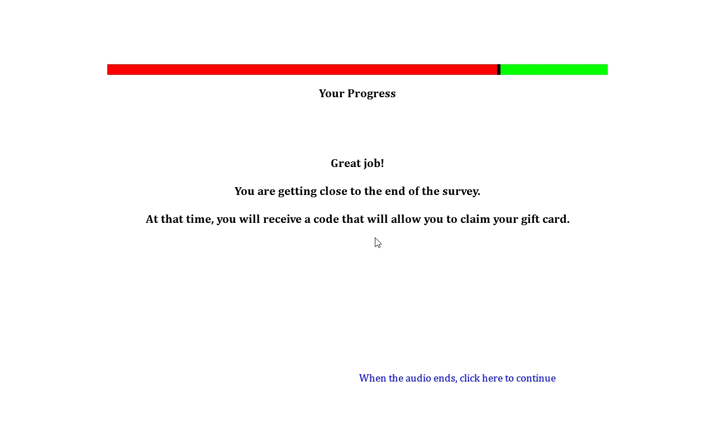

**Drug Use Frequency Scale**

**Source:** Items 17 and 18 developed based on D. Paul Moberg, Center for Health Policy and Program Evaluation, University of Wisconsin Medical School. Adapted with permission from Mayer, J., Filstead, W.J. (1979). The Adolescent Alcohol Involvement Scale. An instrument for measuring adolescents' use and misuse of alcohol. *Journal of Studies on Alcohol, 40*(3), 291-300.

The definition of drinks was provided by Johnston, L.D., O’Malley, P.M., Bachman, J.G., & Schulenberg, J.E. (2014) 2011 Monitoring the future survey (MTF). Retrieved from <http://www.monitoringthefuture.org/>. Ann Arbor: Institute for Social Research, The University of Michigan.

Items 18-20 were developed for the first time for this study.

All other items adapted from Graham, J.W., Flay B.R., Johnson, C.A., Hansen, W.B., Grossman, L., Sobel, J.L. (1984) Reliability of self-report measures of drug use in prevention research: Evaluation of the Project SMART questionnaire via the test-retest reliability matrix. *Journal of Drug Education, 14*, 75–193.

It should also be noted that this measure can be used to identify polysubstance users. Polysubstance use is typically defined as the consumption of multiple drugs in the past 30 days according to Moss, H.B., Chen, C.M., Yi, H.Y. (2014). Early adolescent patterns of alcohol, cigarettes, and marijuana polysubstance use and young adult substance use outcomes in a nationally representative sample. *Drug and Alcohol Dependence, 136*(1), 51-62.

**Designed For:** Adolescents

**Psychometrics:** Coefficient Alphas range from .60 to .86. Across Time Coefficient Alphas range from .52 to .80

**Codebook:**

Please answer each of the following questions about tobacco, alcohol, and other drug use.

About how many times have you used each of the drugs below in the PAST YEAR? Select your answer for each drug.

|  |  |  |  |  |  |  |  |  |  |  |  |
| --- | --- | --- | --- | --- | --- | --- | --- | --- | --- | --- | --- |
|  | 0 | 1-10 times | 11-20 times | 21-30 times | 31-40 times | 41-50 times | 51-60 times | 61-70 times | 71-80 times | 81-90 times | 91+ times |
| *1. Cigarettes*  W2BMQ1 W2DrugYearCig1 | ❑0 | ❑1 | ❑2 | ❑3 | ❑4 | ❑5 | ❑6 | ❑7 | ❑8 | ❑9 | ❑10 |
| *2. Electronic Cigarettes, Vaporizers, or Vape Pens*  W2BMQ2 W2DrugYearEcig2 | ❑0 | ❑1 | ❑2 | ❑3 | ❑4 | ❑5 | ❑6 | ❑7 | ❑8 | ❑9 | ❑10 |
| *3. Cigars, Cigarillos, or Little Cigars*  W2BMQ3W2DrugYearCigar3 | ❑0 | ❑1 | ❑2 | ❑3 | ❑4 | ❑5 | ❑6 | ❑7 | ❑8 | ❑9 | ❑10 |
| *4. Chewing Tobacco, Snuff, or Dip*  W2BMQ4 W2DrugYearChew4 | ❑0 | ❑1 | ❑2 | ❑3 | ❑4 | ❑5 | ❑6 | ❑7 | ❑8 | ❑9 | ❑10 |
| *5. Alcohol (beer, wine, wine coolers, liquor)*  W2BMQ5 W2DrugYearAlco5 | ❑0 | ❑1 | ❑2 | ❑3 | ❑4 | ❑5 | ❑6 | ❑7 | ❑8 | ❑9 | ❑10 |

About how many times have you used each of the drugs below in the PAST YEAR?

|  |  |  |  |  |  |  |  |  |  |  |  |
| --- | --- | --- | --- | --- | --- | --- | --- | --- | --- | --- | --- |
|  | 0 | 1-10 times | 11-20 times | 21-30 times | 31-40 times | 41-50 times | 51-60 times | 61-70 times | 71-80 times | 81-90 times | 91+ times |
| *6. Marijuana (weed, grass, pot, chronic)*  W2BMQ6 W2DrugYearPot6 | ❑0 | ❑1 | ❑2 | ❑3 | ❑4 | ❑5 | ❑6 | ❑7 | ❑8 | ❑9 | ❑10 |
| *7. Cocaine or crack*  W2BMQ7 W2DrugYearCoke7 | ❑0 | ❑1 | ❑2 | ❑3 | ❑4 | ❑5 | ❑6 | ❑7 | ❑8 | ❑9 | ❑10 |
| *8. Caffeine (coffee, energy drinks, soda, NoDoz pills)*  W2BMQ8 W2DrugYearCaff8 | ❑0 | ❑1 | ❑2 | ❑3 | ❑4 | ❑5 | ❑6 | ❑7 | ❑8 | ❑9 | ❑10 |
| *9. Ecstasy (“E”)*  W2BMQ9 W2DrugYearE9 | ❑0 | ❑1 | ❑2 | ❑3 | ❑4 | ❑5 | ❑6 | ❑7 | ❑8 | ❑9 | ❑10 |
| *10. Hallucinogens (LSD, PCP, peyote, mushrooms)*  W2BMQ10 W2DrugYearLSD10 | ❑0 | ❑1 | ❑2 | ❑3 | ❑4 | ❑5 | ❑6 | ❑7 | ❑8 | ❑9 | ❑10 |
| *11. Methamphetamine (speed, crank, ice, crystal meth)*  W2BMQ11 W2DrugYearMeth11 | ❑0 | ❑1 | ❑2 | ❑3 | ❑4 | ❑5 | ❑6 | ❑7 | ❑8 | ❑9 | ❑10 |

About how many times have you used each of the drugs below in the PAST YEAR?

|  |  |  |  |  |  |  |  |  |  |  |  |
| --- | --- | --- | --- | --- | --- | --- | --- | --- | --- | --- | --- |
|  | 0 | 1-10 times | 11-20 times | 21-30 times | 31-40 times | 41-50 times | 51-60 times | 61-70 times | 71-80 times | 81-90 times | 91+ times |
| *12. Inhalants or vapors (poppers, rush, nitrous, gas, paint, glues)*  W2BMQ14 W2DrugYearInhal14 | ❑0 | ❑1 | ❑2 | ❑3 | ❑4 | ❑5 | ❑6 | ❑7 | ❑8 | ❑9 | ❑10 |
| *13. Other club/party drugs (special K, ketamine, Rohypnol, GHB)*  W2BMQ15 W2DrugYearClub15 | ❑0 | ❑1 | ❑2 | ❑3 | ❑4 | ❑5 | ❑6 | ❑7 | ❑8 | ❑9 | ❑10 |

About how many times have you used each of the drugs below in the PAST YEAR? (without a doctor telling you to take them, or taking more than a doctor told you to take).

|  |  |  |  |  |  |  |  |  |  |  |  |
| --- | --- | --- | --- | --- | --- | --- | --- | --- | --- | --- | --- |
|  | 0 | 1-10 times | 11-20 times | 21-30 times | 31-40 times | 41-50 times | 51-60 times | 61-70 times | 71-80 times | 81-90 times | 91+ times |
| *14. Tranquilizers (valium, Xanax)*  W2BMQ12 W2DrugYearTranq12 | ❑0 | ❑1 | ❑2 | ❑3 | ❑4 | ❑5 | ❑6 | ❑7 | ❑8 | ❑9 | ❑10 |
| *15. Opiates (heroin, opium, morphine, Vicodin, OxyContin)*  W2BMQ13 W2DrugYearOpiate13 | ❑0 | ❑1 | ❑2 | ❑3 | ❑4 | ❑5 | ❑6 | ❑7 | ❑8 | ❑9 | ❑10 |
| *16. Ritalin/ Adderall (addy, bennies, uppers)*  W2BMQ16 W2DrugYearRita16 | ❑0 | ❑1 | ❑2 | ❑3 | ❑4 | ❑5 | ❑6 | ❑7 | ❑8 | ❑9 | ❑10 |

17. When you drink alcohol, how much do you usually drink?

(A “drink” is a bottle of beer, a glass of wine, a wine cooler, a shot glass of liquor, a mixed drink, etc.)

W2BMQ17 W2DrugQuantAlco17

1 drink 1

2 drinks 2

3-4 drinks 3

5-9 drinks 4

10 or more drinks 5

I do not drink alcohol 0

18. When you smoke pot, how many hits do you usually take?

W2BMQ18 W2DrugQuantPot18

1 hit 1

2 hits 2

3-4 hits 3

5-9 hits 4

10 or more hits 5

I do not smoke pot 0

About how many times have you used the drugs below AT THE SAME TIME in the PAST YEAR?

|  |  |  |  |  |  |  |  |  |  |  |  |
| --- | --- | --- | --- | --- | --- | --- | --- | --- | --- | --- | --- |
|  | 0 | 1-10 times | 11-20 times | 21-30 times | 31-40 times | 41-50 times | 51-60 times | 61-70 times | 71-80 times | 81-90 times | 91+ times |
| *19. Tobacco and Alcohol*  W2BMQ19 W2DrugYearSimulTobAlco19 | ❑0 | ❑1 | ❑2 | ❑3 | ❑4 | ❑5 | ❑6 | ❑7 | ❑8 | ❑9 | ❑10 |
| *20. Tobacco and Marijuana*  W2BMQ20 W2DrugYearSimulTobPot20 | ❑0 | ❑1 | ❑2 | ❑3 | ❑4 | ❑5 | ❑6 | ❑7 | ❑8 | ❑9 | ❑10 |
| *21. Tobacco and Methamphetamine (speed, crank, ice, crystal meth)*  W2BMQ21 W2DrugYearSimulTobMeth21 | ❑0 | ❑1 | ❑2 | ❑3 | ❑4 | ❑5 | ❑6 | ❑7 | ❑8 | ❑9 | ❑10 |
| *22. Tobacco, Alcohol, and Energy Drinks (Red Bull, RockStar, Monster, etc.)*  W2BMQ25 W2DrugYearSimulTobEnergy25 | ❑0 | ❑1 | ❑2 | ❑3 | ❑4 | ❑5 | ❑6 | ❑7 | ❑8 | ❑9 | ❑10 |

In the PAST YEAR, how often did you…

|  |  |  |  |  |  |
| --- | --- | --- | --- | --- | --- |
|  | **Never** | **Less than half the time** | **About half the time** | **More than half the time** | **All the time** |
| **23. Smoke cigarettes while high or drunk on alcohol**  W2BMQ22 W2DrugYearHighAlco22 | ❑0 | ❑1 | ❑2 | ❑3 | ❑4 |
| **24. Smoke cigarettes while high on marijuana**  W2BMQ23 W2DrugYearHighPot23 | ❑0 | ❑1 | ❑2 | ❑3 | ❑4 |
| **25. Smoke cigarettes while high on methamphetamine (speed, crank, meth)**  W2BMQ24 W2DrugYearHighMeth24 | ❑0 | ❑1 | ❑2 | ❑3 | ❑4 |

Please answer each of the following questions about tobacco, alcohol, and other drug use.

About how many times have you used each of the drugs below in the PAST 30 DAYS? Select your answer for each drug.

|  |  |  |  |  |  |  |  |  |  |  |  |
| --- | --- | --- | --- | --- | --- | --- | --- | --- | --- | --- | --- |
|  | 0 | 1-10 times | 11-20 times | 21-30 times | 31-40 times | 41-50 times | 51-60 times | 61-70 times | 71-80 times | 81-90 times | 91+ times |
| *1. Cigarettes*  W2BNQ1 W2Drug30DayCig1 | ❑0 | ❑1 | ❑2 | ❑3 | ❑4 | ❑5 | ❑6 | ❑7 | ❑8 | ❑9 | ❑10 |
| *2. Electronic Cigarettes, Vaporizers, or Vape Pens*  W2BNQ2 W2Drug30DayEcig2 | ❑0 | ❑1 | ❑2 | ❑3 | ❑4 | ❑5 | ❑6 | ❑7 | ❑8 | ❑9 | ❑10 |
| *3. Cigars, Cigarillos, or Little Cigars*  W2BNQ3W2Drug30DayCigar3 | ❑0 | ❑1 | ❑2 | ❑3 | ❑4 | ❑5 | ❑6 | ❑7 | ❑8 | ❑9 | ❑10 |
| *4. Chewing Tobacco, Snuff, or Dip*  W2BNQ4 W2Drug30DayChew4 | ❑0 | ❑1 | ❑2 | ❑3 | ❑4 | ❑5 | ❑6 | ❑7 | ❑8 | ❑9 | ❑10 |
| *5. Alcohol (beer, wine, wine coolers, liquor)*  W2BNQ5 W2Drug30DayAlco5 | ❑0 | ❑1 | ❑2 | ❑3 | ❑4 | ❑5 | ❑6 | ❑7 | ❑8 | ❑9 | ❑10 |

About how many times have you used each of the drugs below in the PAST 30 DAYS?

|  |  |  |  |  |  |  |  |  |  |  |  |
| --- | --- | --- | --- | --- | --- | --- | --- | --- | --- | --- | --- |
|  | 0 | 1-10 times | 11-20 times | 21-30 times | 31-40 times | 41-50 times | 51-60 times | 61-70 times | 71-80 times | 81-90 times | 91+ times |
| *6. Marijuana (weed, grass, pot, chronic)*  W2BNQ6 W2Drug30DayPot6 | ❑0 | ❑1 | ❑2 | ❑3 | ❑4 | ❑5 | ❑6 | ❑7 | ❑8 | ❑9 | ❑10 |
| *7. Methamphetamine (speed, crank, ice, crystal meth)*  W2BNQ7 W2Drug30DayMeth7 | ❑0 | ❑1 | ❑2 | ❑3 | ❑4 | ❑5 | ❑6 | ❑7 | ❑8 | ❑9 | ❑10 |

About how many times have you used the drug below in the PAST 30 DAYS? (without a doctor telling you to take them, or taking more than a doctor told you to take).

|  |  |  |  |  |  |  |  |  |  |  |  |
| --- | --- | --- | --- | --- | --- | --- | --- | --- | --- | --- | --- |
|  | 0 | 1-10 times | 11-20 times | 21-30 times | 31-40 times | 41-50 times | 51-60 times | 61-70 times | 71-80 times | 81-90 times | 91+ times |
| *8. Ritalin/Adderall (addy, bennies, uppers)*  W2BNQ8 W2Drug30DayRita8 | ❑0 | ❑1 | ❑2 | ❑3 | ❑4 | ❑5 | ❑6 | ❑7 | ❑8 | ❑9 | ❑10 |

About how many times have you used the drugs below AT THE SAME TIME in the PAST 30 DAYS?

|  |  |  |  |  |  |  |  |  |  |  |  |
| --- | --- | --- | --- | --- | --- | --- | --- | --- | --- | --- | --- |
|  | 0 | 1-10 times | 11-20 times | 21-30 times | 31-40 times | 41-50 times | 51-60 times | 61-70 times | 71-80 times | 81-90 times | 91+ times |
| *9. Tobacco and Alcohol*  W2BNQ9 W2Drug30DaySimulTobAlco9 | ❑0 | ❑1 | ❑2 | ❑3 | ❑4 | ❑5 | ❑6 | ❑7 | ❑8 | ❑9 | ❑10 |
| *10. Tobacco and Marijuana*  W2BNQ10 W2Drug30DaySimulTobPot10 | ❑0 | ❑1 | ❑2 | ❑3 | ❑4 | ❑5 | ❑6 | ❑7 | ❑8 | ❑9 | ❑10 |
| *11. Tobacco and Methamphetamine (speed, crank, ice, crystal meth)*  W2BNQ11 W2Drug30DaySimulTobMeth11 | ❑0 | ❑1 | ❑2 | ❑3 | ❑4 | ❑5 | ❑6 | ❑7 | ❑8 | ❑9 | ❑10 |
| *12. Tobacco, Alcohol, and Energy Drinks (Red Bull, RockStar, Monster, etc.)*  W2BNQ12 W2Drug30DaySimulTobEnergy12 | ❑0 | ❑1 | ❑2 | ❑3 | ❑4 | ❑5 | ❑6 | ❑7 | ❑8 | ❑9 | ❑10 |

**Depression Anxiety Stress Scale (DASS-21)**

**Source:** Henry, J.D., & Crawford, J.R. (2005). The short-form version of the Depression Anxiety Stress Scales (DASS-21): construct validity and normative data in a large non-clinical sample. *The* *British Journal of Clinical Psychology / the British Psychological Society*, *44(2)*, 227–239.

Szabo, M. (2010). The short version of the Depression Anxiety Stress Scales (DASS-21): Factor structure in a young adolescent sample. *Journal of Adolescence, 33*(1), 1–8.

**Designed For:** Adults, Adolescents

**Psychometrics:**

Depression = .88

Anxiety = .82

Stress = .90

Total Scale = .93

**Codebook:**

Please read each statement and select an answer to indicate how much the statement applied to you *over the past week*. There are no right or wrong answers. Do not spend too much time on any statement.

1. I found it hard to wind down. W2BPQ1 W2DASSStress1

Did not apply Applied to me to some Applied to me to a considerable Applied to me very much

to me at all degree or some of the time degree, or a good part of the time or most of the time

0 1 2 3

1. I was aware of dryness of my mouth. W2BPQ2 W2DASSAnx2

Did not apply Applied to me to some Applied to me to a considerable Applied to me very much

to me at all degree or some of the time degree, or a good part of the time or most of the time

0 1 2 3

1. I couldn't seem to experience any positive feeling at all. W2BPQ3 W2DASSDep3

Did not apply Applied to me to some Applied to me to a considerable Applied to me very much

to me at all degree or some of the time degree, or a good part of the time or most of the time

0 1 2 3

1. I experienced breathing difficulty (e.g., excessively rapid breathing, breathlessness in the absence of physical exertion). W2BPQ4 W2DASSAnx4

Did not apply Applied to me to some Applied to me to a considerable Applied to me very much

to me at all degree or some of the time degree, or a good part of the time or most of the time

0 1 2 3

1. I found it difficult to work up the initiative to do things. W2BPQ5 W2DASSDep5

Did not apply Applied to me to some Applied to me to a considerable Applied to me very much

to me at all degree or some of the time degree, or a good part of the time or most of the time

0 1 2 3

1. I tended to over-react to situations. W2BPQ6 W2DASSStress6

Did not apply Applied to me to some Applied to me to a considerable Applied to me very much

to me at all degree or some of the time degree, or a good part of the time or most of the time

0 1 2 3

1. I experienced trembling (e.g., in the hands). W2BPQ7 W2DASSAnx7

Did not apply Applied to me to some Applied to me to a considerable Applied to me very much

to me at all degree or some of the time degree, or a good part of the time or most of the time

0 1 2 3

1. I felt that I was using a lot of nervous energy. W2BPQ8 W2DASSStress8

Did not apply Applied to me to some Applied to me to a considerable Applied to me very much

to me at all degree or some of the time degree, or a good part of the time or most of the time

0 1 2 3

1. I was worried about situations in which I might panic and make a fool of myself. W2BPQ9 W2DASSAnx9

Did not apply Applied to me to some Applied to me to a considerable Applied to me very much

to me at all degree or some of the time degree, or a good part of the time or most of the time

0 1 2 3

1. I felt that I had nothing to look forward to. W2BPQ10 W2DASSDep10

Did not apply Applied to me to some Applied to me to a considerable Applied to me very much

to me at all degree or some of the time degree, or a good part of the time or most of the time

0 1 2 3

1. I found myself getting agitated. W2BPQ11 W2DASSStress11

Did not apply Applied to me to some Applied to me to a considerable Applied to me very much

to me at all degree or some of the time degree, or a good part of the time or most of the time

0 1 2 3

1. I found it difficult to relax. W2BPQ12 W2DASSStress12

Did not apply Applied to me to some Applied to me to a considerable Applied to me very much

to me at all degree or some of the time degree, or a good part of the time or most of the time

0 1 2 3

1. I felt down-hearted and blue. W2BPQ13 W2DASSDep13

Did not apply Applied to me to some Applied to me to a considerable Applied to me very much

to me at all degree or some of the time degree, or a good part of the time or most of the time

0 1 2 3

1. I was intolerant of anything that kept me from getting on with what I was doing. W2BPQ14 W2DASSStress14

Did not apply Applied to me to some Applied to me to a considerable Applied to me very much

to me at all degree or some of the time degree, or a good part of the time or most of the time

0 1 2 3

1. I felt I was close to panic. W2BPQ15 W2DASSAnx15

Did not apply Applied to me to some Applied to me to a considerable Applied to me very much

to me at all degree or some of the time degree, or a good part of the time or most of the time

0 1 2 3

1. I was unable to become enthusiastic about anything. W2BPQ16 W2DASSDep16

Did not apply Applied to me to some Applied to me to a considerable Applied to me very much

to me at all degree or some of the time degree, or a good part of the time or most of the time

0 1 2 3

1. I felt I wasn't worth much as a person. W2BPQ17 W2DASSDep17

Did not apply Applied to me to some Applied to me to a considerable Applied to me very much

to me at all degree or some of the time degree, or a good part of the time or most of the time

0 1 2 3

1. I felt that I was rather touchy. W2BPQ18 W2DASSStress18

Did not apply Applied to me to some Applied to me to a considerable Applied to me very much

to me at all degree or some of the time degree, or a good part of the time or most of the time

0 1 2 3

1. I was aware of the action of my heart in the absence of physical exertion (e.g., sense of heart rate increase, heart missing a beat). W2BPQ19 W2DASSAnx19

Did not apply Applied to me to some Applied to me to a considerable Applied to me very much

to me at all degree or some of the time degree, or a good part of the time or most of the time

0 1 2 3

1. I felt scared without any good reason. W2BPQ20 W2DASSAnx20

Did not apply Applied to me to some Applied to me to a considerable Applied to me very much

to me at all degree or some of the time degree, or a good part of the time or most of the time

0 1 2 3

1. I felt that life was meaningless. W2BPQ21 W2DASSDep21

Did not apply Applied to me to some Applied to me to a considerable Applied to me very much

to me at all degree or some of the time degree, or a good part of the time or most of the time

0 1 2 3

**Head Injury**

**Source** Suhr, J.A., & Gunstad, J. (2002). ‘Diagnosis threat’: The effect of negative expectations on cognitive performance in head injury. *Journal of Clinical and Experimental Neuropsychology, 24*, 448-457.

**Designed For:** Adolescents

**Psychometrics:** Not provided

**Codebook:**

Have you experienced a concussion or a head injury in the past year where you were knocked unconscious?

W2BRQ1 W2HeadInjury1

Yes 1

No 0

**Electronic Cigarette Commercials**

**Source:** Items 1-7 are adapted from Grube, J.W., & Wallack, L. (1994). Television beer advertising and drinking knowledge, beliefs, and intentions among schoolchildren. *American Journal of Public Health, 84*(2), 254-259.

Items 13-20 were adapted from measures used to analyze the content of individual tobacco advertisements and warning signs photographed at stores near participating schools.

Items 21-25 and 27-28 are adapted from Unger, J.B., Schuster, D., Zogg, J.B., Dent, C.W., & Stacy, A.W. (2003). Alcohol advertising exposure and adolescent alcohol use: A comparison of exposure measures. *Addiction Research & Theory, 11(3)*, 177-193.

Items 29-30 are adapted from:

* Schooler, C., Feighery, E., Flora, J.A. (1996). Seventh graders’ self-reported exposure to cigarette marketing and its relationship to their smoking behavior. *American Journal of Public Health, 86(9)*, 1216–1221.
* Stacy, A.W., Zogg, J.B., Unger, J.B., & Dent, C.W. (2004). Exposure to televised alcohol ads and subsequent adolescent alcohol use. *American Journal of Health Behavior, 28(6)*, 498-509.

**Designed For:** Adolescents

**Psychometrics**:

General Television Viewing: Cronbach’s alpha = 0.82.

Liking of Electronic Cigarette Advertisements: Cronbach’s alpha = 0.80

Pro-Electronic Cigarette Receptivity: Cronbach’s alpha = 0.77

Self-Reported Frequency of Exposure to Electronic Cigarette Commercials: Cronbach’s alpha = 0.67.

**Codebook:**

[*General Television Viewing*]

In the last month on a typical weekday (Monday through Friday), how many hours a day did you watch TV or watch videos online (YouTube, Hulu, Netflix, etc.)?

|  |  |  |  |  |  |
| --- | --- | --- | --- | --- | --- |
|  | Did not watch TV or Online Videos | Less than 1 hour | 1-2 hours | 3-4 hours | 5 hours or more |
| 1. Before school? W2BSQ1 W2ECigComTVWeekdayBeforeSchool1 | ❑0 | ❑1 | ❑2 | ❑3 | ❑4 |
| 2. After school before dinner? W2BSQ2 W2ECigComTVWeekdayAfterSchool2 | ❑0 | ❑1 | ❑2 | ❑3 | ❑4 |
| 3. From dinner until bedtime? W2BSQ3 W2ECigComTVWeekdayAfterDinner3 | ❑0 | ❑1 | ❑2 | ❑3 | ❑4 |

In the last month on a typical weekend (Saturday and Sunday), how many hours a day did you watch TV or watch videos online (YouTube, Hulu, Netflix, etc.)?

|  |  |  |  |  |  |
| --- | --- | --- | --- | --- | --- |
|  | Did not watch TV or Online Videos | Less than 1 hour | 1-2 hours | 3-4 hours | 5 hours or more |
| 4. Saturday morning until noon? W2BSQ4 W2ECigComTVSatBeforeNoon4 | ❑0 | ❑1 | ❑2 | ❑3 | ❑4 |
| 5. Saturday noon until bedtime? W2BSQ5 W2ECigComTVSatAfterNoon5 | ❑0 | ❑1 | ❑2 | ❑3 | ❑4 |
| 6. Sunday morning until noon? W2BSQ6 W2ECigComTVSunBeforeNoon6 | ❑0 | ❑1 | ❑2 | ❑3 | ❑4 |
| 7. Sunday noon until bedtime? W2BSQ7 W2ECigComTVSunAfterNoon7 | ❑0 | ❑1 | ❑2 | ❑3 | ❑4 |

[*Electronic Cigarette Commercial Viewing*]

1. Have you ever seen a commercial for electronic cigarettes on television? W2BSQ8 W2ECigComSeenOnTV8

Yes 1

No 0

1. Have you ever seen a commercial for electronic cigarettes online (YouTube, Hulu, Netflix etc.)? W2BSQ9 W2ECigComSeenOnline9

Yes 1

No 0

**Think of the last time you saw a commercial for electronic cigarettes either on TV or online. Try to form a picture of this commercial in your mind.**

1. What were you doing when you saw the electronic cigarette commercial? W2BSQ10 W2ECigComWhatDoing10

Watching television 1

Watching a video online at a website like YouTube, Hulu, Netflix, etc. 2

Using a social network like Facebook, Instagram, etc. 3

Other (please specify): _____________ 4 W2BSQ10Other W2ECigComWhatDoingOther10

1. When did you last see this electronic cigarette commercial? W2BSQ11 W2ECigComWhenSaW21

1-2 days ago 7

3-6 days ago 6

1-2 weeks ago 5

3-4 weeks ago 4

1-2 months ago 3

3-6 months ago 2

More than 6 months ago 1

1. What brand was being advertised in the electronic cigarette commercial? W2BSQ12 W2ECigComBrandSeen12

Blu 1

Green Smart Living 2

MarkTen 3

NJOY 4

Xcite* -5

Square 5

Vuse 6

V2 7

I don’t know -7

Another brand (please specify): 8 ___________ W2BSQ12Other W2ECigComBrandSeenOther12

For each numbered item below answer the following question.

How did the electronic cigarette commercial make you feel?

W2BSQ13 W2ECigComFeelHappy13

1. Very Unhappy 1 Unhappy 2 Neutral 3 Happy 4 Very Happy 5

W2BSQ14 W2ECigComFeelPleasant14

1. Very Unpleasant 1 Unpleasant 2 Neutral 3 Pleasant 4 Very Pleasant 5

W2BSQ15 W2ECigComFeelGood15

1. Very Bad 1 Bad 2 Neutral 3 Good 4 Very Good 5

W2BSQ16 W2ECigComFeelCool16

1. Very Uncool 1 Uncool 2 Neutral 3 Cool 4 Very Cool 5
2. Were there people in the electronic cigarette commercial? W2BSQ17 W2ECigComPeoplePresent17

Yes 1

No 0

1. How old were the people in the electronic cigarette commercial? (Check all that apply) W2BSQ18 W2ECigComPeopleAge18, 0 When Not Selected, 1 When Selected

Under 18 W2BSQ18option1 W2ECigComPeopleAgeUnder18_18

18 to 25 W2BSQ18option2 W2ECigComPeopleAge18_25_18

26 to 30 W2BSQ18option3 W2ECigComPeopleAge26_30_18

31 or older W2BSQ18option4 W2ECigComPeopleAge31Over18

There were no people in the advertisement W2BSQ18option5 W2ECigComPeopleAgeNone18

1. What was the gender of the people in the electronic cigarette commercial? W2BSQ19 W2ECigComPeopleGender19

One male only 1

Two or more males (no females) 2

One female only 3

Two or more females (no males) 4

A mix of males and females 5

There were no people in the advertisement 0

1. What was the race/ethnicity of the people in the electronic cigarette commercial? (Check all that apply) W2BSQ20 W2ECigComPeopleRace20, 0 When Not Selected, 1 When Selected

White W2BSQ20option1 W2ECigComPeopleRaceWhite20

Hispanic W2BSQ20option2 W2ECigComPeopleRaceHispanic20

Black or African American W2BSQ20option3 W2ECigComPeopleRaceBlack20

Asian W2BSQ20option4 W2ECigComPeopleRaceAsian20

Native Hawaiian or Other Pacific Islander W2BSQ20option5 W2ECigComPeopleRacePacIs20

American Indian or Alaska Native W2BSQ20option6 W2ECigComPeopleRaceNative20

There were no people in the advertisement W2BSQ20option7 W2ECigComPeopleNone20

Other (please specify): W2BSQ20option8 W2ECigComPeopleOther20__________________ W2BSQ20other W2ECigComPeopleOtherSpecify20

[*Liking of Electronic Cigarette Advertisements*]

**When you see electronic cigarettes commercials on TV or online…**

1. Do you think they are funny? W2BSQ21 W2ECigComLikeFunny21

Yes, always 3

Yes, usually 2

No, usually not 1

No, never 0

1. Do you think they are sexy? W2BSQ22 W2ECigComLikeSexy22

Yes, always 3

Yes, usually 2

No, usually not 1

No, never 0

1. Do you wish you were like the people in the commercials? W2BSQ23 W2ECigComLikeWishPeople23

Yes, always 3

Yes, usually 2

No, usually not 1

No, never 0

[*New Screen*]

1. When you see electronic cigarette commercials, how often do you pay attention to them? W2BSQ24 W2ECigComLikeAttention24

Always 3

Most of the time 2

Some of the time 1

Never 0

1. Of all the commercials you see, how much do you like electronic cigarette commercials? W2BSQ25 W2ECigComLikeMost25

I like electronic cigarette commercials the most 3

I like electronic cigarette commercials a little more than the other commercials 2

I like electronic cigarette commercials a little less than the other commercials 1

I like electronic cigarette commercials the least 0

[*Talking About Electronic Cigarette Advertisements*]

1. How often do you talk to other people about electronic cigarette commercials you saw on TV or online? W2BSQ26 W2ECigComTalkAbout26

Very Often 3

Often 2

Sometimes 1

Never 0

[*Pro-Electronic Cigarette Receptivity*]

1. Think back to the electronic cigarette commercials you have seen in the past month. What brand of electronic cigarette was advertised the most? W2BSQ27 W2ECigComBrandMostSeen27

Blu 1

Green Smart Living 2

MarkTen 3

NJOY 4

Xcite* -5

Square 5

Vuse 6

V2 7

I don’t know -7

Another brand (please specify): 8 ___________ W2BSQ27other W2ECigComBrandMostSeenOther27

1. What is the name of the brand of your favorite electronic cigarette commercial? W2BSQ28 W2ECigComBrandFav28

Blu 1

Green Smart Living 2

MarkTen 3

NJOY 4

Xcite* -5

Square 5

Vuse 6

V2 7

I don’t know -7

Another brand (please specify): 8 ___________ W2BSQ28other W2ECigComBrandFavOther28

[*Self-Reported Frequency of Exposure to Electronic Cigarette Commercials*]

1. About how often did you see an electronic cigarette commercial in the last six months? W2BSQ29 W2ECigComSeen6MonthFreq29

Every day 6

2-6 times a week 5

Once a week 4

2-3 times a month 3

Once a month 2

Less than once a month 1

Never 0

1. In the past week, how many commercials have you seen for electronic cigarettes? W2BSQ30 W2ECigComSeenWeekQuant30

0 0

1 1

2 2

3 3

4 4

5 5

6 or more 6

**Point-of-Sale Sensitivity**

**Source:** Germain, D., McCarthy, M., & Wakefield, M. (2009). Smoker sensitivity to retail tobacco displays and quitting: a cohort study. *Addiction. 105*, 159-163.

**Designed For:** Adult smokers in Australia

**Psychometrics**: Smokers who had a medium or high level of sensitivity to POS displays were significantly less likely to have quit at follow-up [odds ratio (OR) = 0.32, 95% confidence interval

(CI) = 0.14–0.74; OR = 0.27, 95% CI = 0.08–0.91, respectively].

**Codebook:**

1. When you are in a supermarket, convenience store, gas station, or tobacco store, how often do you notice the cigarette pack display near the cash register? W2BTQ1 W2POSSNoteCig1

Never 0 Less than half the time 1 About half the time 2 More than half the time 3 All the time 4

1. When shopping for something other than cigarettes, how often do you decide to buy cigarettes as a result of seeing the cigarette pack display in the store? W2BTQ2 W2POSSBuyCig2

Never 0 Less than half the time 1 About half the time 2 More than half the time 3 All the time 4

1. When buying cigarettes, how often do you decide what brand or type of cigarettes to buy based on the cigarette pack display in the store? W2BTQ3 W2POSSBrandChoice3

Never 0 Less than half the time 1 About half the time 2 More than half the time 3 All the time 4

**90% Update**

[*A 90% Progress Bar Will Be Shown Here*]

Your Progress

Almost done! There are only a few more questions to answer.

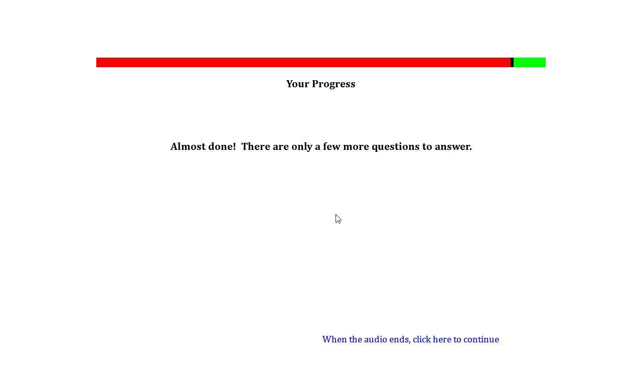

**Perceived Stress PSS-10**

**Source:** Cohen, S., Kamarck, T., Mermelstein, R. (1983). A global measure of perceived stress. *Journal of Health and Social Behavior, 24*, 385-396.

Cohen, S. (1988). Perceived stress in a probability sample of the United States. In S. Spacapan, S. Oskamp (Eds.), *The social psychology of health* (pp. 31-67). Thousand Oaks, CA, US: Sage Publications, Inc.

**Designed For:** Adults

**Psychometrics:** Cronbach’s alpha = .78

**Codebook:**

The following questions will ask about your stress.

1. In the last month, how often have you been upset because of something that happened unexpectedly? W2BWQ1 W2PerStress1

Never 0 Almost Never 1 Sometimes 2 Fairly Often 3 Very Often 4

1. In the last month, how often have you felt that you were unable to control the important things in life? W2BWQ2 W2PerStress2

Never 0 Almost Never 1 Sometimes 2 Fairly Often 3 Very Often 4

1. In the last month, how often have you felt nervous and “stressed”? W2BWQ3 W2PerStress3

Never 0 Almost Never 1 Sometimes 2 Fairly Often 3 Very Often 4

1. In the last month, how often have you felt confident about your ability to handle your personal problems? W2BWQ4 W2PerStress4

Never 0 Almost Never 1 Sometimes 2 Fairly Often 3 Very Often 4

1. In the last month, how often have you felt that things were going your way? W2BWQ5 W2PerStress5

Never 0 Almost Never 1 Sometimes 2 Fairly Often 3 Very Often 4

1. In the last month, how often have you found that you could not cope with all the things that you had to do? W2BWQ6 W2PerStress6

Never 0 Almost Never 1 Sometimes 2 Fairly Often 3 Very Often 4

1. In the last month, how often have you been able to control irritations in your life? W2BWQ7 W2PerStress7

Never 0 Almost Never 1 Sometimes 2 Fairly Often 3 Very Often 4

1. In the last month, how often have you felt that you were on top of things? W2BWQ8 W2PerStress8

Never 0 Almost Never 1 Sometimes 2 Fairly Often 3 Very Often 4

1. In the last month, how often have you been angered because of things that happened that were outside of your control? W2BWQ9 W2PerStress9

Never 0 Almost Never 1 Sometimes 2 Fairly Often 3 Very Often 4

1. In the last month, how often have you felt difficulties were piling up so high that you could not overcome them? W2BWQ10 W2PerStress10

Never 0 Almost Never 1 Sometimes 2 Fairly Often 3 Very Often 4

**Price Consciousness**

**Source:** Wells, W.D. & Tigert, D. (1971). Activities, interests, and opinions. *Journal of Advertising Research, 11*, 27-35.

Tat, P.K., & Bejou, D. (1994). Examining black consumer motives for coupon usage. *Journal of Advertising Research, 34*, 29-35.

**Designed For:** Adults

**Psychometrics:** Cronbach’s alpha = .78

**Codebook:**

Please indicate whether you disagree or agree with each statement.

1. I shop a lot for “specials.” W2CBQ1 W2PriceCon1

Strongly Disagree 1 Disagree 2 Agree 3 Strongly Agree 4

1. I check the prices even for inexpensive items. W2CBQ2 W2PriceCon2

Strongly Disagree 1 Disagree 2 Agree 3 Strongly Agree 4

1. I pay attention to sales and specials. W2CBQ3 W2PriceCon3

Strongly Disagree 1 Disagree 2 Agree 3 Strongly Agree 4

**Tobacco Shopper Type**

**Source:** Modeled on research from Sorensen, H. (2009). Inside the mind of the shopper: The science of retailing. Upper Saddle River, N.J.: Prentice Hall.

**Designed For:** Adults

**Psychometrics**: Not reported

**Items**:

[*Page 1*]

1. Have you ever bought tobacco products at a store? W2CCQ1 W2TobShopStore1

Yes 1

No 0

(If Yes To Question 1…) [*Page 2*]

**Think of the last time you bought tobacco products at a store. Try to form a picture of this in your mind.**

1. In addition to tobacco products, did you buy any of the following? (Check all that apply) W2CCQ2 W2TobShopType2, 0 When Not Selected, 1 When Selected

Snack Foods W2CCQ2option1 W2TobShopSnack2

Alcohol W2CCQ2option2 W2TobShopAlco2

Coffee Drinks W2CCQ2option3 W2TobShopCofee2

Soda or Energy Drinks W2CCQ2option4 W2TobShopSoda2

Lottery Tickets W2CCQ2option5 W2TobShopLotto2

Magazines or Newspapers W2CCQ2option6 W2TobShopMag2

None of the above W2CCQ2option7 W2TobShopNone2

1. How many different types of products did you buy? W2CCQ3 W2TobShopAmount3

One 1

Two 2

Three 3

Four 4

Five 5

Six or more 6

[*Page 3*]

1. When did you last purchase a pack of cigarettes at a store? W2CCQ4 W2TobShopLastCig4

1-2 days ago 7

3-6 days ago 6

1-2 weeks ago 5

3-4 weeks ago 4

1-2 months ago 3

3-6 months ago 2

More than 6 months ago 1

I have never bought a pack of cigarettes at a store -7

(If Purchased Cigarettes in Prior Question…) [*Page 4*]

1. How much did you pay for the last pack of cigarettes you bought at a store? $___________ W2CCQ5 W2TobShopCostCig5
2. What brand did you buy? W2CCQ6 W2TobShopBrandCig6

American Spirit 1

Camel 2

GPC, Basic, or Doral 3

Kool 4

Lucky Strike 5

Marlboro 6

Newport 7

Parliament 8

Summit -5

Virginia Slims 9

Another brand (please specify): 10 _________ W2CCQ6other W2TobShopBrandCigOther6

**Enrollment In The Military**

**Source:** Adapted from Johnston, L.D., O’Malley, P.M., Bachman, J.G., & Schulenberg, J.E. (2014) 2011 Monitoring the future survey (MTF). Retrieved from <http://www.monitoringthefuture.org/>. Ann Arbor: Institute for Social Research, The University of Michigan.

**Designed For:** Adolescent

**Psychometrics**: Not provided

**Codebook:**

Please answer the following questions.

1. Are you a member of the... W2BXQ1 W2MilitaryMember1, 0 When Not Selected, 1 When Selected

Army W2BXQ1option1 W2MilitaryMemberArmy1

Navy W2BXQ1option2 W2MilitaryMemberNavy1

Marine Corps W2BXQ1option3 W2MilitaryMemberMarine1

Air Force W2BXQ1option4 W2MilitaryMemberAirForce1

Coast Guard W2BXQ1option5 W2MilitaryMemberCoast1

None of the above W2BXQ1option6 W2MilitaryMemberNone1

1. Are you thinking about enlisting in the... W2BXQ2 W2MilitaryEnlist2, 0 When Not Selected, 1 When Selected

Army W2BXQ2option1 W2MilitaryEnlistArmy2

Navy W2BXQ2option2 W2MilitaryEnlistNavy2

Marine Corps W2BXQ2option3 W2MilitaryEnlistMarine2

Air Force W2BXQ2option4 W2MilitaryEnlistAirForce2

Coast Guard W2BXQ2option5 W2MilitaryEnlistCoast2

None of the above W2BXQ2option6 W2MilitaryEnlistNone2

**Extracurricular Activities**

**Source:** Adapted from Hornik, D., Hornik, S., Hornik, R., & Maklan, D. (2011). National survey of parents and youth (NSPY), 1998-2004 -- Restricted Use Files. ICPSR27868-v2. Ann Arbor, MI: Inter-university Consortium for Political and Social Research [distributor], 2011-03-03. <http://doi.org/10.3886/ICPSR27868.v2>

**Designed for:** Adolescents

**Psychometrics:** Not provided

**Items:**

1. In the last 12 months, which of the following organized activities or groups have you participated in? (Check all that apply) W2CDQ1 W2ExCurPast1, 0 When Not Selected, 1 When Selected

Music, dance, theater or other performing arts (in or outside of school) W2CDQ1option1 W2ExCurPastArts1

Athletic teams or organized sports (in or outside of school) W2CDQ1option2 W2ExCurPastSports1

Boys or girls clubs (Boy Scouts, Girl Scouts, etc.) W2CDQ1option3 W2ExCurPastScouts1

Youth groups sponsored by a church, synagogue, mosque, or other religious institution W2CDQ1option4 W2ExCurPastChurch1

Another club or activity, in or outside of school, or volunteer work W2CDQ1option5 W2ExCurPastOther1

None of these clubs or activities W2CDQ1option6 W2ExCurPastNone1

(If an option other than ‘None of these clubs or activities’ is selected…) [*Page 2*]

1. How many hours a week did you participate in these activities? ___________ W2CDQ2 W2ExCurPastHours1

[*Page 3*]

1. Which of the following organized activities or groups are you currently participating in? (Check all that apply) W2CDQ3 W2ExCurNow1, 0 When Not Selected, 1 When Selected

Music, dance, theater or other performing arts (in or outside of school) W2CDQ3option1 W2ExCurNowArts1

Athletic teams or organized sports (in or outside of school) W2CDQ3option2 W2ExCurNowSports1

Boys or girls clubs (Boy Scouts, Girl Scouts, etc.) W2CDQ3option3 W2ExCurNowScouts1

Youth groups sponsored by a church, synagogue, mosque, or other religious institution W2CDQ3option4 W2ExCurNowChurch1

Another club or activity, in or outside of school, or volunteer work W2CDQ3option5 W2ExCurNowOther1

None of these clubs or activities W2CDQ3option6 W2ExCurNowNone1

(If an option other than ‘None of these clubs or activities’ is selected…) [*Page 4*]

1. How many hours a week do you participate in these activities? ___________ W2CDQ4 W2ExCurNowHours1
2. How many close friends participate in these activities with you? W2CDQ5 W2ExCurNowFriends1

None of them 0

A few of them 1

About half of them 2

Most of them 3

All of them 4

**Attrition**

**Source:** Adapted from Ford, W. (2003). Communication practices of professional service providers: Predicting customer satisfaction and loyalty. *Journal Of Applied Communication Research, 31*(3), 189-211.

Garnefeld, I., Helm, S., & Eggert, A. (2011). Walk your talk: An experimental investigation of the relationship between word of mouth and communicators’ loyalty. *Journal Of Service* *Research, 14*(1), 93-107.

**Designed For:** Adolescents

**Psychometrics:** Not provided

**Codebook:**

Please indicate whether you disagree or agree with each statement.

I am likely to complete the next CHAMP survey a year from now. W2BYQ1 W2AttritionComplete1

Strongly Disagree 1 Disagree 2 Agree 3 Strongly Agree 4

I am likely to recommend to my friends that they participate in studies by the CHAMP team. W2BYQ2 W2AttritionRecommend2

Strongly Disagree 1 Disagree 2 Agree 3 Strongly Agree 4

I am likely to participate in future studies by the CHAMP team. W2BYQ3 W2AttritionFuture3

Strongly Disagree 1 Disagree 2 Agree 3 Strongly Agree 4

Now imagine that you are sitting with a friend. Your friend tells you they were contacted by CHAMP about a new study, but didn’t sign up. What would you say to convince your friend to do this? W2BYQ4 W2AttritionFriend4

Do you think I should sign up?

[Text Field]



**Final Screen**

Congratulations! You are done with the survey.

All you have to do now is email or text the following keyword to your Study Coordinator.

[*4 Digit Code*]

In the next couple days, they will send you a Target eGiftCard.

Thank you for all the time you have given to CHAMP. If you have any questions or need any assistance, don’t hesitate to contact us or visit our website at [www.champsurvey.com](http://www.champsurvey.com).